|  |  |  |
| --- | --- | --- |
|  | AptechIDCE160511H |  |

**NVL Tech**

**DOCUMENTATION**

**Group’s members:**

**- Student1150068 : TRAN NGHE NANG**

**- Student1148047 : DO DUC LONG**

**- Student1165526 : HOANG VIET**

**Instructor: PHAN HỮU TRÍ**

**Class: ACCP1808**

**CERTIFICATION**

* Thank to the instruction of Instructor **PHAN HỮU TRÍ**, all members of the group have made the efforts to complete the requirement of eProject.
* Thank to **AptechSaigon** for supporting us during the learning process.
* Thank to **Aptech Computer** **Education** for giving us the opportunity to improve experience in many aspects.

**By the approvement of Mr. PHAN** , we are proud to present this product with the appreciate for him.

We expect this product can get the archievements the eProject requires.

Thank you.

**CATEGORY**

**Content 94 pages**

Section 1: Introduction 04

Section 2: Acknowledgements 10

Section 3: Synopsis 10

Section 4: Analysis 11

Session 5: Design 12

Session 6: User guild 20

Session 7: Developer guild 52

# **Section 1: Introduce the Project**

## The background:

In these days, with the significant developing of science and technology, applying Information Technology becomes an indispensable demand in every matters of life thanks to its efficient, convenient and rapidness. In the array of human’s IT creation, Phone is one of the greatest. By not only having basic functions like calling, messaging or playing music but also making user experience in surfing webs, watching movies or chatting with friend… Owning a phone now becomes an equipment that every single person requires.

However, living in the hustle and bustle society, make people have to use the most of their time effectively. It will take a lot of time for people to go to the store to refer and get the phone that they desire most.

For the drawbacks mentioned above, in searching of recovery methods, we notice that Online Shopping is the key solution that becomes the trump card of every entrepreneur want their products approached by customers without limitations. By taking the advantages of widely expansive web development, applying Shopping Online in the cell phone business will help people reduce their time and effort in real interaction, make the selection more simpler, customer can have their need in an easy way…

Coming up with those ideas, we unified and decided the topic: “establish and develop the mobile website selling online with accessory, the NVL TECH”.

Through the process of researching and analyzing, we present the document in order to help user and reader to understand clearly about the functions, contents and advantages of the website.

## Main task:

### Introduce the task:

NVL Tech is one of the specific websites applying the Information Technology for purposes: sell mobiles and accessories online. NVL Tech is a company specializing importing mobiles form infamous company: Nokia, Samsung, Sony, Apple… and the accessories comes from well-known brands: iJoy, Apple, Beats, Sony… so the NVL could approach customers in a professional way. Almost the transaction takes place on the website. When products are out of stock, NVL will contact to the production company to demand those products as soon as possible and notify to the customers via the website.

The main purpose of developing the website is to help customers can communicating the company, see overview products, select and buy the product online via the internet. Wherever the customers are, they still can greed for information of the product they need, compare to the others in a rapid, convenient way and saving their time, meet the needs they require. The search system is easy to use, friendly user interface help the user access to the website and can login to the system with the existed account (if they have already registered) or buy freely at the NVL site. Besides that, news and information about products of the NVL showed in front page so customers can easily read an update the events.

### Review the task:

The ecommerce problem is a big and complex problem with many different modules: find product, bring product to cart, register member, security, managing functions…

The present problems of the real interact store: come up with the diversity of different mobile brands, the requirement of market expansion and the way of fastest product marketing to customers, the store has to face with the problems that the old structure couldn’t solve:

Customers have to take time to go directly to the store for selection and buying products.

Dependence on the marketing service skills of every employee, if one has low marketing service skill, they could not attract the customers to products.

Management the inventory is always a priority problem. If the connection between the store and the warehouse is loose, it could lead to the difficult problems in management and the lacking of information for customers.

### Solve the task:

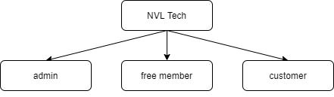NVL Tech website diagram:

Description:

**Admins**: is the manager of the site, after login with the admin role, user can have the total right to view and add, edit or delete data of the website, view details of orders, control the information of brands, products, or members…

**Customer**: is the guest who want to view or buy product, they have right to access the information of product and buy product, approach the promotions of NVL, register to become member…

Free member: is the guest who already registered (have all the rights of customer) and accepted by the admin, the information of member is saved to the database and managed by admin. Member have the right to be prioritized in service policies of NVL (access and buy product “ASAP”, have voucher, comment or rate the products…).

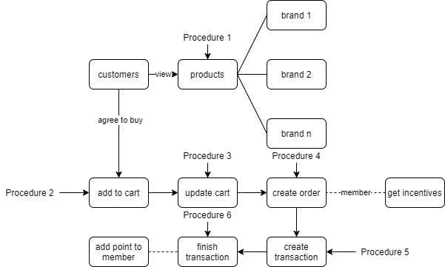Paradigm of buying products:

**Description**:

* Procedure 1: When the main page shows, customers can view products of different brands in the list, the products could be duplicated by name, category but the admin can distinguish them belongs to specific brand.
* Procedure 2: After selecting products, customer add the products to cart.
* Procedure 3: In the cart, customer can update the quantity of products, remove or add other products.
* Procedure 4: Customer will create an order after deciding to get the products in cart. (if they login as member and the account have enough voucher points, they can exchange for sale off).
* Procedure 5: After creating order, customer will filling the form to begin a transaction for payment.
* Procedure 6: Transaction will finish after online payments system finishes handling money transferring.

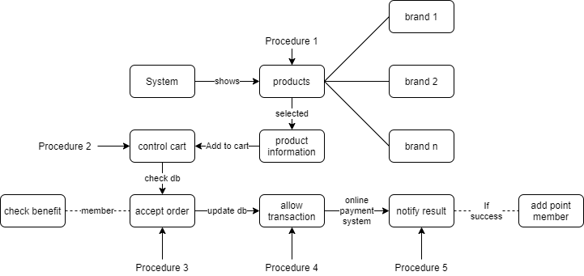Paradigm of selling products:

**Description:**

* Procedure 1: System will display the products list by categories, brands or requests of customers.
* Procedure 2: System create a cart to store and control products and quantity selected by customers.
* Procedure 3: After checking database for validation of products, system accepts order and show benefit of member (customer logins), validates information of customer.
* Procedure 4: System updates database after customer request payment, payment form will be created for customer to request a transaction for online payment system (PAYPAL).
* Procedure 5: After receiving result of online payment system for the transaction, system will update database (order status and member point if successful or rollback the quantity of product) and notify message for customer.

### Mission of the Project:

Shopping online is now becoming a global trend for most business fields, the amount of customers using internet for shopping online speeds up because of its conveniences. Leading to the requirements and services of selling companies have to upgrade and improvement so that they could demand the customer’s satisfaction. Many companies decided to apply ecommerce in the business field beginning with introduction the products for customer via internet and now the payment is processed by the online payment system. The mission of NVL is trying to make the website (system) maximum supports for the users (customers and administrators) in buying, selling and managing the business.

Website system includes many features:

**For the administrator:**

Operating all the activity of the website.

Adding, updating, deleting the products, brands, categories…

Updating, deleting members, their information and managing voucher points.

Receiving, editing and processing the product orders and delivery orders of customers.

Managing and approving the comment of members about products.

Accessing and enquiring the statistics of the categories, brands, products and changing over time.

**For the customer:**

Visit and view the content of store of the website.

Registering freely to become member.

Viewing, selecting, searching the products and their comment or feedback made by members.

Buying the products.

**Processing:**

Ordering automatically.

Searching information right on the website.

Not supporting forum or any relative functions.

**Interface:**

System works on web application interface.

**Scope:**

Using for studying purpose only.

Using free data on various resources.

**Internet:**

System supports working on internet (selling via internet).

### Works:

* + **Building the UI for users.**
  + **Building the system structure for users.**
  + **Building the functions for buying and selling.**
  + **Building the functions for management.**
  + **Building database structure for management.**

#### Hardware Requirements

* + - PC Intel core i family
    - OS Windows® 7 or better.
    - HDD 500MB.
    - RAM 2GB or better.

#### Software Requirements

For server (developer)

* + - Computer with OS having JAVA environment installation.
    - XAMPP (WAMP) to connect Database.
    - Spring Tool Suite or Eclipse.
    - Internet for retrieving libraries.

For client (user)

* + - Internet Explorer (IE, Edge, Firefox, Chrome…).

# **Section 2: Acknowledgements**

Java Spring Framework and others libraries…, HML5, JavaScript, jQuery and Bootstrap…

# **Section 3: Synopsis**

## User side:

* Pages : Home Page, Shop Page, Contact Page, Order Tracking Page, Search Page, Register Page…
* Home Page : display the products by categories, promotions and high rate.
* Shop Page : display all the products, have filter bar for customer filter find the product easily.
* Product Page : display the information, comment and rate of a product.
* Cart Page : display product(s) have added to shopping cart by customer.
* Payment Page : customer check the order, and fill out the information for trading.
* Order Tracking Page : for customer tracking an order.
* Search Page : display products were searched by customer.
* Register Page : for customer register to become member.
* Sign in Page : login to website, checking the order(s) history.
* Manage Profile Page : update member information.

## Admin side:

* Login Page: accepts only account with role admin, prevents illegal accesses.
* Dashboard Page: statistic contents of buying, selling and member activities.
* Products Page: displays products of the site, methods: insert, update, delete, sort.
* Orders Page: displays orders of the site, methods: update, sort, filter.
* Deliveries Page: displays deliveries requirement of members, method: update, sort, filter.
* Brands Page: displays brands of products, methods: insert, update, delete, sort.
* Members Page: display members of the site, method: update, delete, sort,
* Discounts Page: display promotions and vouchers of the product, method: insert, update, delete.
* Commend Box Page: display comments of members for product, method: accept, delete.

# **Section 4: Analysis**

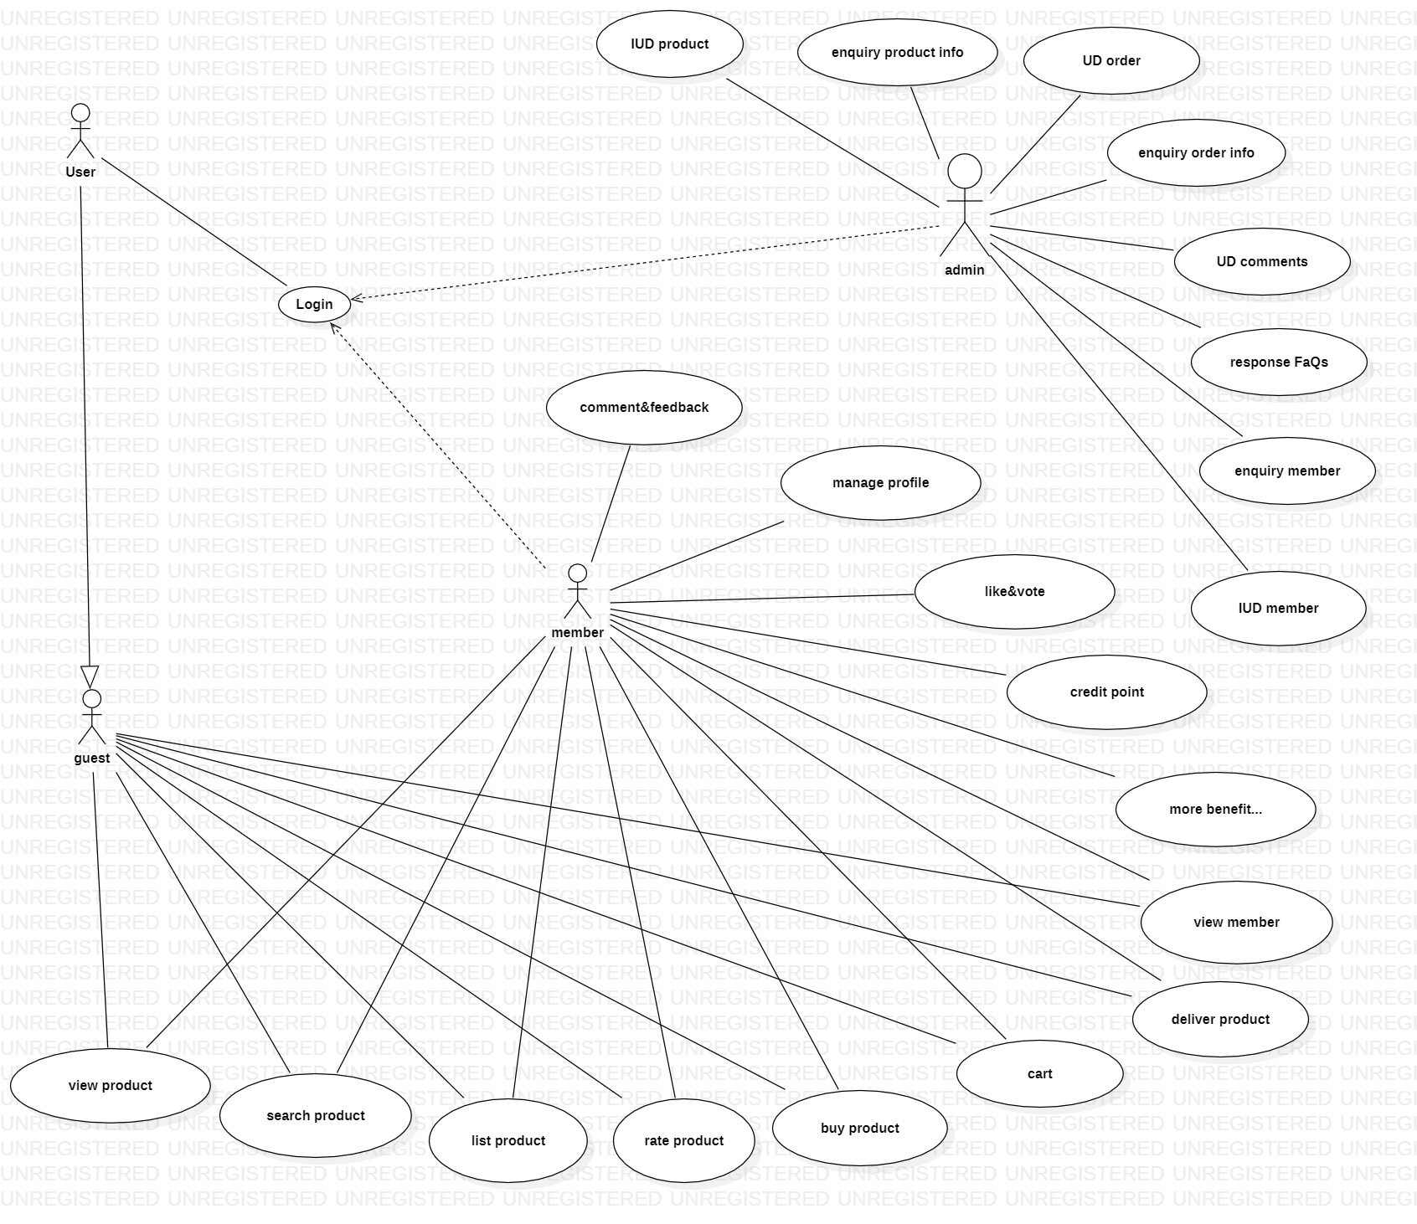

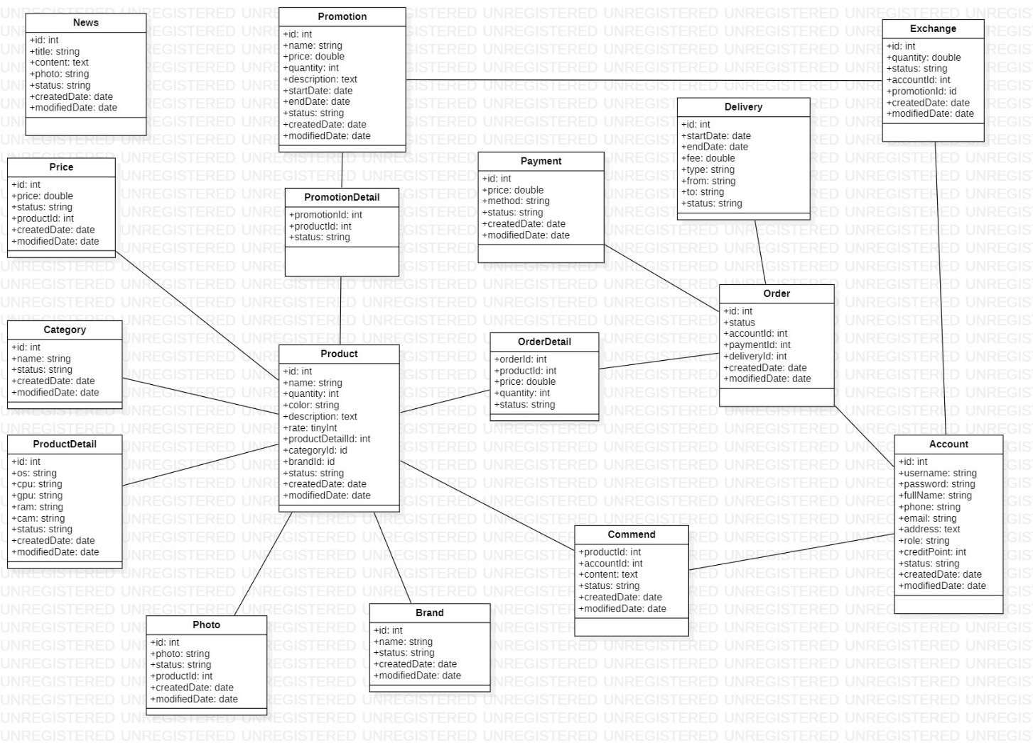

# **Section 5: Design**

## Diagrams

### Customer-site diagrams:

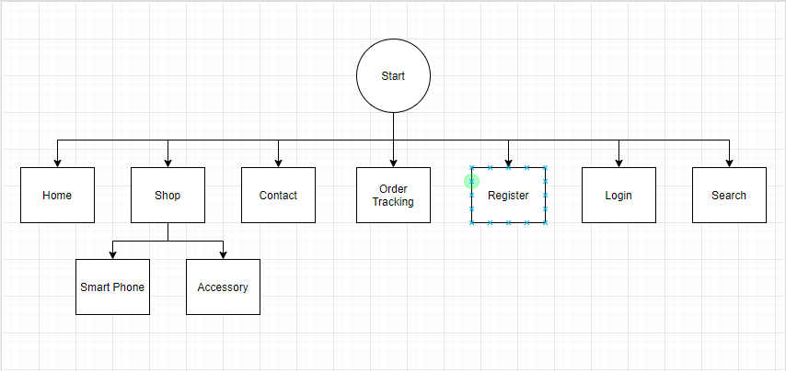

Template

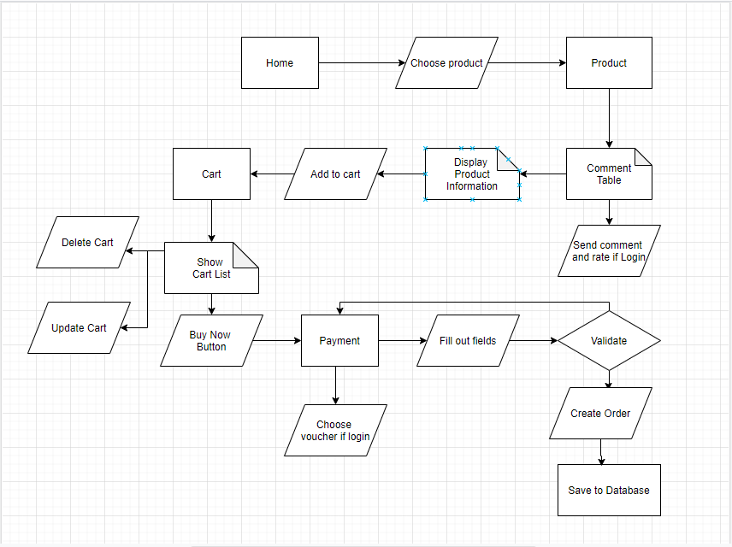

Home

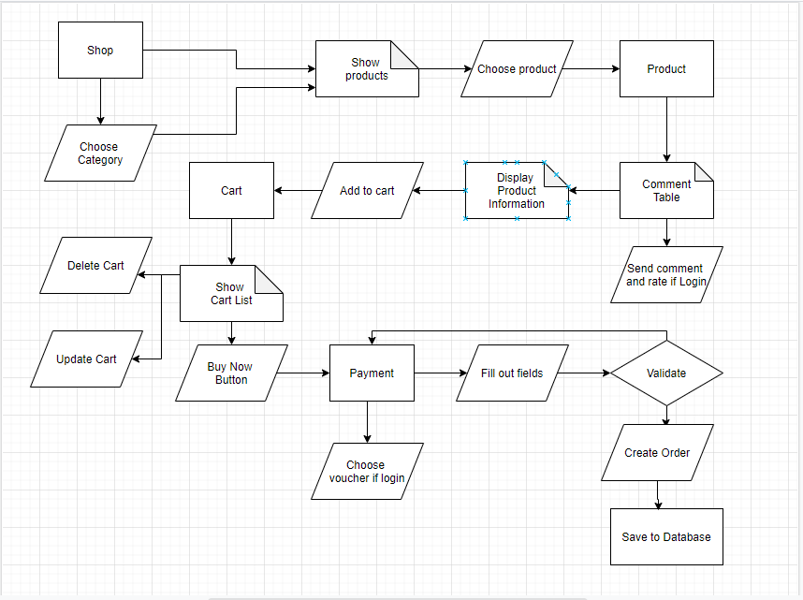

Shop

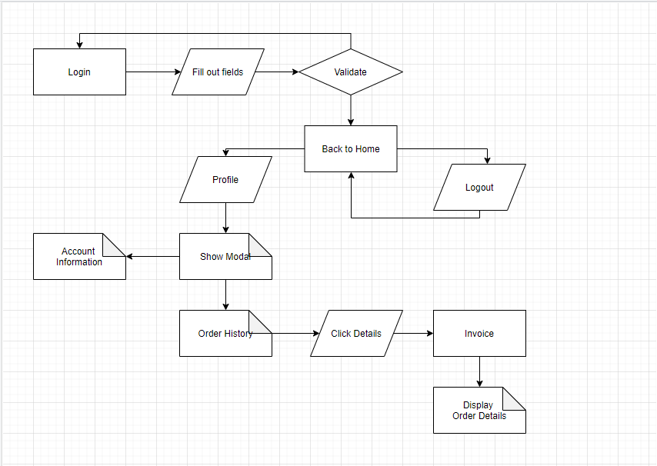

Login

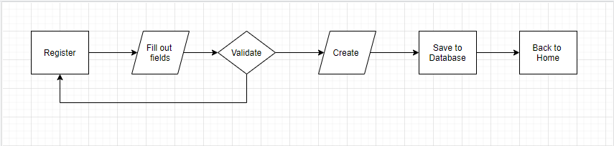

Register

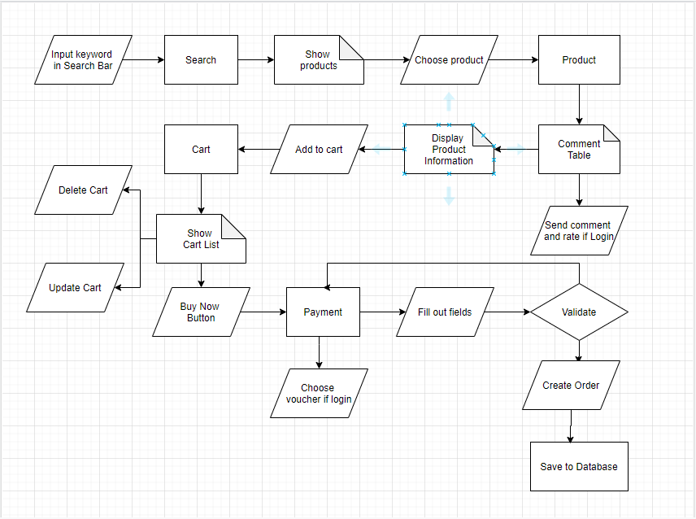

Search

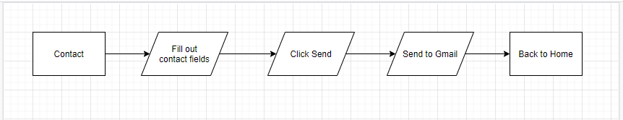

Contact

## Database nvl

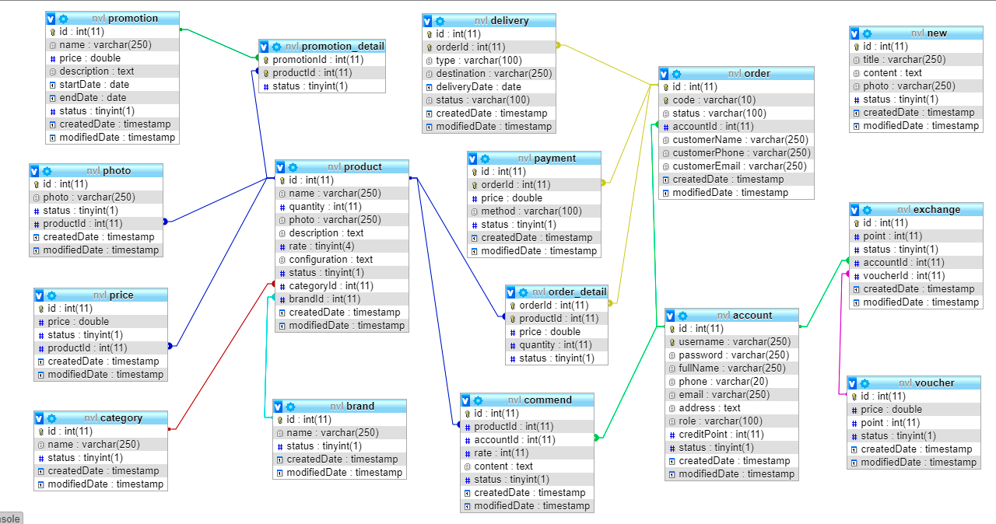

### Table structure for table account

|  |  |  |  |
| --- | --- | --- | --- |
| **Column** | **Type** | **Null** | **Default** |
| ***id*** | int(11) | No |  |
| **username** | varchar(250) | No |  |
| password | varchar(250) | No |  |
| fullName | varchar(250) | No |  |
| phone | varchar(20) | No |  |
| email | varchar(250) | No |  |
| address | text | No |  |
| role | varchar(100) | No |  |
| creditPoint | int(11) | No |  |
| status | tinyint(1) | No |  |
| createdDate | timestamp | No | CURRENT_TIMESTAMP |
| modifiedDate | timestamp | No | CURRENT_TIMESTAMP |

### Table structure for table brand

|  |  |  |  |
| --- | --- | --- | --- |
| **Column** | **Type** | **Null** | **Default** |
| ***id*** | int(11) | No |  |
| name | varchar(250) | No |  |
| status | tinyint(1) | No |  |
| createdDate | timestamp | No | CURRENT_TIMESTAMP |
| modifiedDate | timestamp | No | CURRENT_TIMESTAMP |

### Table structure for table category

|  |  |  |  |
| --- | --- | --- | --- |
| **Column** | **Type** | **Null** | **Default** |
| ***id*** | int(11) | No |  |
| name | varchar(250) | No |  |
| status | tinyint(1) | No |  |
| createdDate | timestamp | No | CURRENT_TIMESTAMP |
| modifiedDate | timestamp | No | CURRENT_TIMESTAMP |

### Table structure for table commend

|  |  |  |  |
| --- | --- | --- | --- |
| **Column** | **Type** | **Null** | **Default** |
| ***id*** | int(11) | No |  |
| productId | int(11) | No |  |
| accountId | int(11) | No |  |
| rate | int(11) | No |  |
| content | text | No |  |
| status | tinyint(1) | No |  |
| createdDate | timestamp | No | CURRENT_TIMESTAMP |
| modifiedDate | timestamp | No | CURRENT_TIMESTAMP |

### Table structure for table delivery

|  |  |  |  |
| --- | --- | --- | --- |
| **Column** | **Type** | **Null** | **Default** |
| ***id*** | int(11) | No |  |
| **orderId** | int(11) | No |  |
| type | varchar(100) | Yes | NULL |
| destination | varchar(250) | Yes | NULL |
| deliveryDate | date | Yes | NULL |
| status | varchar(100) | Yes | NULL |
| createdDate | timestamp | No | CURRENT_TIMESTAMP |
| modifiedDate | timestamp | No | CURRENT_TIMESTAMP |

### Table structure for table exchange

|  |  |  |  |
| --- | --- | --- | --- |
| **Column** | **Type** | **Null** | **Default** |
| ***id*** | int(11) | No |  |
| point | int(11) | Yes | NULL |
| status | tinyint(1) | Yes | NULL |
| accountId | int(11) | Yes | NULL |
| orderId | int(11) | No |  |
| voucherId | int(11) | Yes | NULL |
| createdDate | timestamp | No | CURRENT_TIMESTAMP |
| modifiedDate | timestamp | No | CURRENT_TIMESTAMP |

### Table structure for table new

|  |  |  |  |
| --- | --- | --- | --- |
| **Column** | **Type** | **Null** | **Default** |
| ***id*** | int(11) | No |  |
| title | varchar(250) | No |  |
| content | text | No |  |
| photo | varchar(250) | No |  |

### Table structure for table order

|  |  |  |  |
| --- | --- | --- | --- |
| **Column** | **Type** | **Null** | **Default** |
| ***id*** | int(11) | No |  |
| **code** | varchar(10) | Yes | NULL |
| status | varchar(100) | Yes | NULL |
| accountId | int(11) | Yes | NULL |
| customerName | varchar(250) | Yes | NULL |
| customerPhone | varchar(250) | Yes | NULL |
| customerEmail | varchar(250) | Yes | NULL |
| createdDate | timestamp | No | CURRENT_TIMESTAMP |
| modifiedDate | timestamp | No | CURRENT_TIMESTAMP |

### Table structure for table order_detail

|  |  |  |  |
| --- | --- | --- | --- |
| **Column** | **Type** | **Null** | **Default** |
| ***orderId*** | int(11) | No |  |
| ***productId*** | int(11) | No |  |
| price | double | No |  |
| quantity | int(11) | No |  |
| status | tinyint(1) | No |  |

### Table structure for table payment

|  |  |  |  |
| --- | --- | --- | --- |
| **Column** | **Type** | **Null** | **Default** |
| ***id*** | int(11) | No |  |
| **orderId** | int(11) | No |  |
| price | double | Yes | NULL |
| method | varchar(100) | Yes | NULL |
| status | tinyint(1) | Yes | NULL |
| createdDate | timestamp | No | CURRENT_TIMESTAMP |
| modifiedDate | timestamp | No | CURRENT_TIMESTAMP |

### Table structure for table photo

|  |  |  |  |
| --- | --- | --- | --- |
| **Column** | **Type** | **Null** | **Default** |
| ***id*** | int(11) | No |  |
| photo | varchar(250) | No |  |
| status | tinyint(1) | No |  |
| productId | int(11) | No |  |
| createdDate | timestamp | No | CURRENT_TIMESTAMP |
| modifiedDate | timestamp | No | CURRENT_TIMESTAMP |

### Table structure for table price

|  |  |  |  |
| --- | --- | --- | --- |
| **Column** | **Type** | **Null** | **Default** |
| ***id*** | int(11) | No |  |
| price | double | No |  |
| status | tinyint(1) | No |  |
| productId | int(11) | No |  |
| createdDate | timestamp | No | CURRENT_TIMESTAMP |
| modifiedDate | timestamp | No | CURRENT_TIMESTAMP |

### Table structure for table product

|  |  |  |  |
| --- | --- | --- | --- |
| **Column** | **Type** | **Null** | **Default** |
| ***id*** | int(11) | No |  |
| name | varchar(250) | Yes | NULL |
| quantity | int(11) | Yes | NULL |
| photo | varchar(250) | Yes | NULL |
| description | text | Yes | NULL |
| rate | tinyint(4) | Yes | NULL |
| configuration | text | Yes | NULL |
| status | tinyint(1) | Yes | NULL |
| categoryId | int(11) | Yes | NULL |
| brandId | int(11) | Yes | NULL |
| createdDate | timestamp | No | CURRENT_TIMESTAMP |
| modifiedDate | timestamp | No | CURRENT_TIMESTAMP |

### Table structure for table promotion

|  |  |  |  |
| --- | --- | --- | --- |
| **Column** | **Type** | **Null** | **Default** |
| ***id*** | int(11) | No |  |
| name | varchar(250) | No |  |
| price | double | No |  |
| description | text | No |  |
| startDate | date | No |  |
| endDate | date | No |  |
| status | tinyint(1) | No |  |
| createdDate | timestamp | No | CURRENT_TIMESTAMP |
| modifiedDate | timestamp | No | CURRENT_TIMESTAMP |

### Table structure for table promotion_detail

|  |  |  |  |
| --- | --- | --- | --- |
| **Column** | **Type** | **Null** | **Default** |
| ***promotionId*** | int(11) | No |  |
| ***productId*** | int(11) | No |  |
| status | tinyint(1) | No |  |

### Table structure for table voucher

|  |  |  |  |
| --- | --- | --- | --- |
| **Column** | **Type** | **Null** | **Default** |
| ***id*** | int(11) | No |  |
| price | double | No |  |
| point | int(11) | No |  |
| status | tinyint(1) | No |  |
| createdDate | timestamp | No | CURRENT_TIMESTAMP |
| modifiedDate | timestamp | No | CURRENT_TIMESTAMP |

# **Session 6: User Guild**

## Customer Side

**Index Page :**

Header : can contact admin by click the email on the top, will go to contact page, on top right side can Register and Sign In, click the Cart icon to go to Shipping Cart Page.

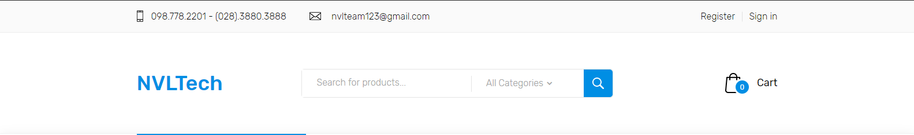

The right side is my logo of us.



Navigation bar on the top separate left and right side :

The categories bar on the left, show all the categories of website.

Menu Bar on the right have Home page (Index Page), Shop Page, and have drop down list : Smart Phone and Accessory Categories, Context Page and Order Tracking Page.

The “Shop Now” button in the miidle of the Main Banner can link to the Shop Page

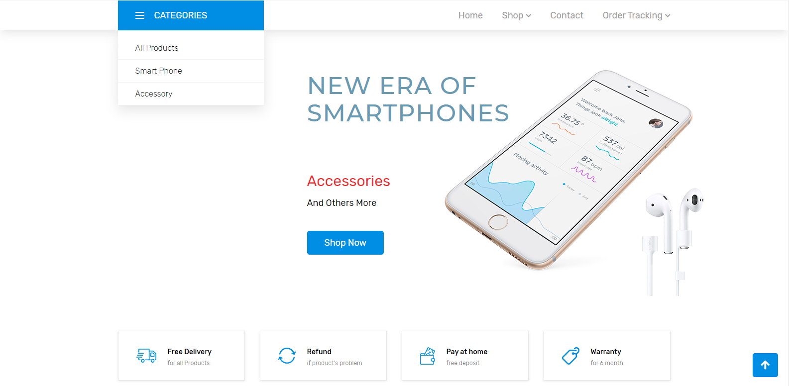

We have good service for customer :

Free Delivery for all Products.

Refund if our products have some proplem.

Pay at home without deposit.

Warranty for 6 months.

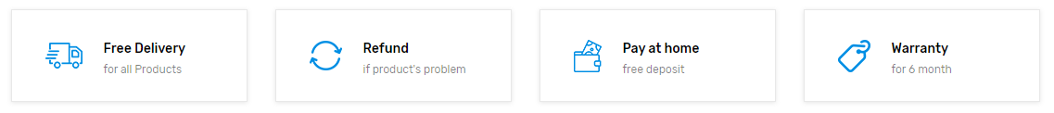

This button click for scroll to the top of the website



Show the products of the categories, let customers view and choose the product easilly. See others category’s product by click the name of that category con the top.

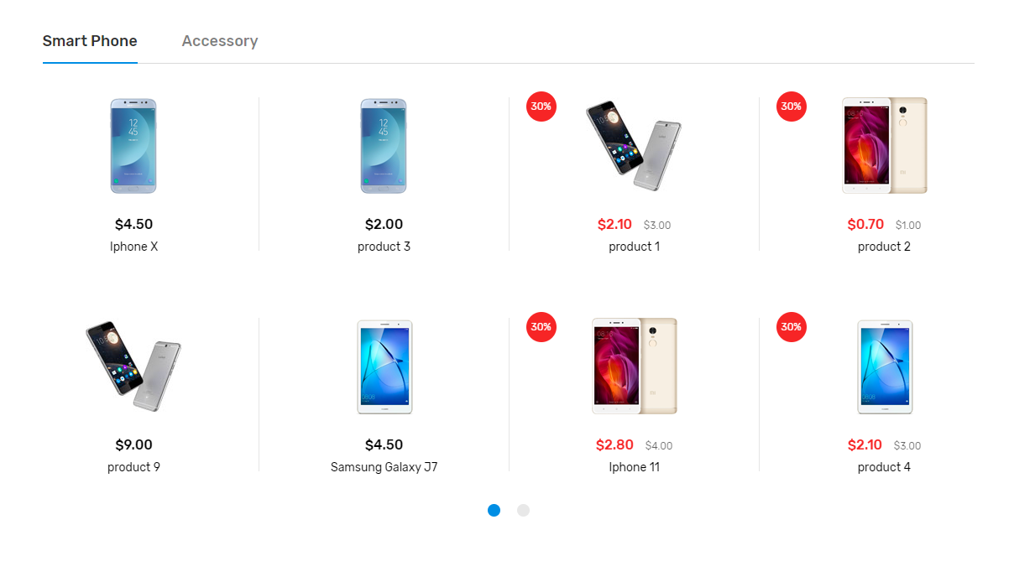

There is show the High Rated products, and promotion products. Just like the category product abrove, click the High Rate or Promotion name to change to products

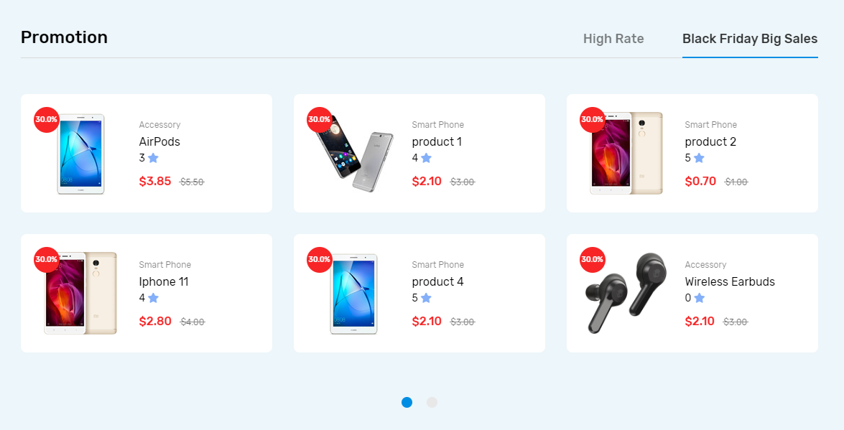

This is our brand bar, show all the products brand of products.

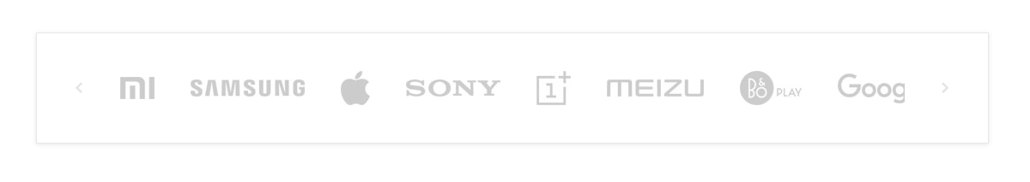

Final we have the footer, left is our information, Logo, Phone, Address, your can contact us by your phone or our go to out shop to have a better consultation.



The left side is search bar.

In the search bar we have text place, some sorting you can choose and the button search.

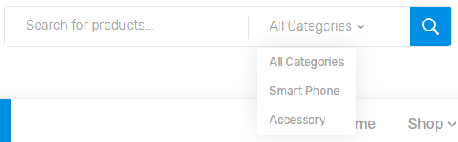

When you searched, the products would be show in the bottom.

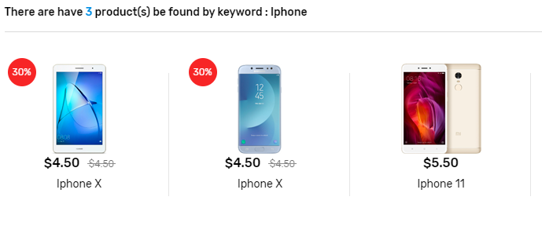

**Register Page :**

Fill out all you information and click Register to become member.

User Name, Password, Confirm Password, Full Name, Phone Number, Email, Address.

Username : username is unique so if register same as the username some one register before, your have to change to another name.

Password : password have minimum 6 characters, and confirm the Password, if password field and confirm field value are diffence, error and can not register, you have to enter again.

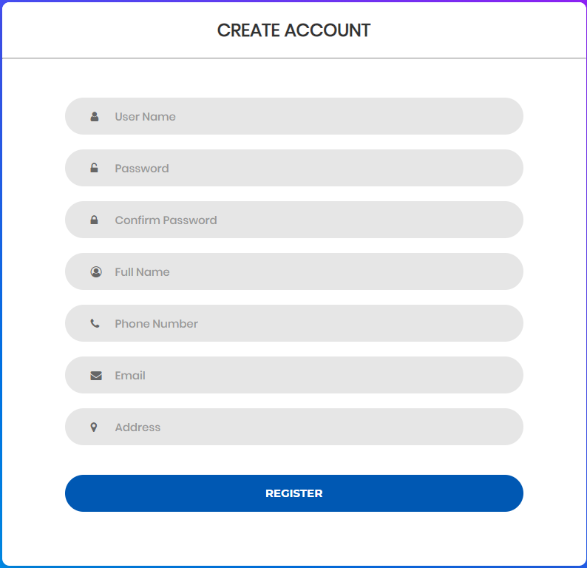

**Sign in Page :**

Enter your User Name and Password then click the Login button to Sign In.

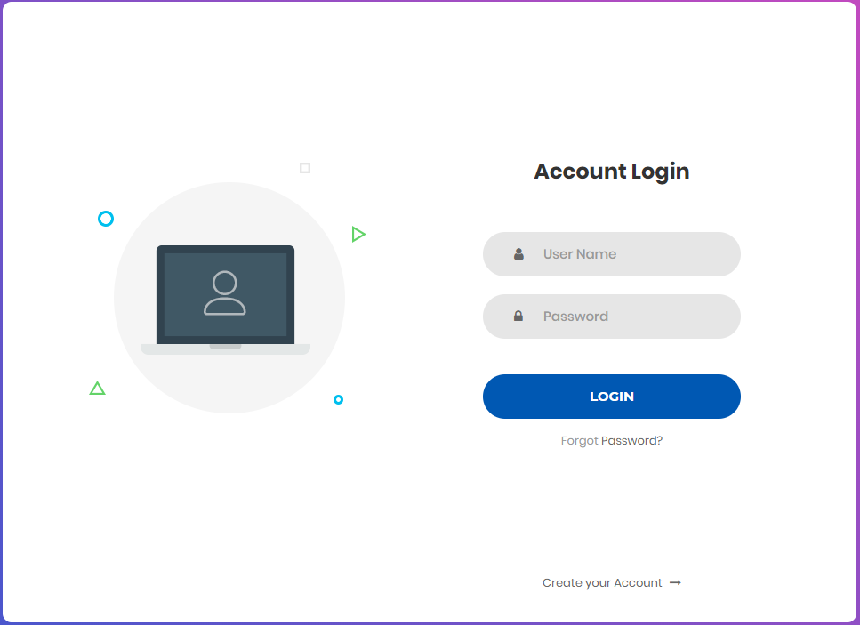

After sign in success, on top header got some little change.

Sign in button replace to Profile button.



Click the Profile button it’s show all your information.

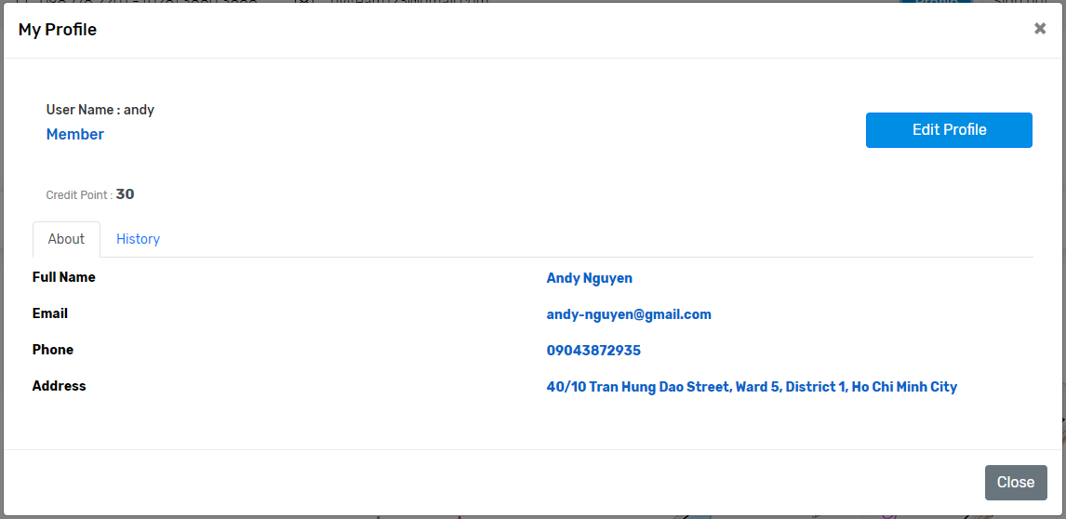

**Shop Page :**

All Products of the website, and the sale off product. click the product to view the product information.

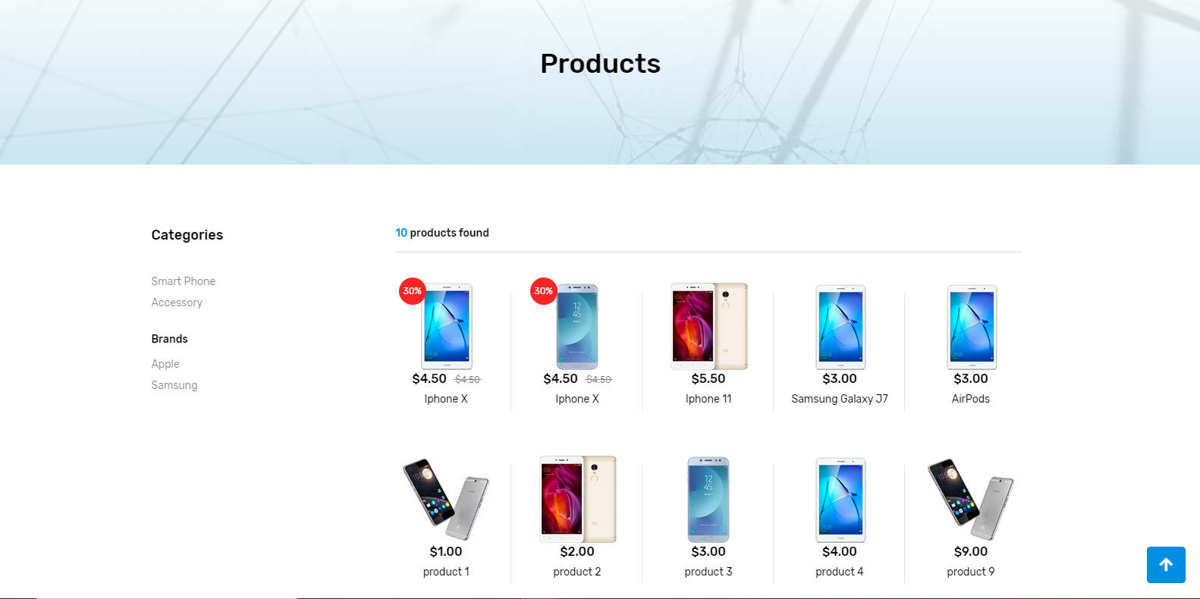

The Category and Brand of the left side can sort the products by that category or brand.

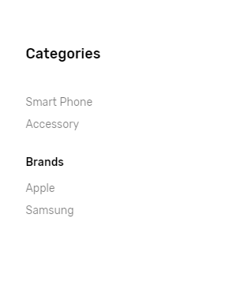

All products show up the right side, you can refer and choose what you want.

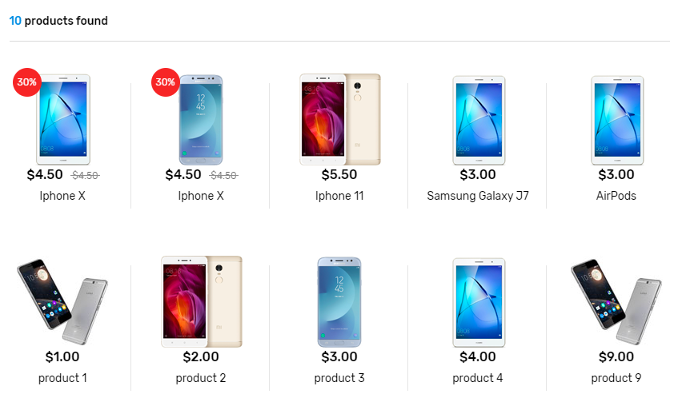

The Pagination bottom click to view others pages and products in that page.



**Product Info Page :**

Click three small product images aside to change the big image.

Increase product quantity then click **Add to Cart** button, add this product to your cart shop

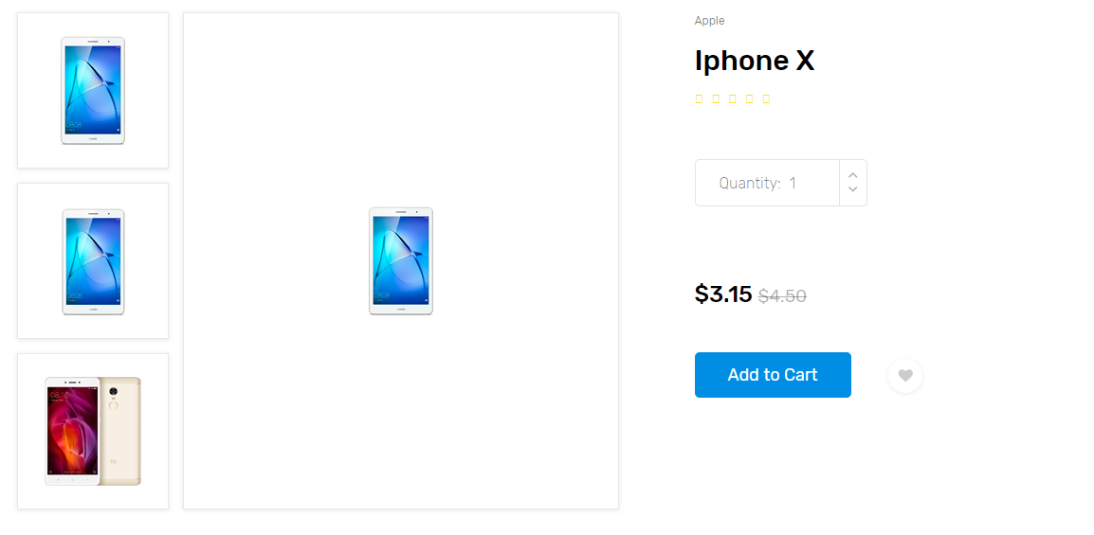

In the left side, that’s description form, it’s show some information you can check to understand the product.

In the right side, that’s configuration and it’s show you all the details of product.

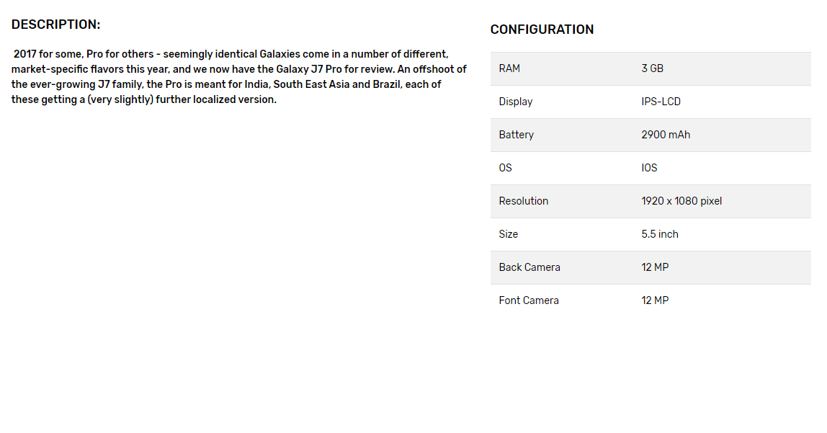

In the Bottom have Comment Table, must sign in your account to comment and rating then click **POST** button.

If you not sign in, you just see another comments from another guys.

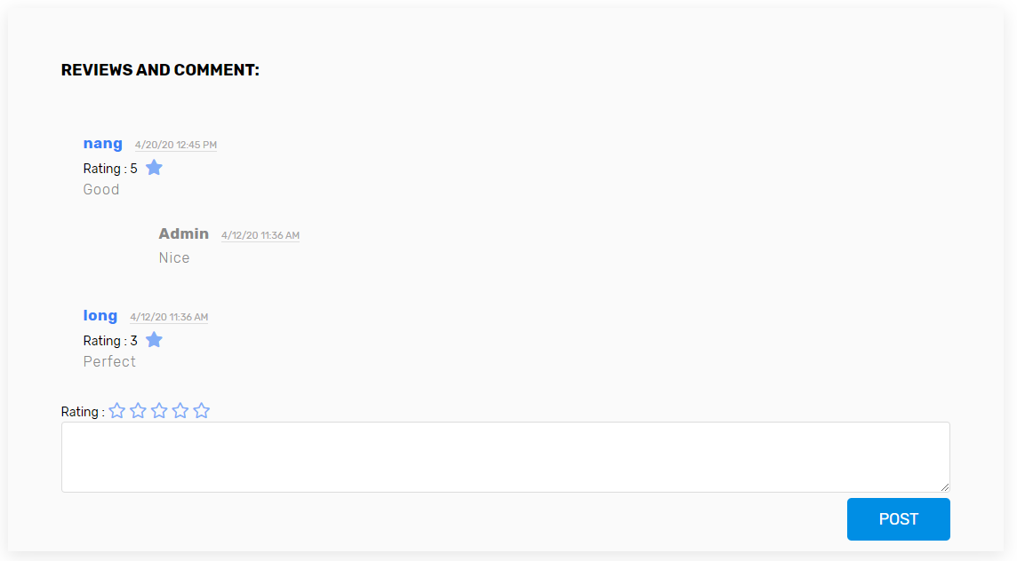

**Cart Page:**

Then you click **Add To Cart** button, this shopping cart will show up.

Products you chose right here, it’s show image of product, the name, quantity, price, total price and button delete.

You can change the quantities you need, after that Total price element will change equivalent.

Can delete that product by button **Delete** if you don’t like.

After the bottom show the Total of the product you need.

Last thing you click **Buy Now** to next step, it’s Payment.

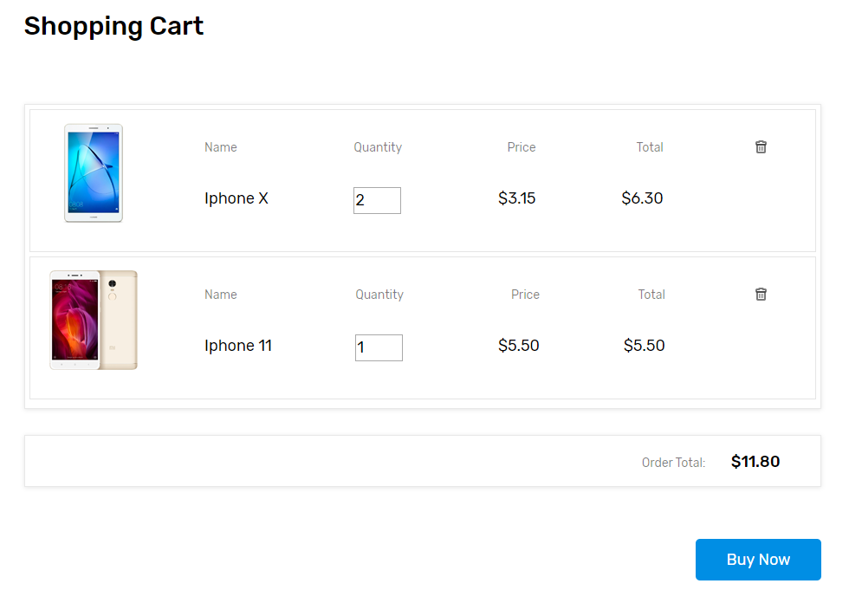

**Payment Page:**

Left side, you must write your infomation at form Billing address.

Right side, that’s your cart info and total price you need to pay.

Then finish the Payment when you click the **Continue to Checkout** button.

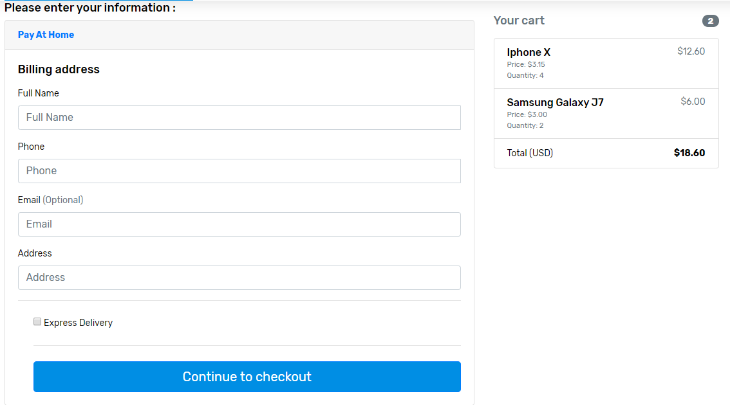

After this notification show the message your payment success and we handling your bill.

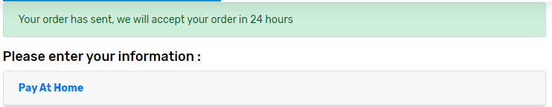

Another, if you sign in, from the right side, you can choose the point accumulation of your ordered to discount persent in present order.

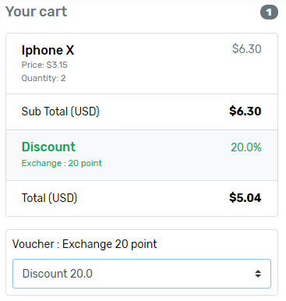

**Invoice Page:**

Then you finish the payment, your invoice show up.

In top show some infomation of you, my shop and your order ID.

Next, show your billed, left side show Payment method you choosed and right side show total ordered price.

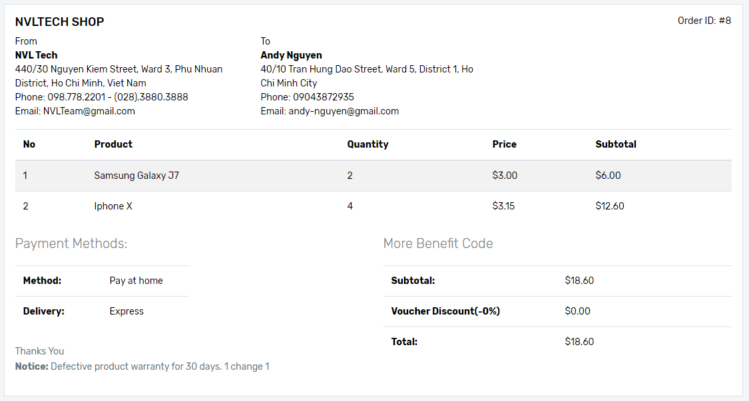

If you sign in, the voucher Discount will be caculated as a percentage you chose.

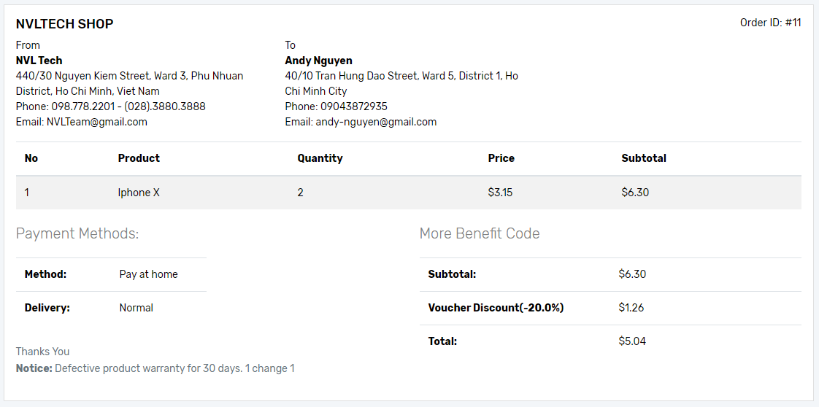

In header bar have the Order Tracking, you can check your invoice by entering the invoice code.

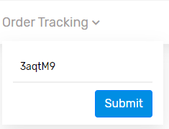

**Contact Page:**

You have question about us, you can call us or meetup or sent email.

Just input some infomation of you, your question in message place and click **Send Message** button.

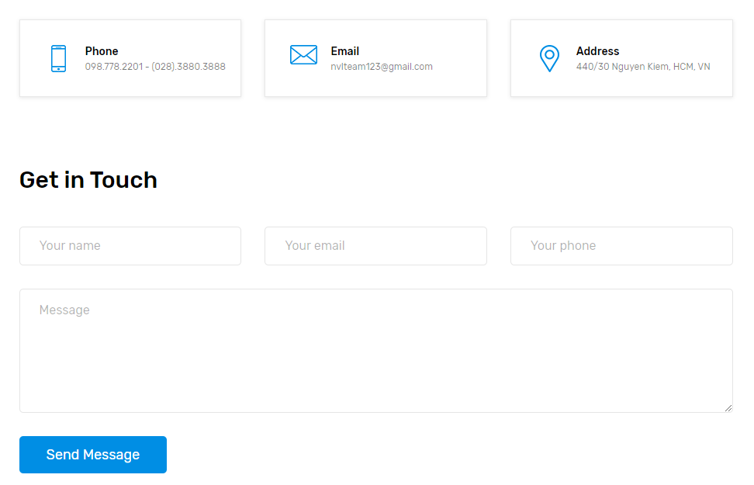

Shop address show you by google map, that’s easy to come my shop.

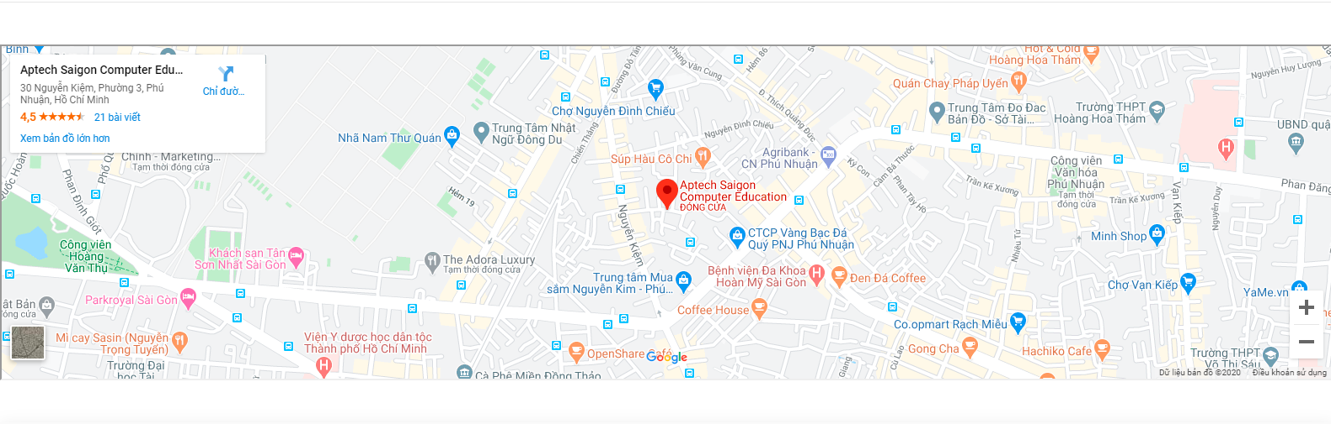

## Admin Side

This manual is written for users who use the website with the administrator role (manager of the store).

**Summary:**

The admin site is created base on the necessary of management of the store manager. It requires security checking when access and user have to remember the URL to access the admin-site. There are many items handling the managements and display contents to the guest site:

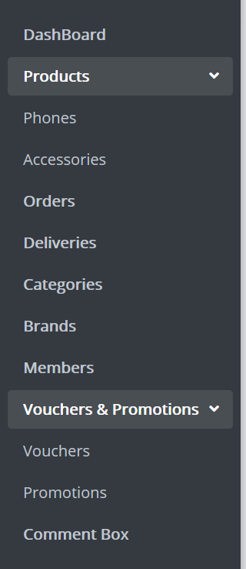Dashboard: displays the statistics of buying, selling or changing over time of products and customers.

Products: displays products sold on the website, there are two type of products right now, one is phone and other is accessory, admin manages products here.

Orders: displays the orders of customers who purchased the products on the guest-site, admin manages orders here.

Deliveries: displays the delivery’s status and other information of the package after admin accepted the order and got the payment, admin manages deliveries here.

Categories: displays the categories of products (phone and accessory right now), admin manages categories here.

Brands: displays the brands of products (Sony, Samsung, Apple...), admin manages categories here.

Members: displays the list of user registering to become member, admin manages members here.

Vouchers and Promotions: displays the vouchers for members and promotions of products, admin manages vouchers and promotions here.

Comment box: displays the comments of member for products they feedback, admin manages comments here.

**Login:**

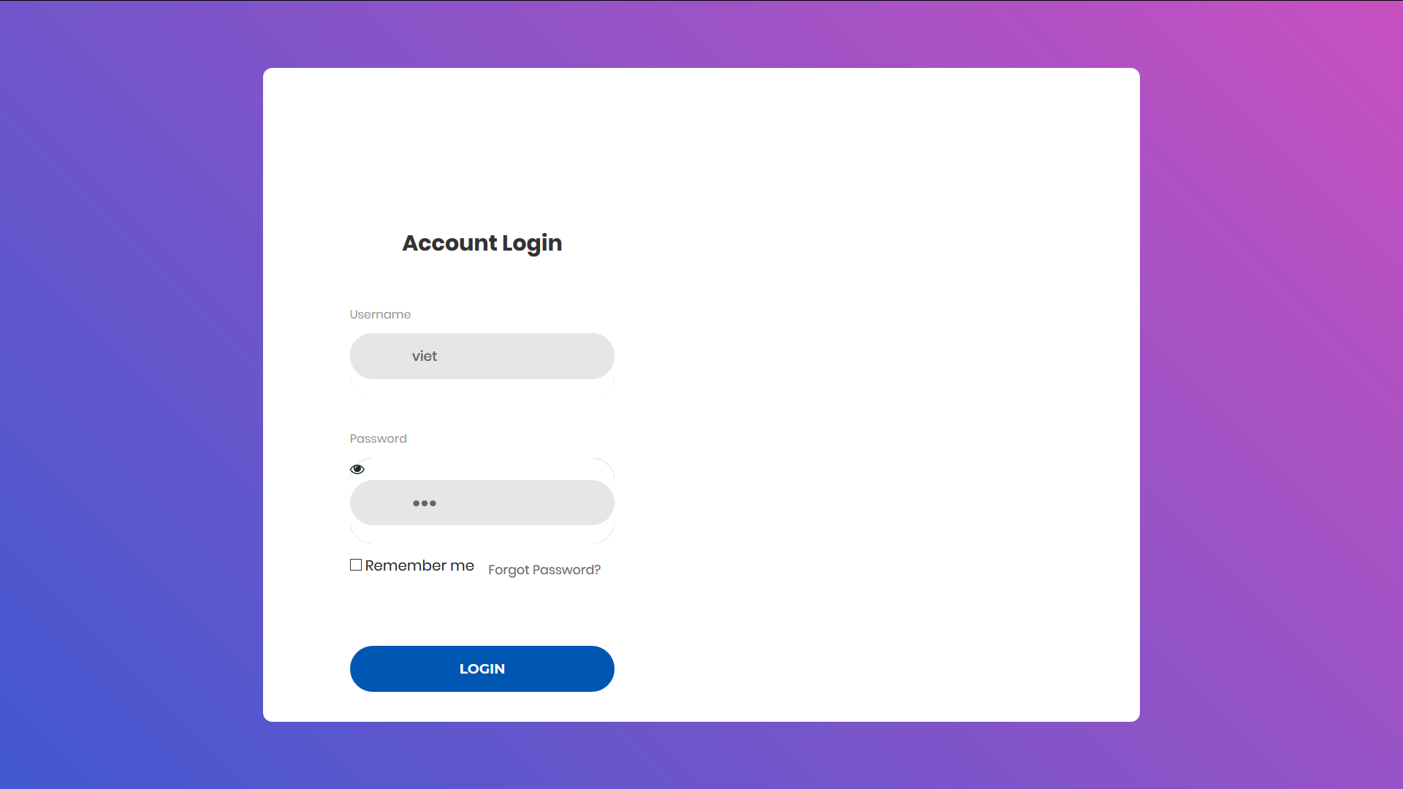

Every access to the admin-sites will be linked to the login site to force users to identify their identity as admin role.

Admin accounts are created by the developer of the website, there won’t be a registration method.

After login success, user now is the admin of the site will be redirected to the dashboard site of the website. If users login failed, they continue to stay in the admin login site.

**Dashboard:**

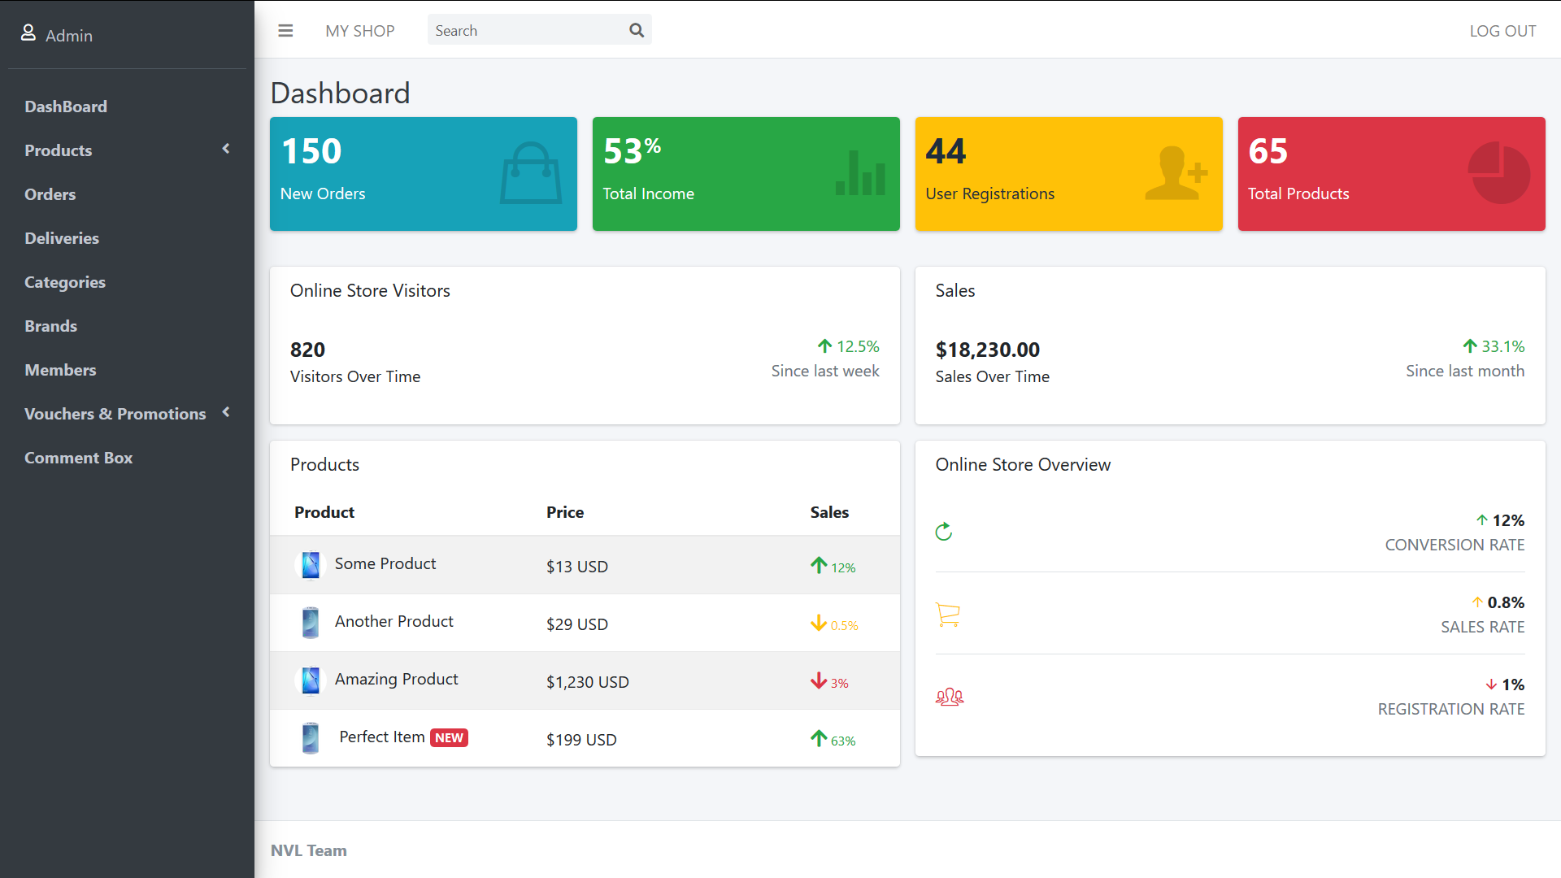

After login successfully with role admin in admin-site, dashboard site will automatically display. To access to dashboard site by self, user click on the dashboard link on navigation bar at the left of the admin-site.

The dashboard site display statistic contents of selling, buying, incomes, members, products… and changing data overtime, they can’t be edited directly.

Products:

There are two type of products base on the number of categories: phone and accessory.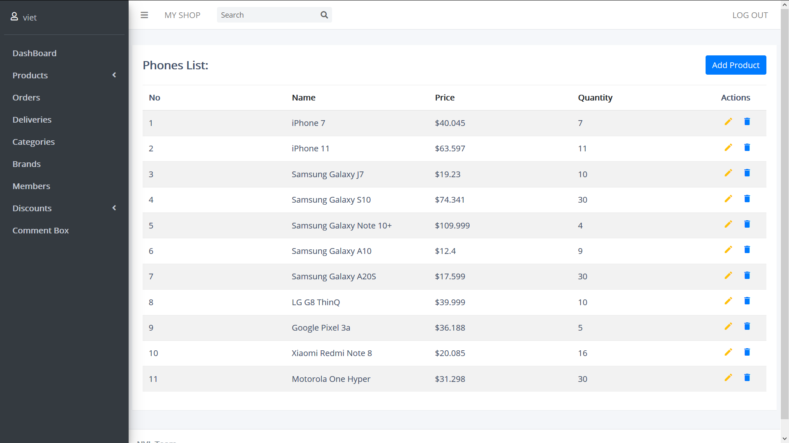

Display the list of all available phones sold on the guest-site.

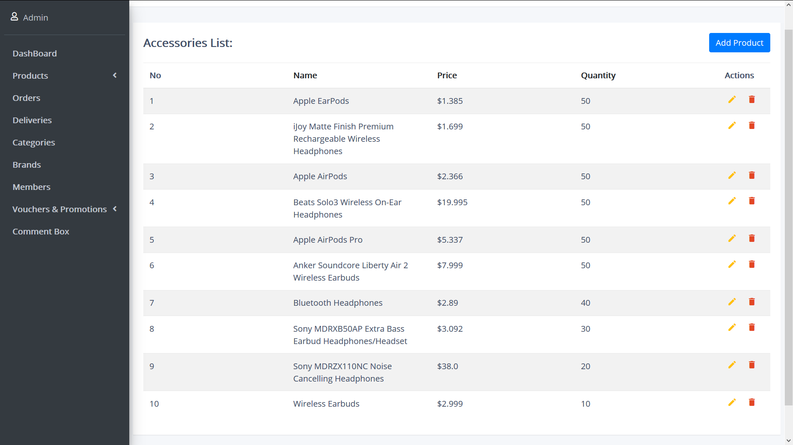

Displays list of accessory sold on the customer-site.

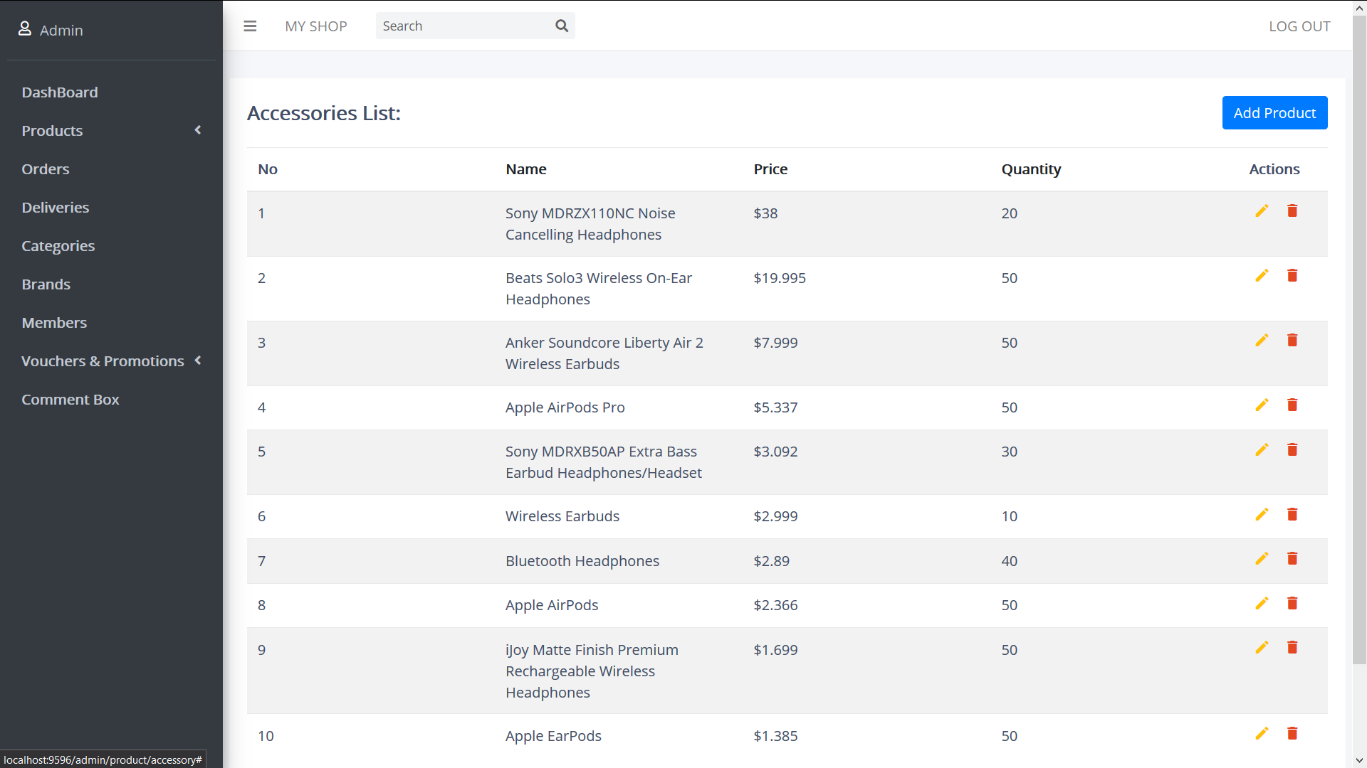

Admin can list the content of product table by click on the headers table (Name, Price, Quantity for this table) to arrange the rows by the ascending or descending. (almost many tables of other fields will have this function).

Admin can add new accessory by click on the “Add Product” button on the top right of the site:

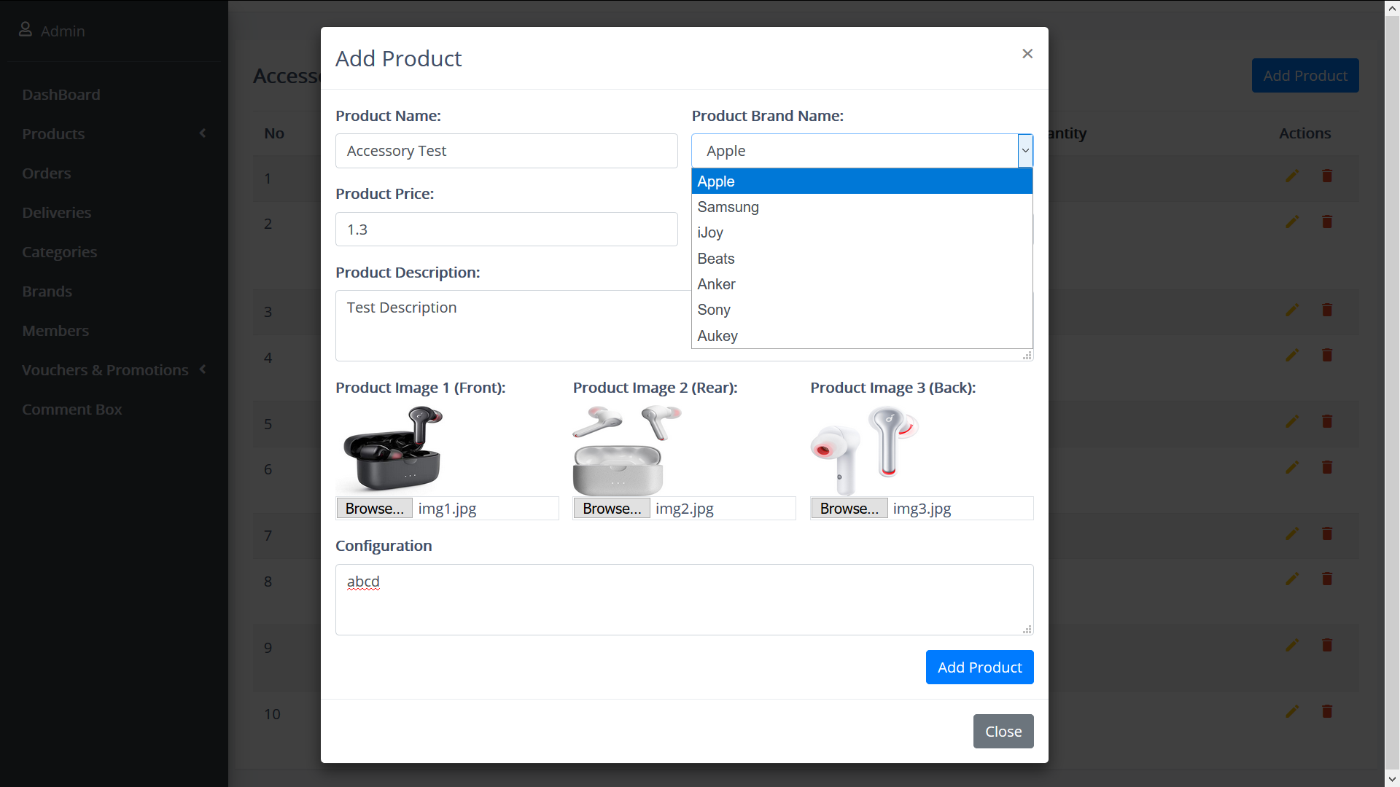

There will be a filling form for admin to fill in the information of the product. After filling the form, admin click on button “Add Product” to save new product to the site so it can be display on the customer-site, click on close if admin abort add new product.

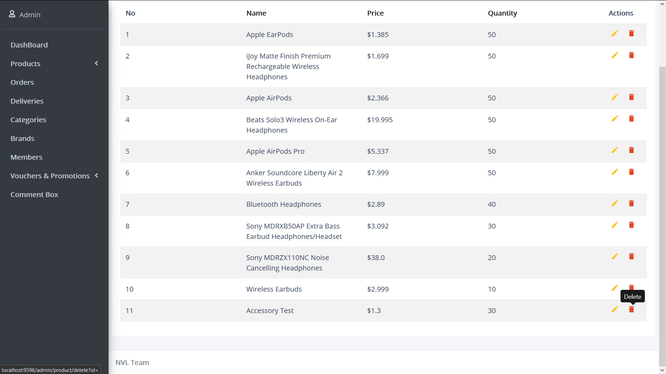

After add new product, the newest product will display at the bottom of the product table, every rows in the table has two button to edit or delete corresponding to product on that row.

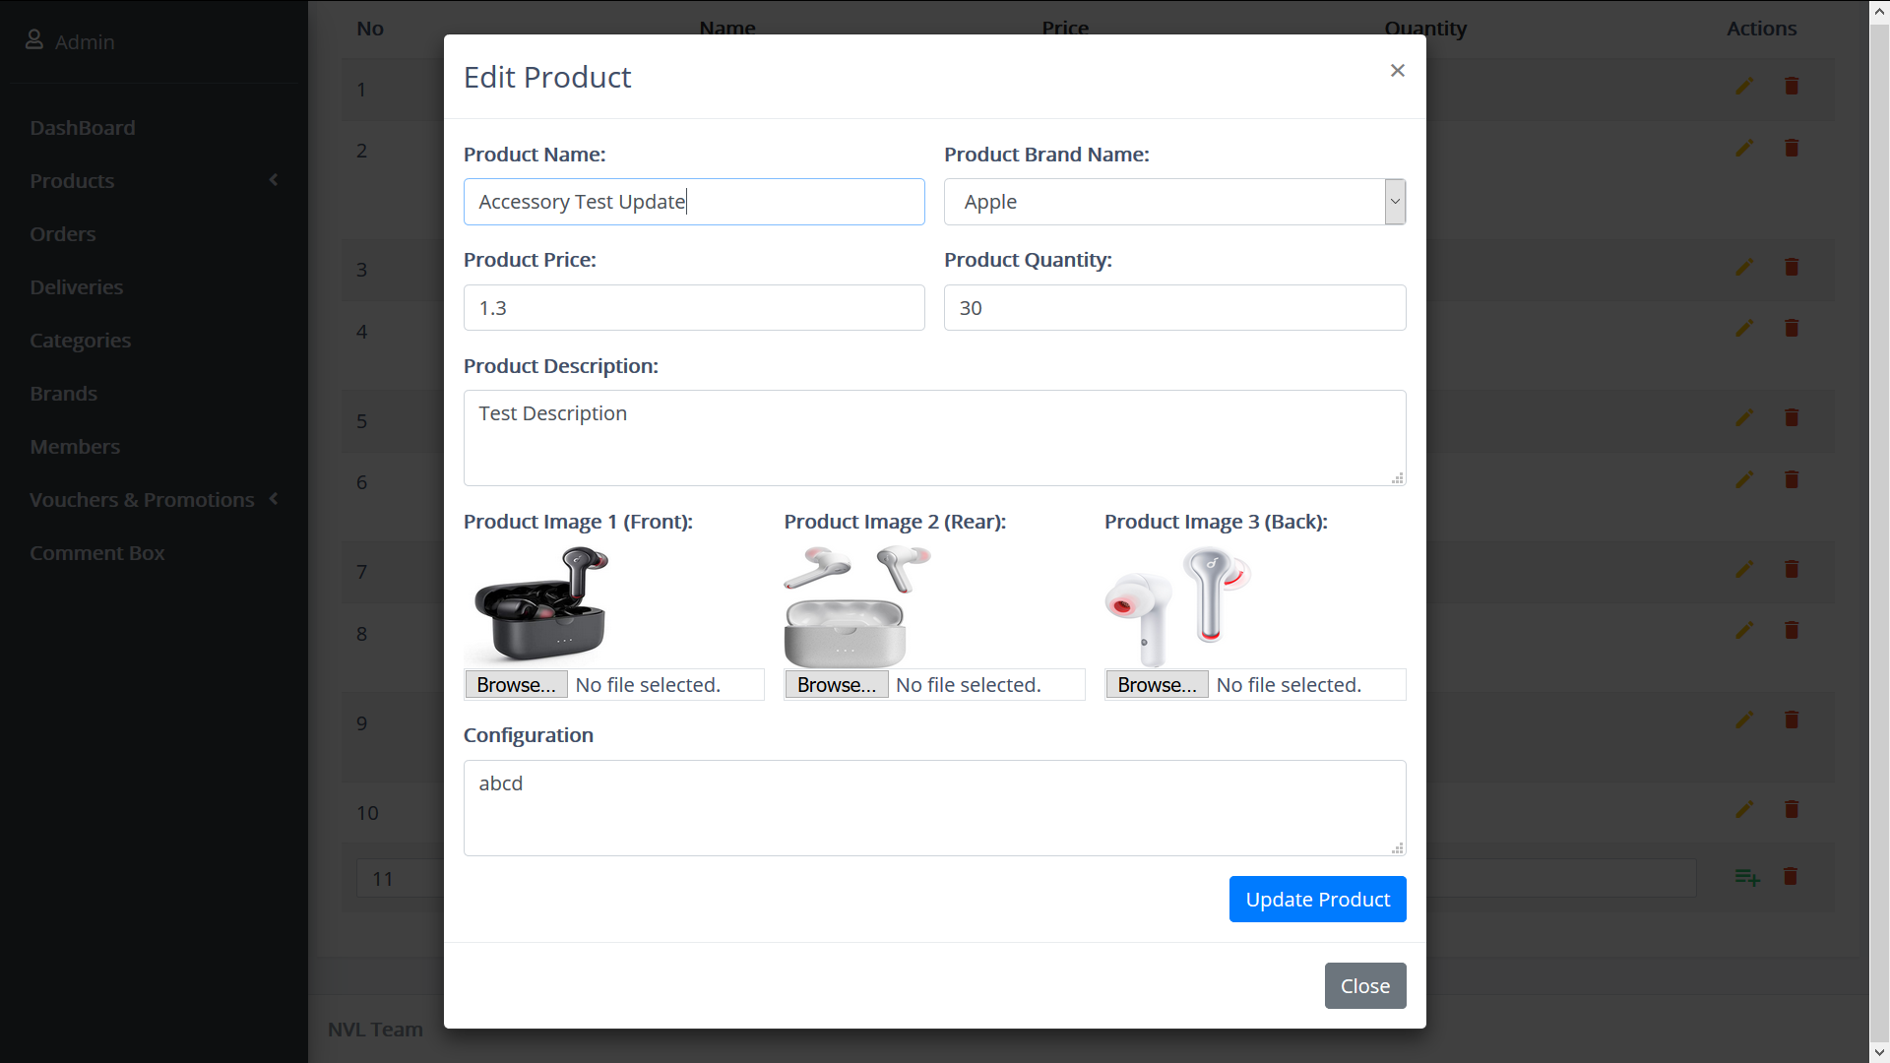

By clicking on the edit button, the filling form shows again with the information of the selected product. Admin adjusts the information the same way they create the new product, any fields weren’t edited will be hold with the old information.

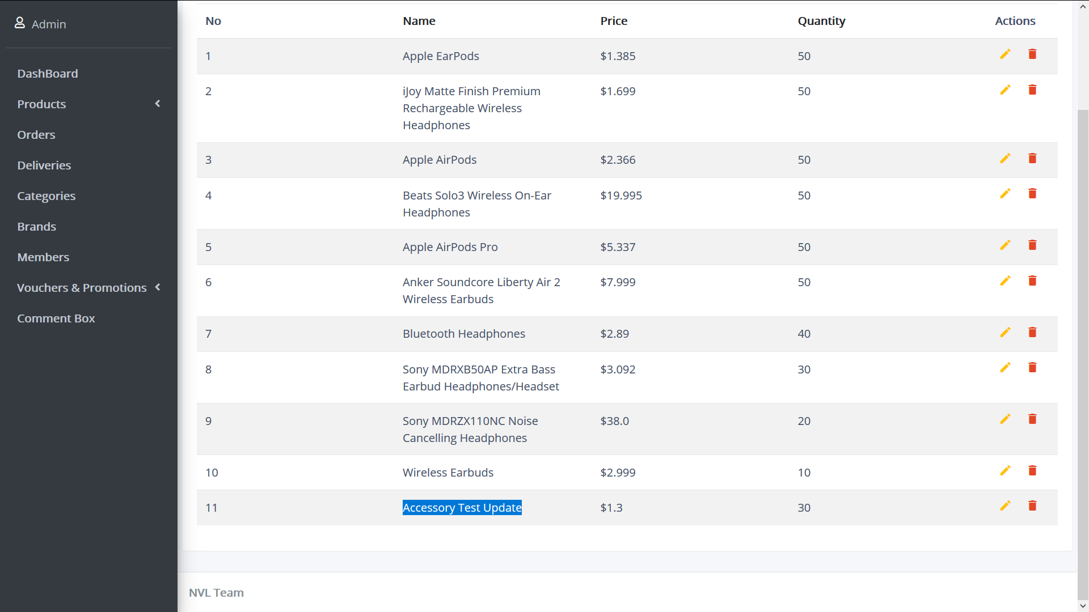

After clicking “Update Product” the new information will be add to the selected product, if admin want to delete the product, click on the delete icon (red bin icon).

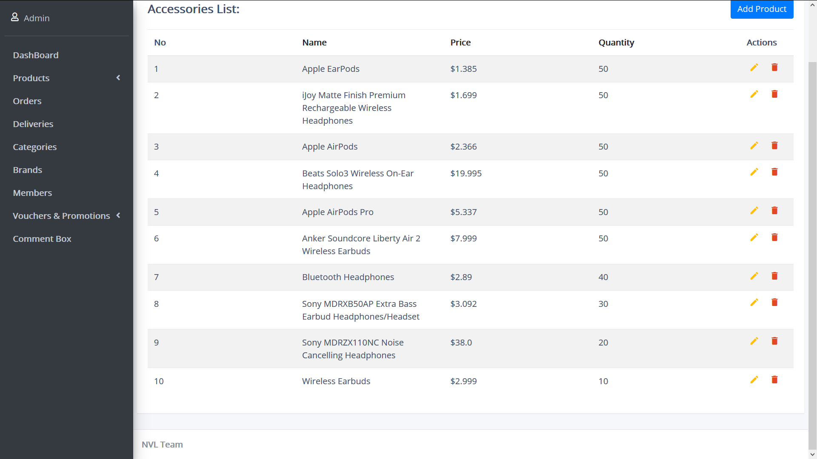

Order:

Order is the site contains the list of customer’s order of the guest-site

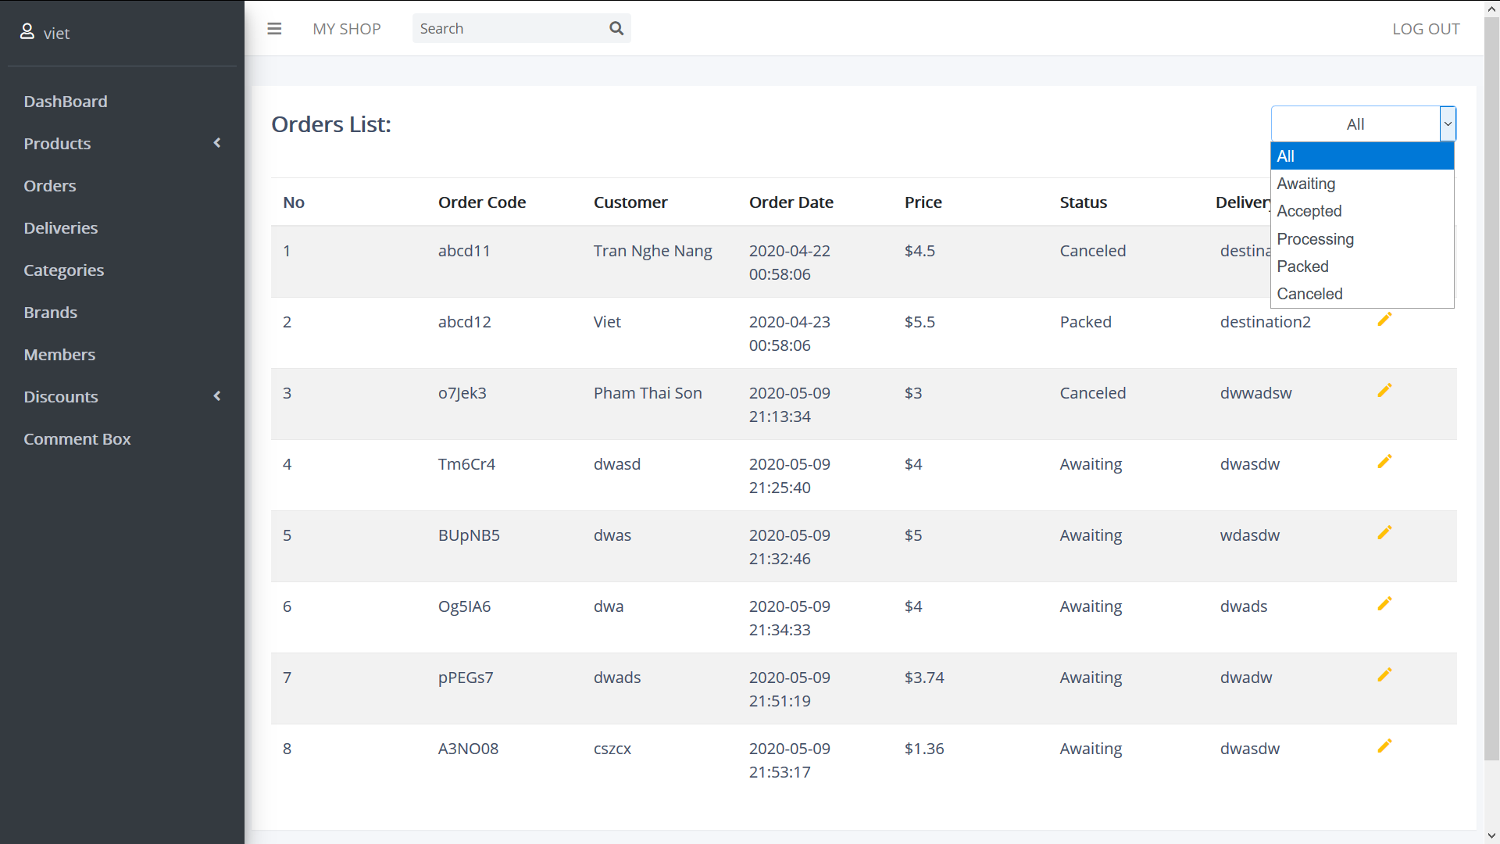

There are many statuses of the order (awaiting, accepted, processing, packed, canceled) depend on admin action to manage the store.

There won’t have a created and delete function because the order must be created by the customer and the statistic calculation will be easier for the owner of the store.

There is a filter drop down list for admin want to display the orders in a kind of status.

Edit:

By clicking on the edit icon, an edit form will display on the screen so admin could see relative information and edit only status of the order.

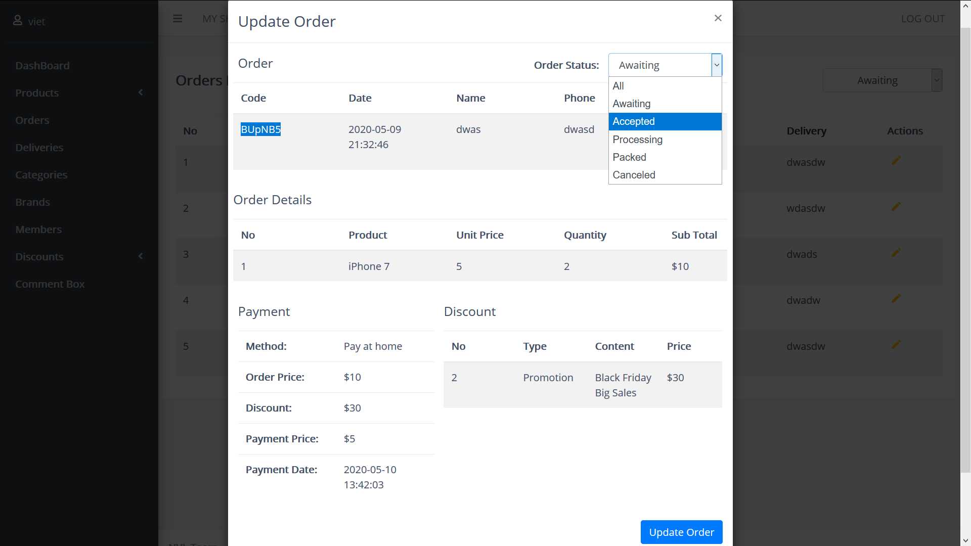

After click on update order button, the table will update the edited order

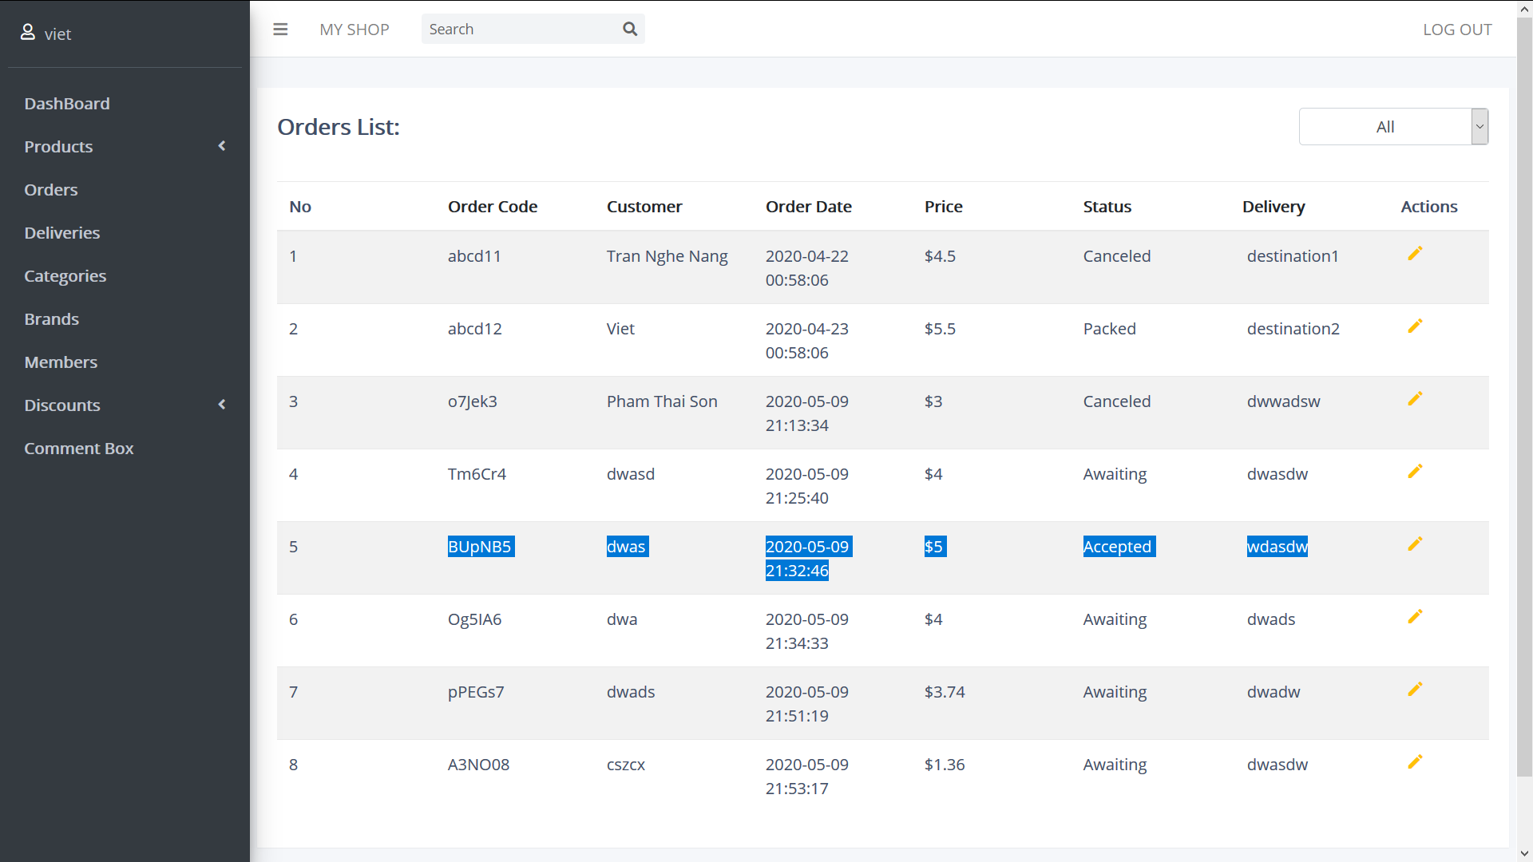

Deliveries:

Same as order, delivery is created by the customer so admin can’t create or delete the delivery but only edit the status and type of delivery.

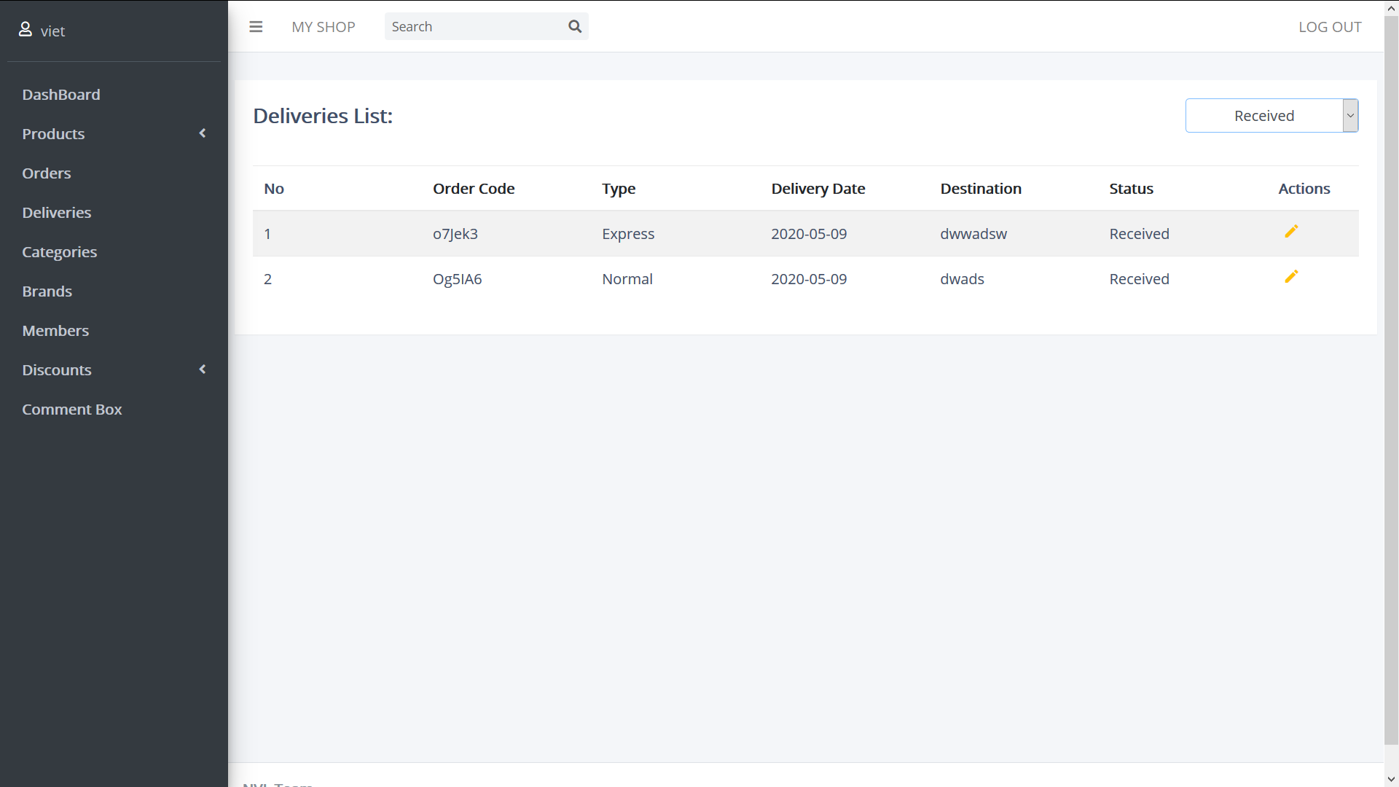

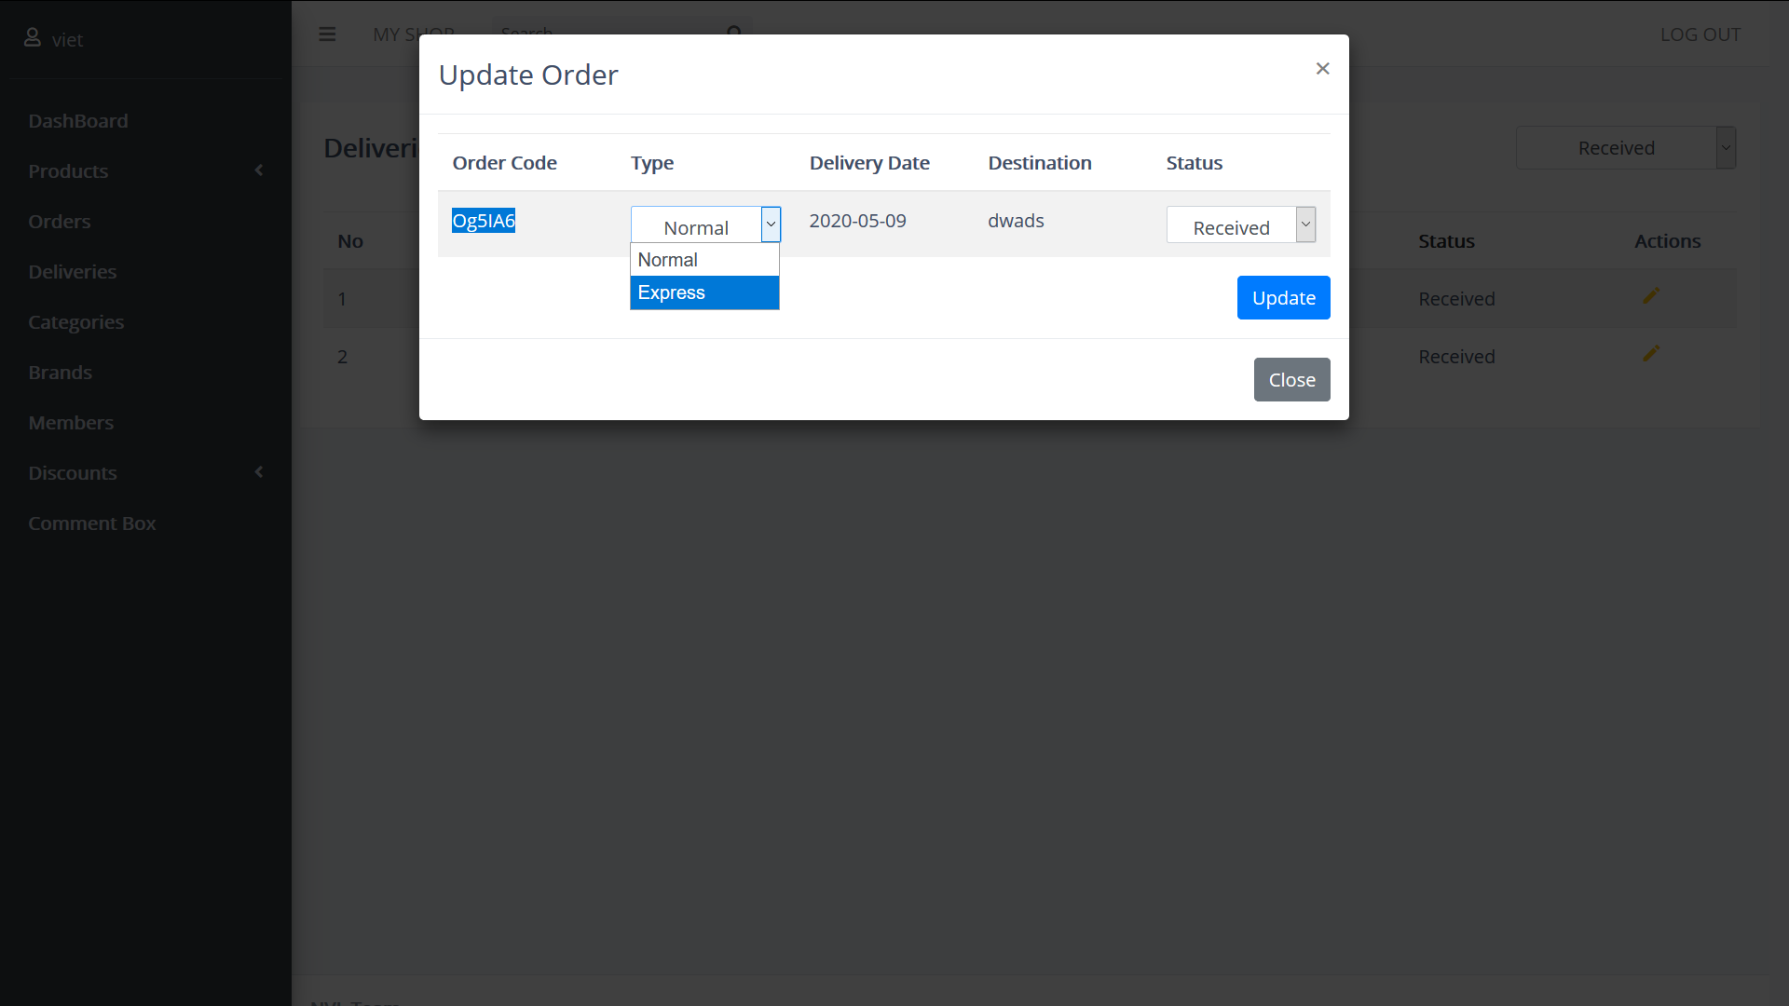

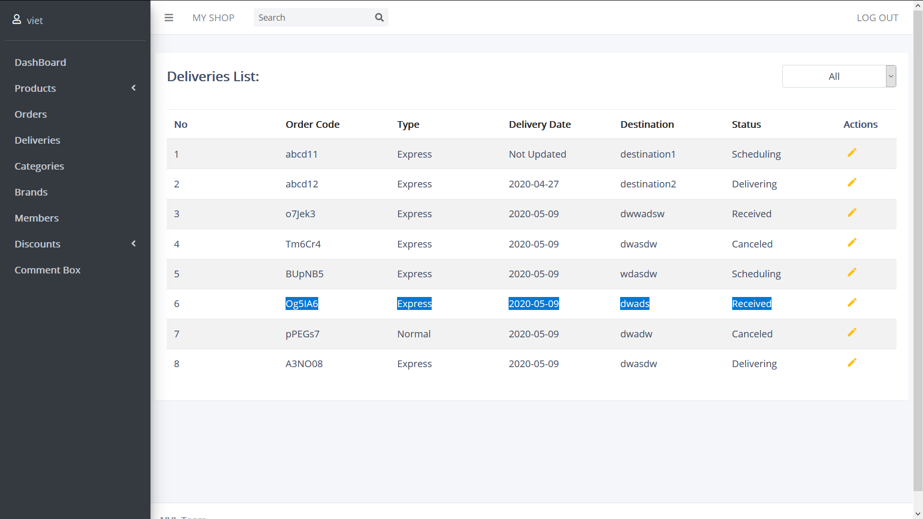

Categories:

Categories field contains the categories sold on the guest site, right now NVL developed 2 type of categories: one is phone and another is accessory

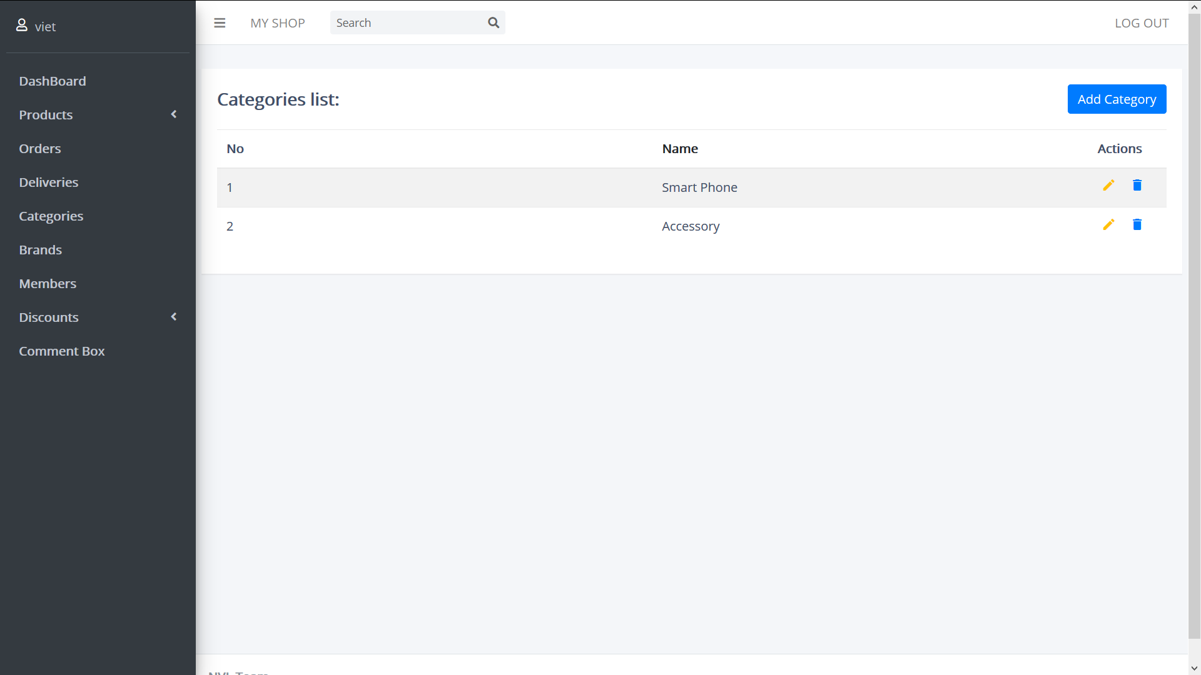

Brands:

Brands field contains many infamous brand name of mobile companies. Every brand name will be add into brand drop down list in product creating form.

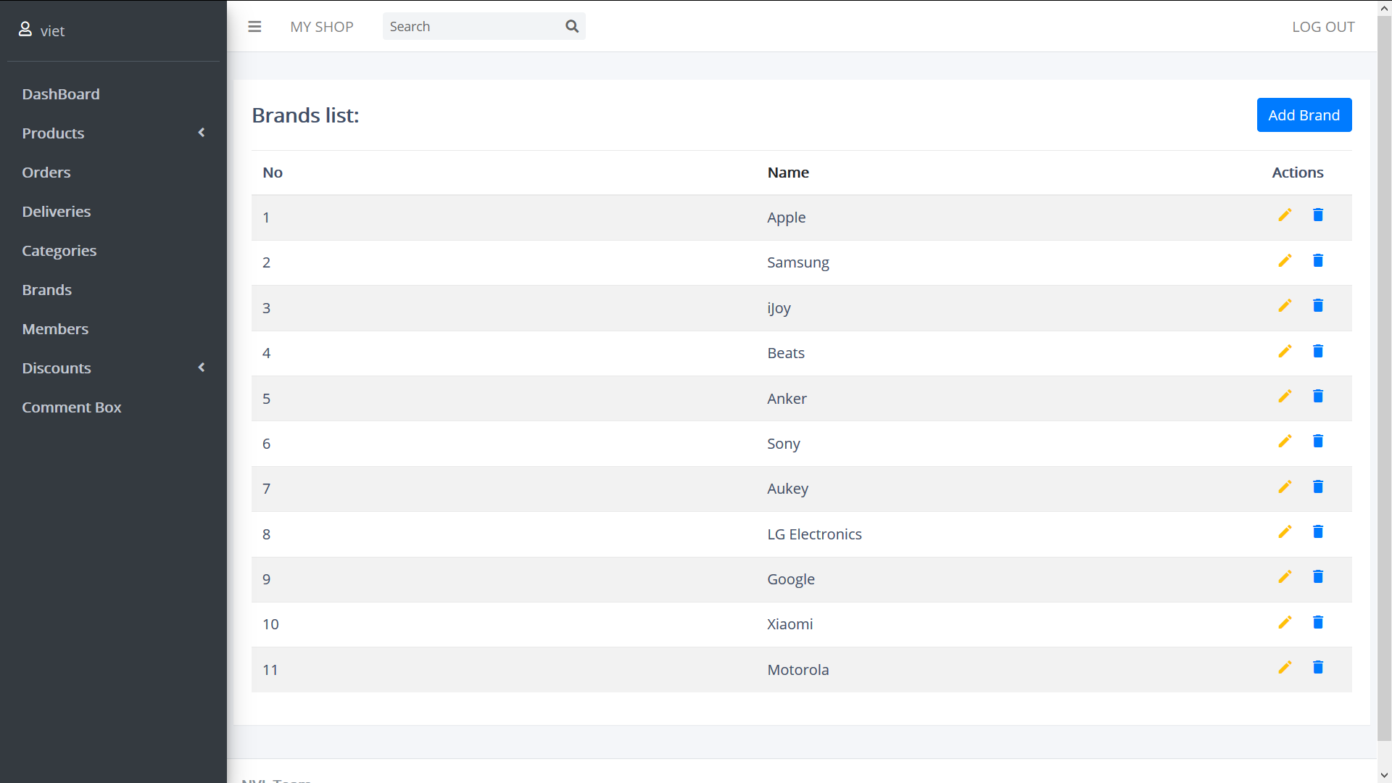

Add brand:

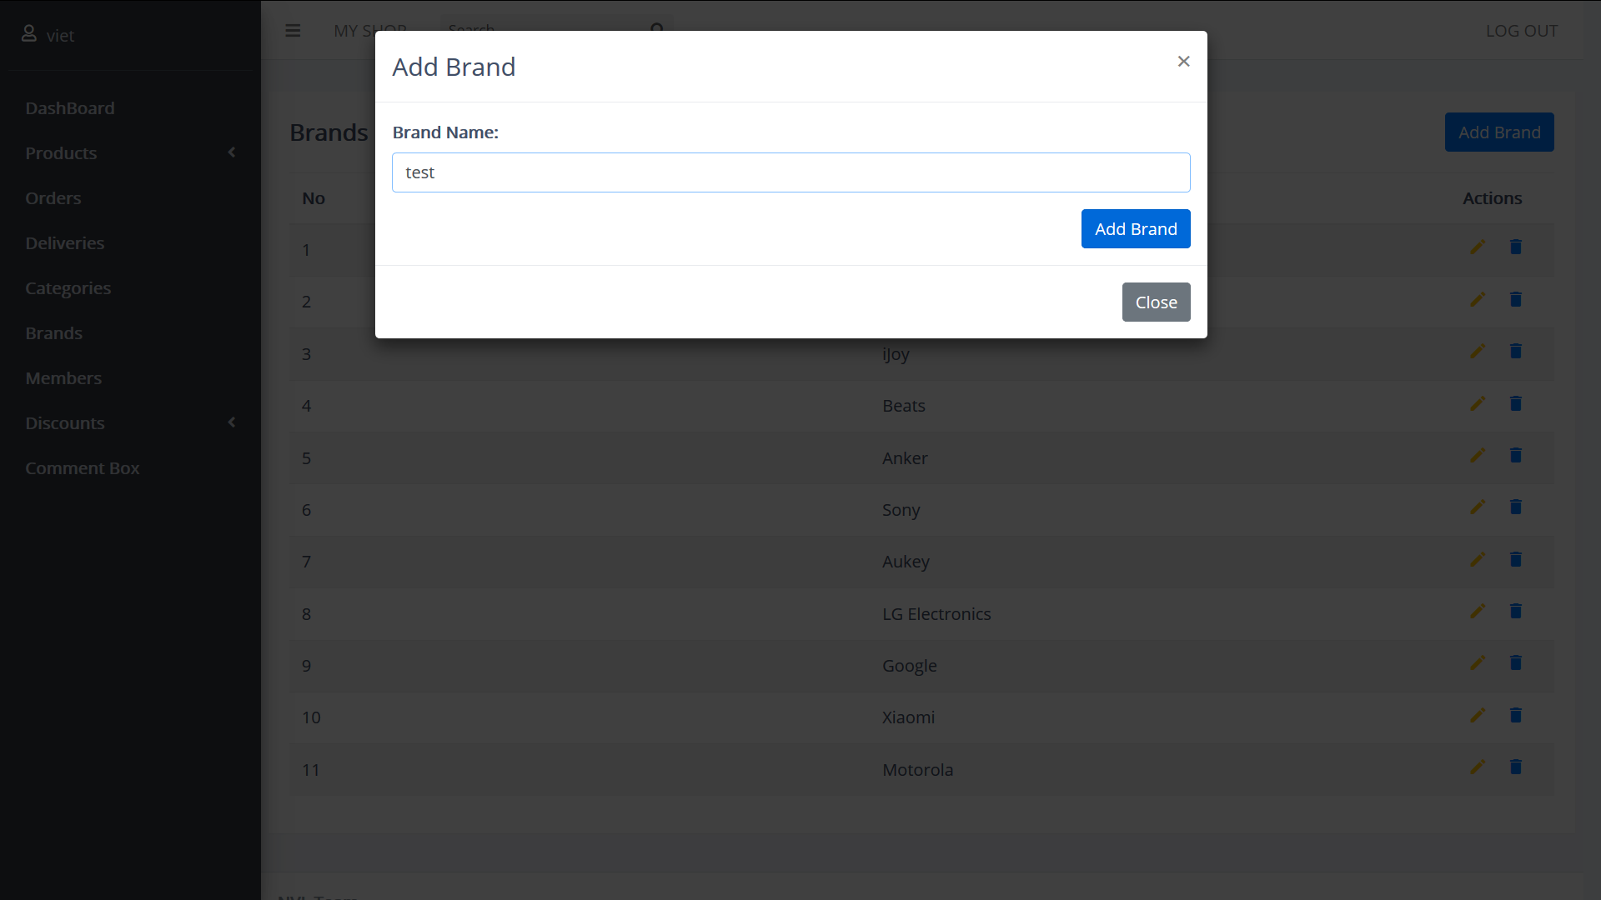

Update:

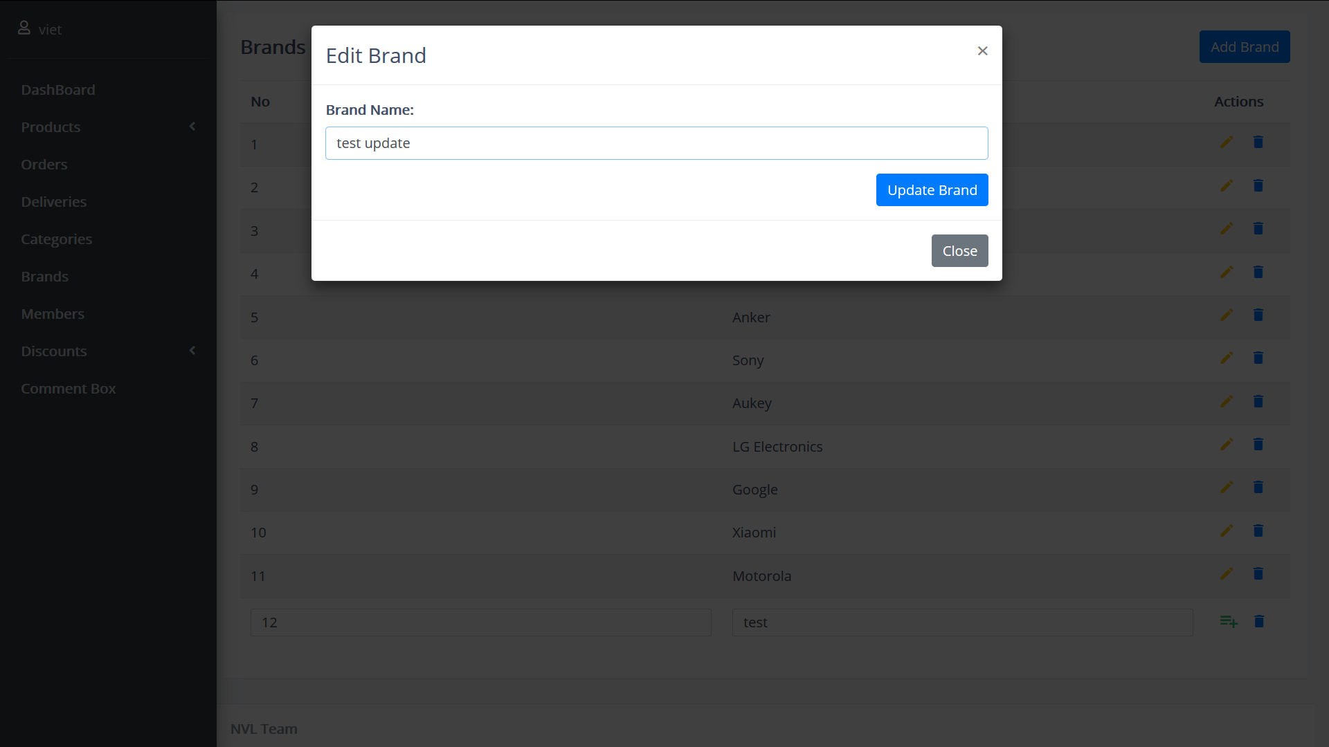

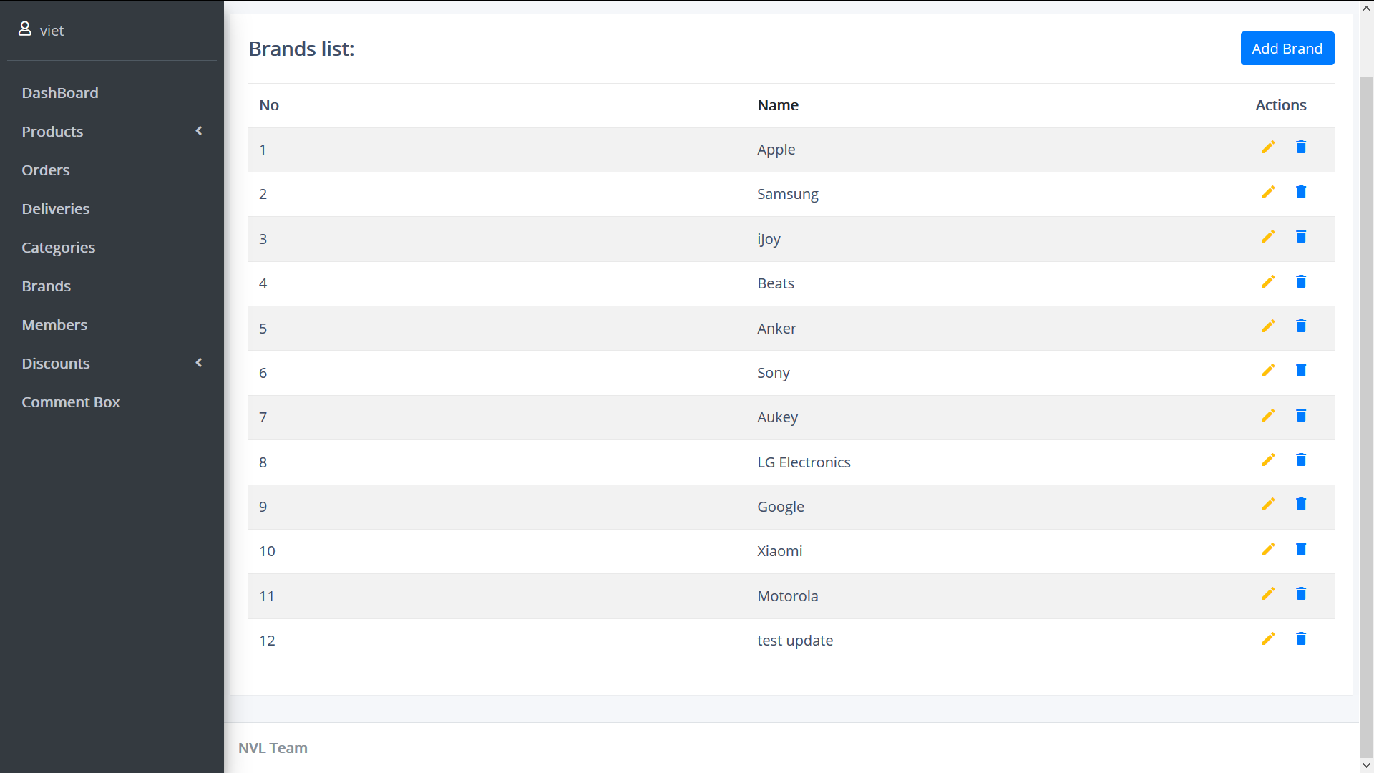

Members:

Members is the field contain registered account created by customer who want to be a member to accumulate point after pay an order.

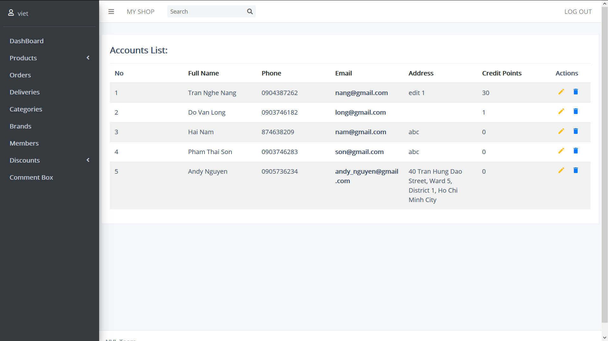

Edit:

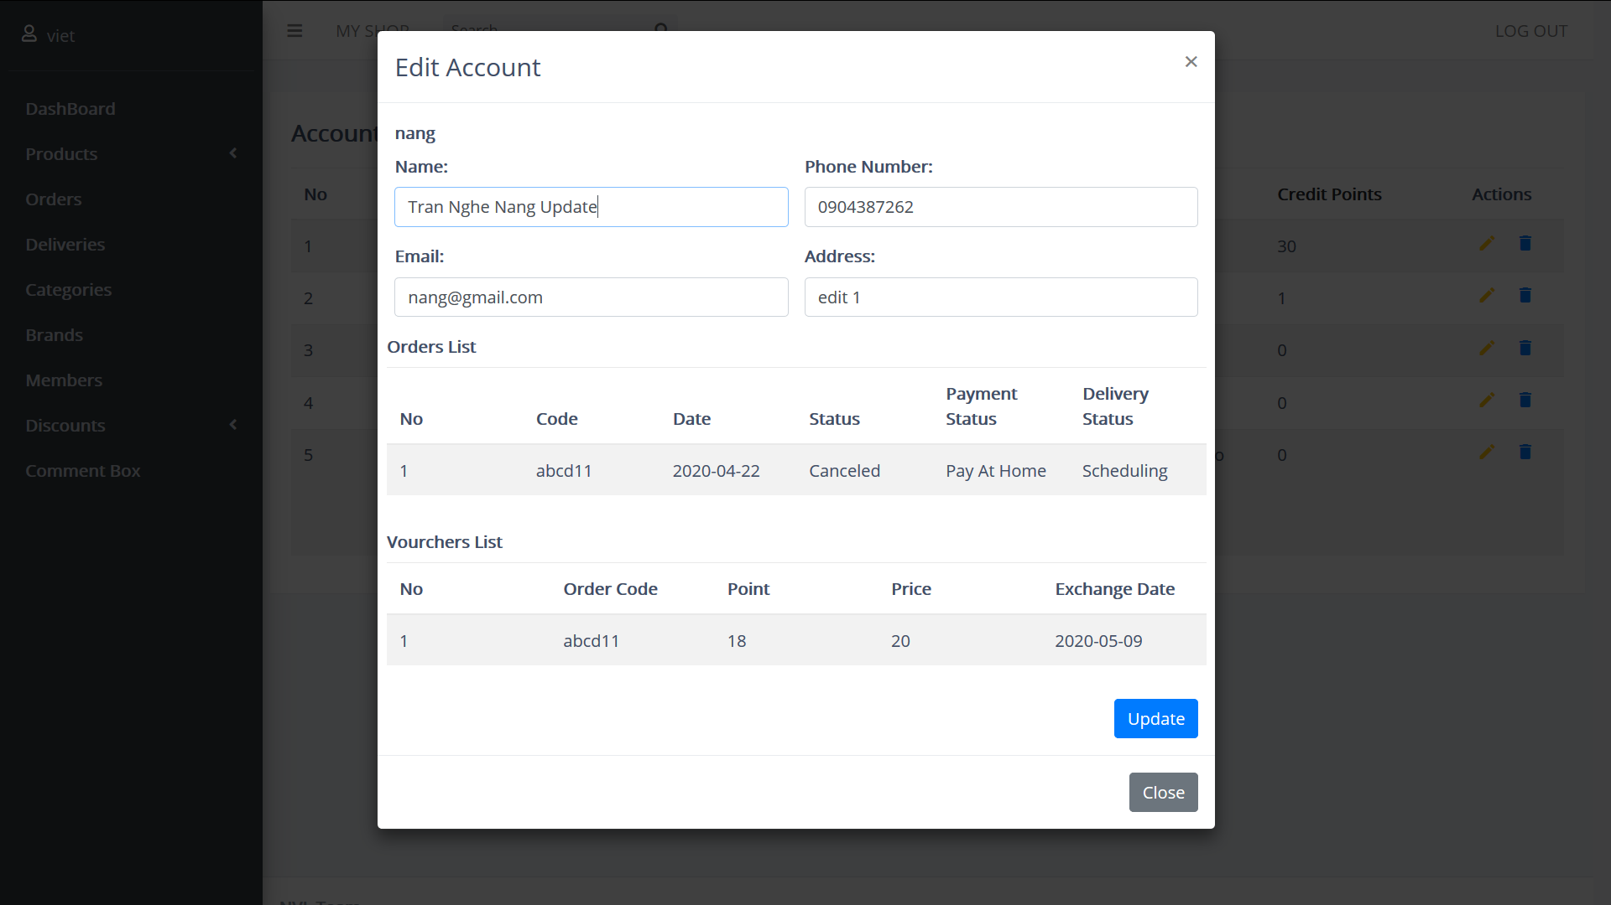

Delete:

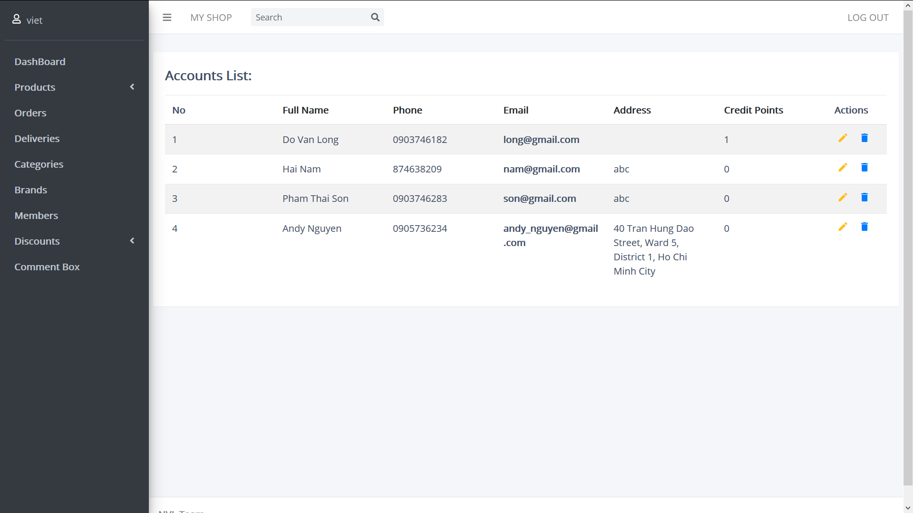

Promotion:

Contains all promotions of the site, the price in the promotion is the discount percent of the total price of product.

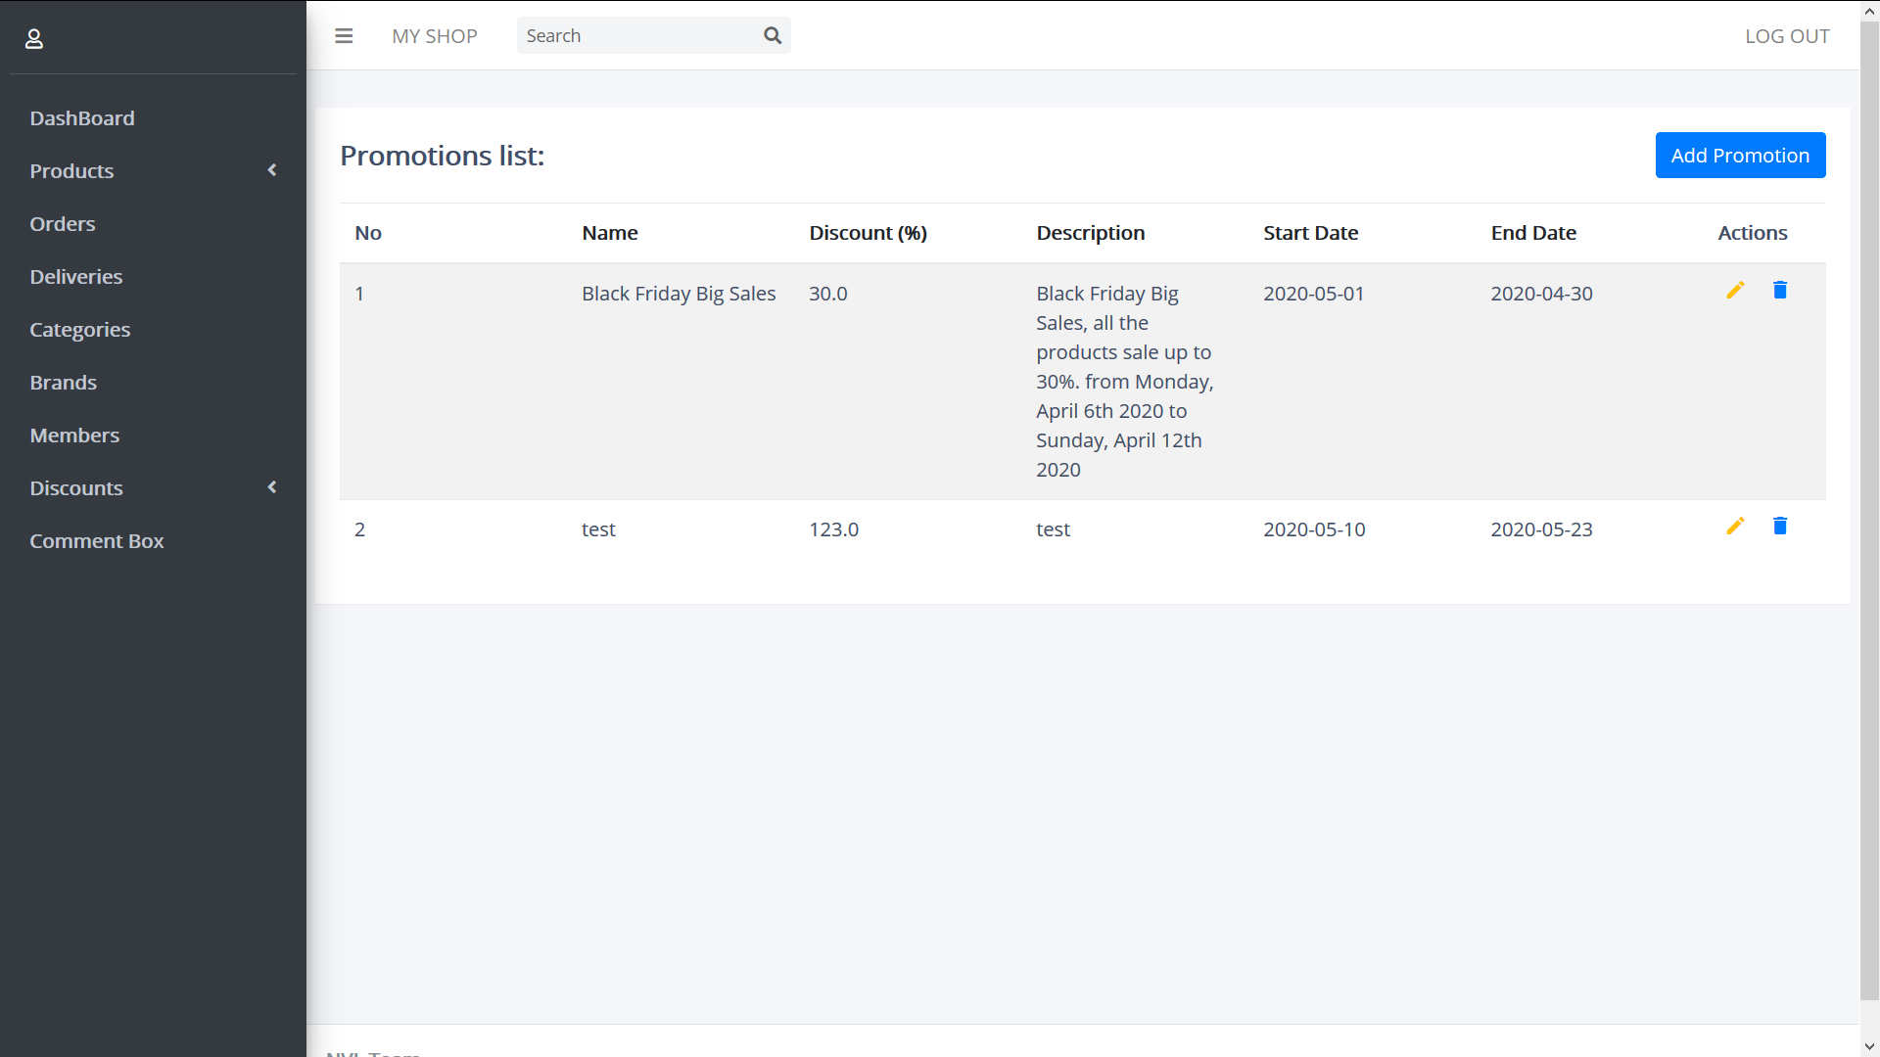

Create:

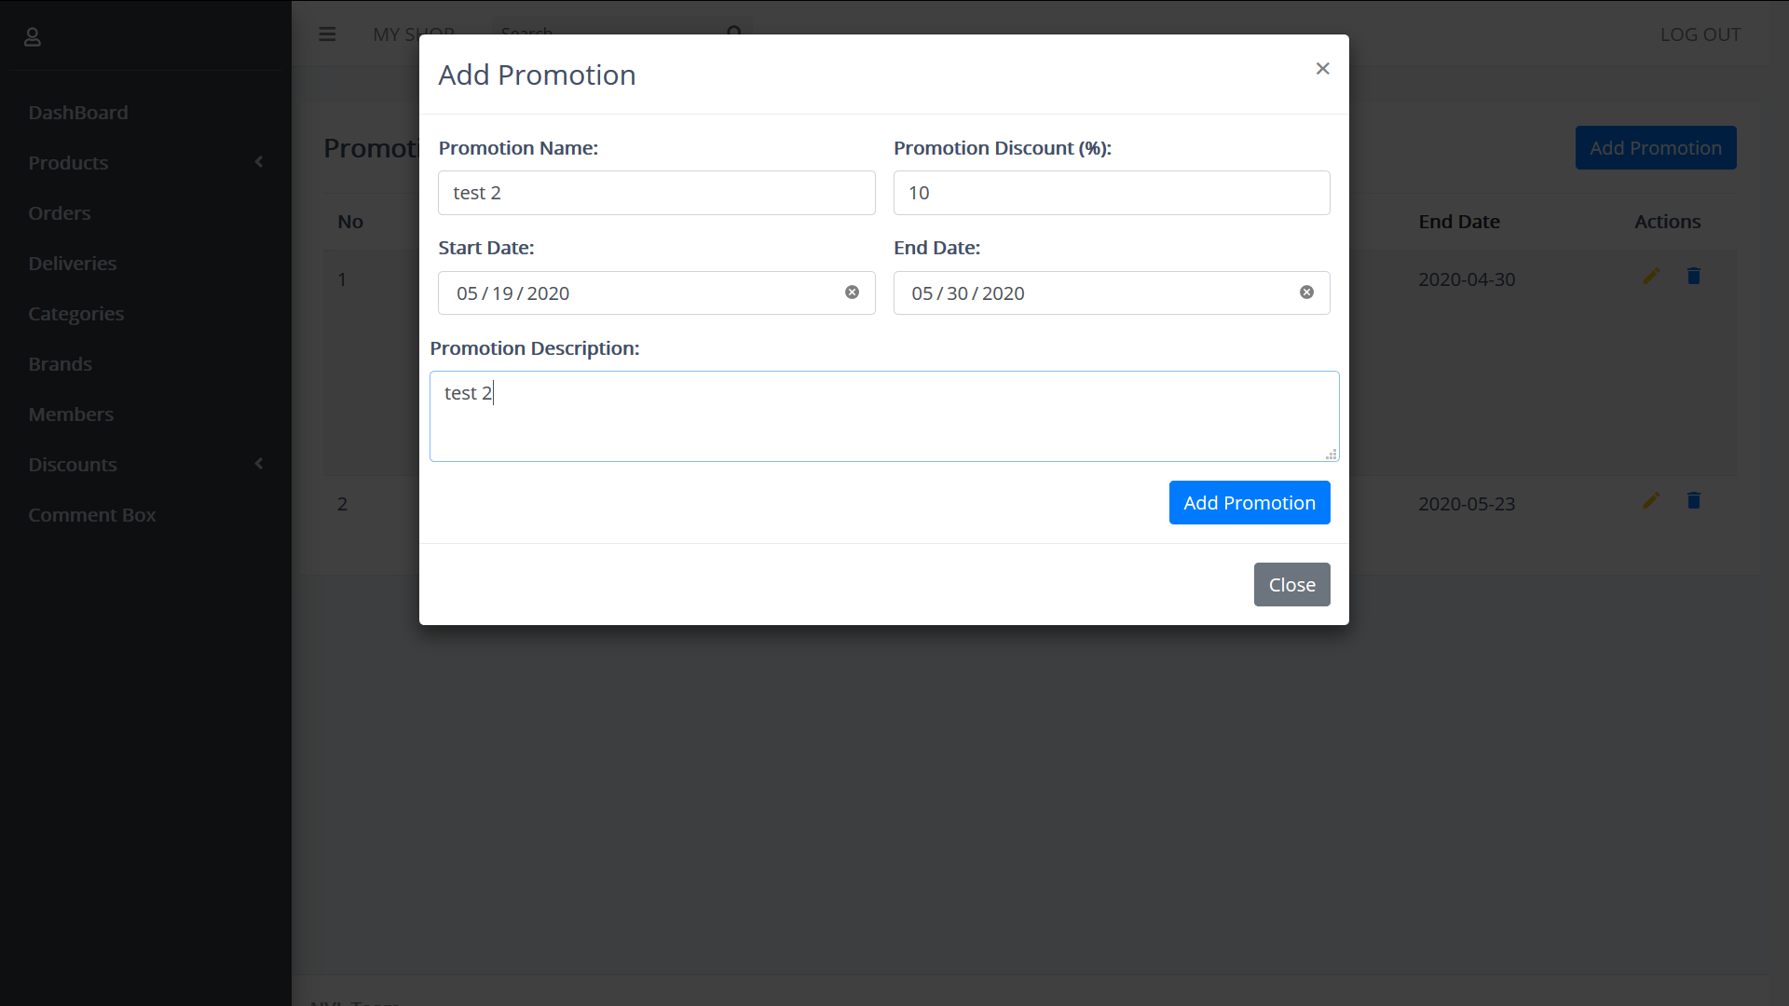

Update:

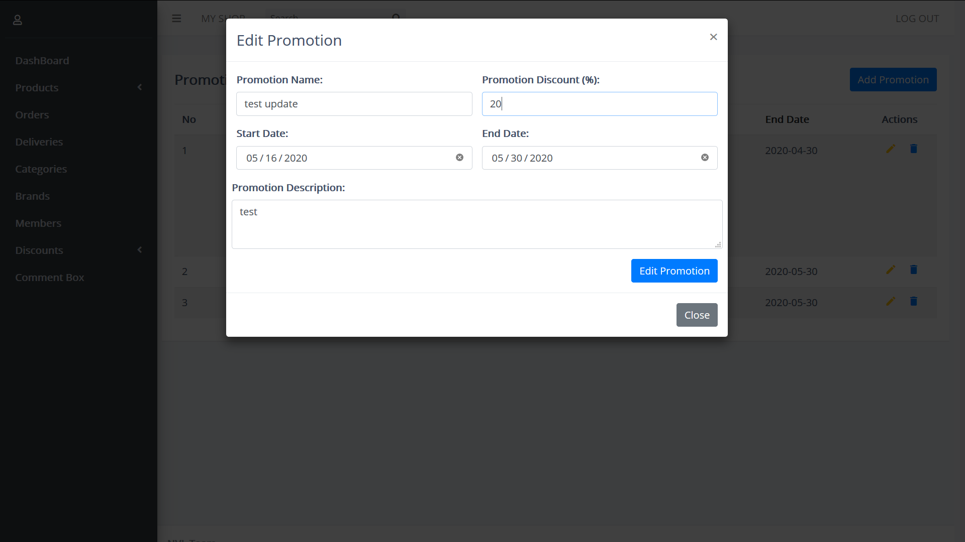

Delete:

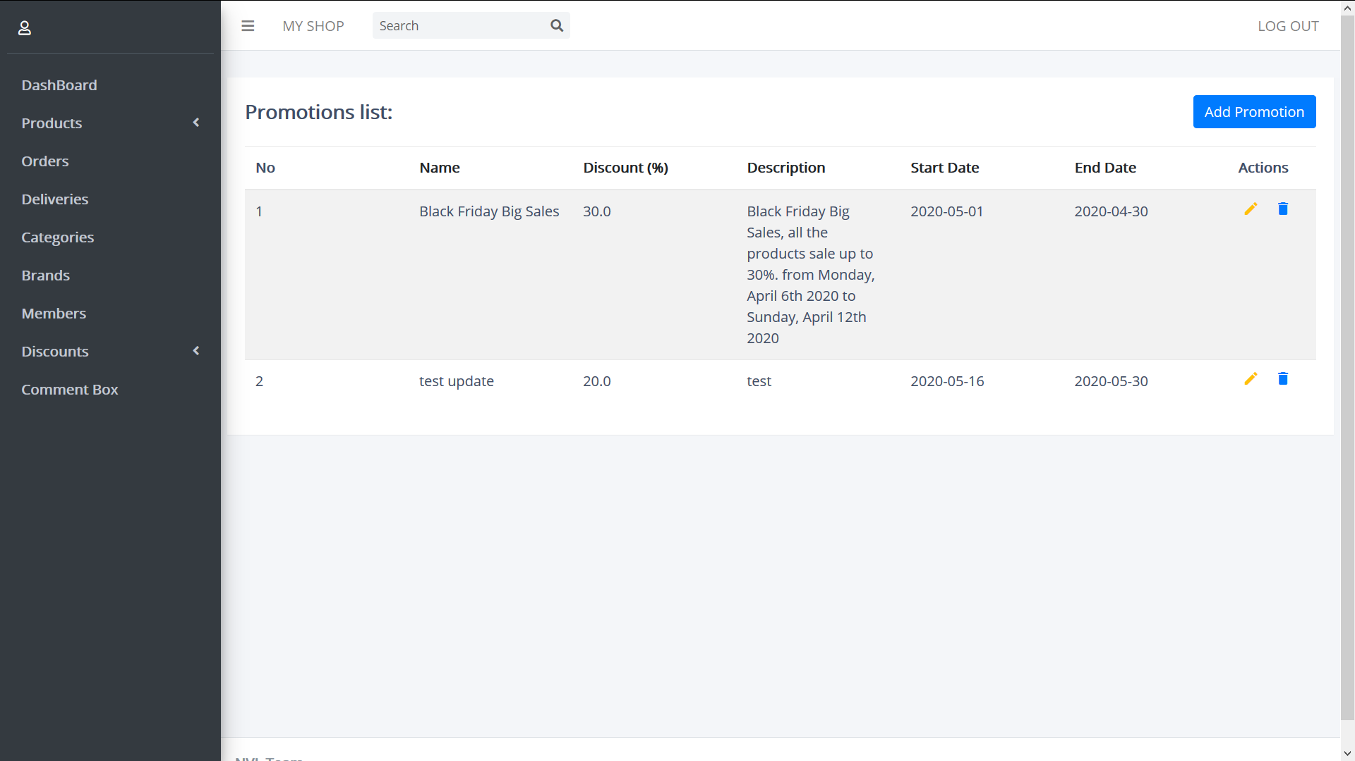

Voucher:

Contains the list of voucher created by admin, voucher is used as a gift for members have enough of points by paying their payment. voucher can used in every payment to reduce the price of the payment.

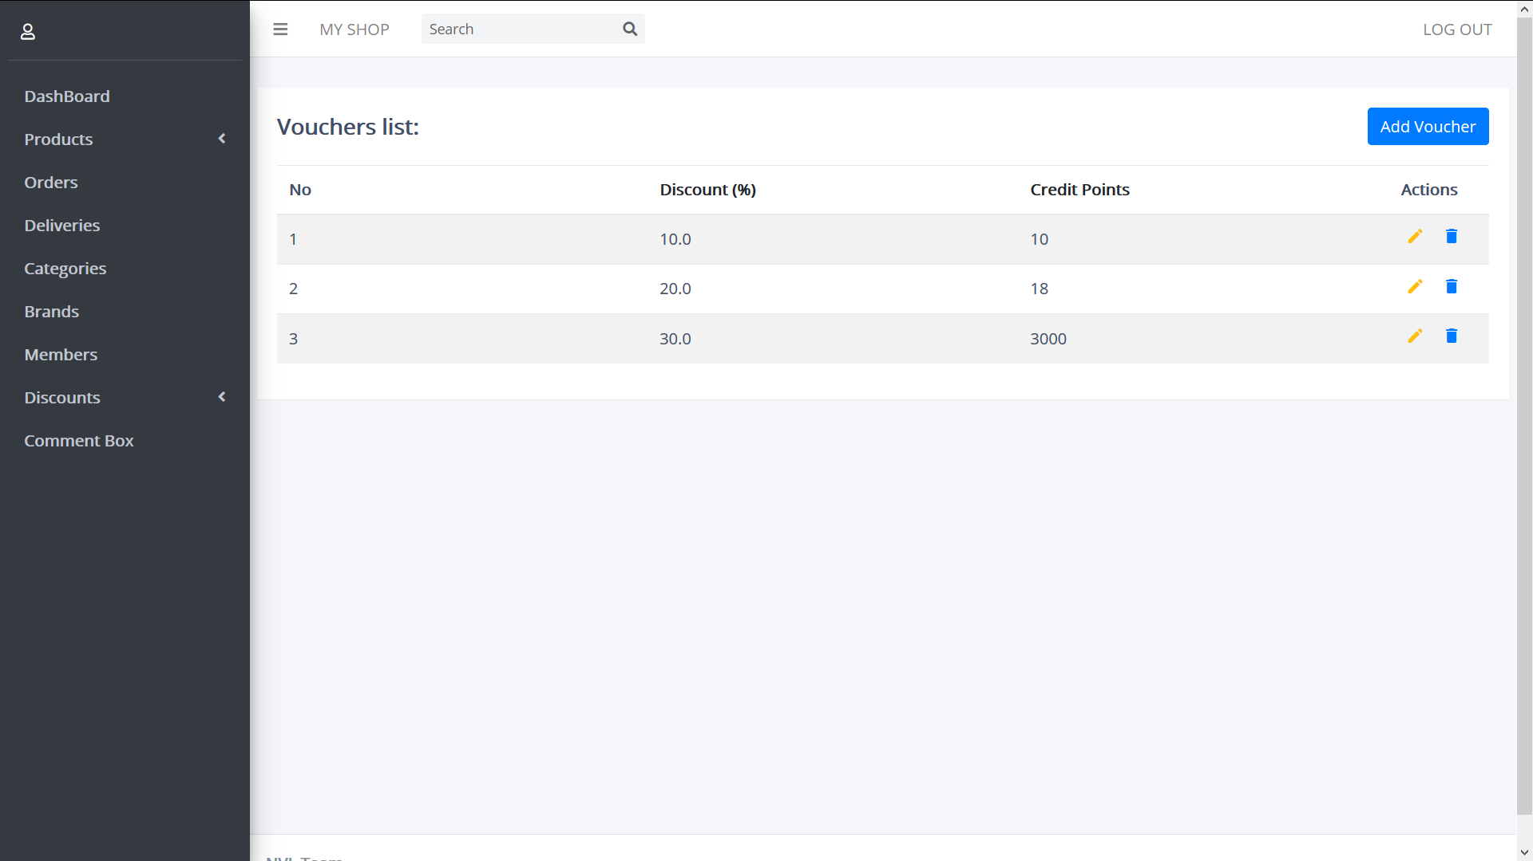

Add:

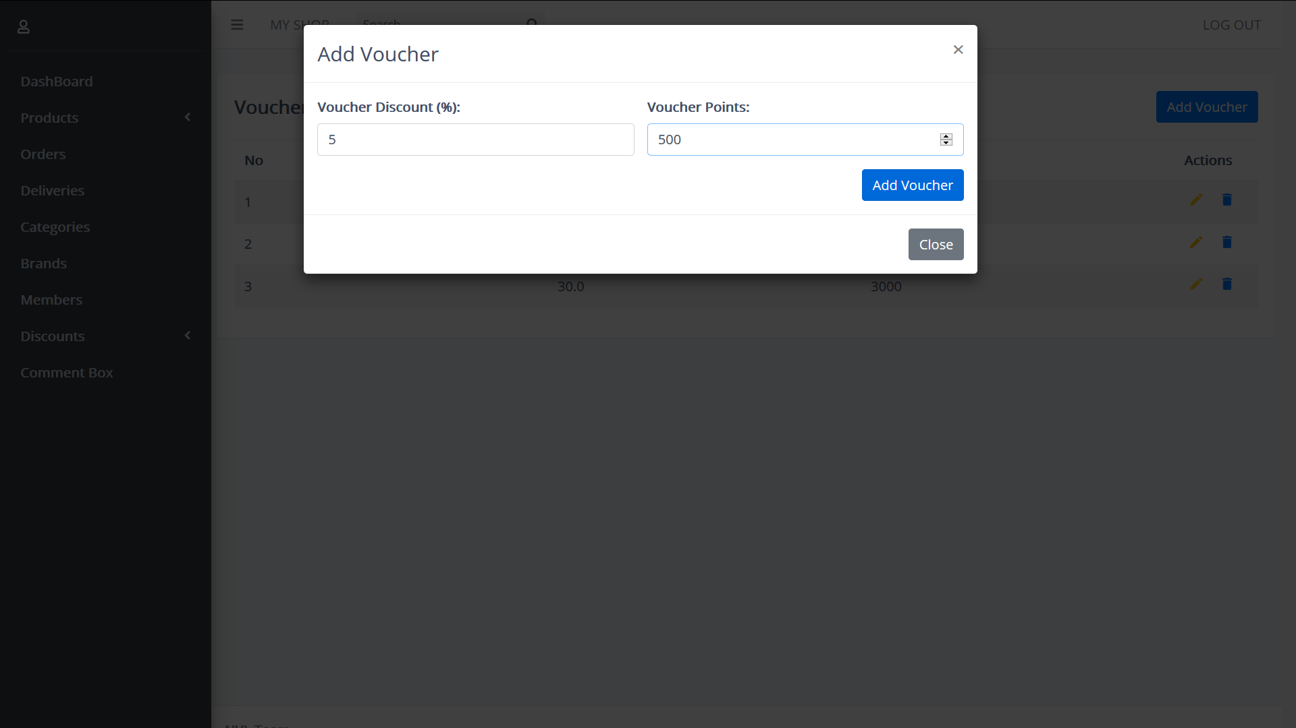

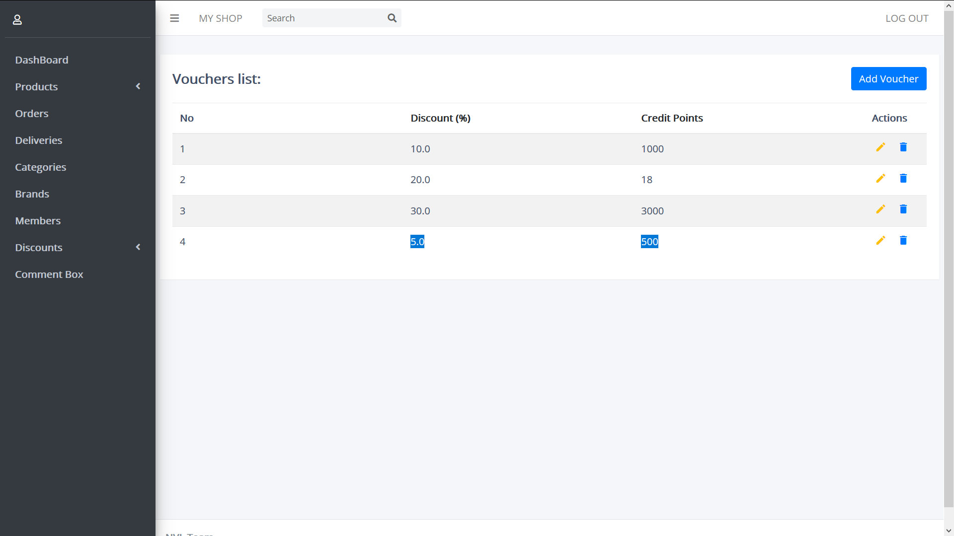

Delete:

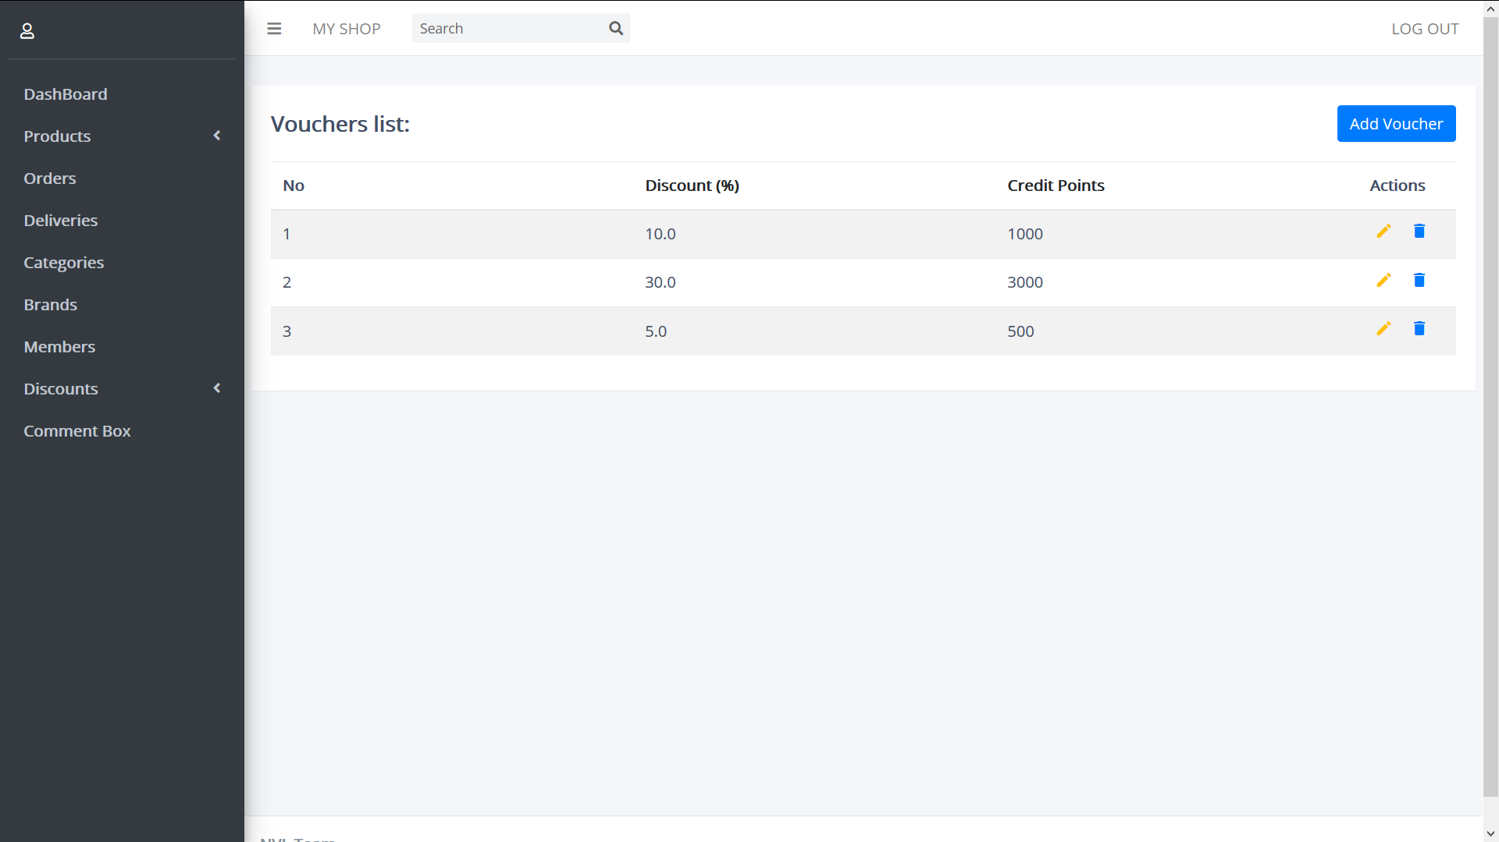

Commend Box:

This menu contains all commends (Accepted or Non-Accepted) of members who had feedbacks on the products.

Commends will be controlled by admin through action update or delete. Only accepted comment can display on the product detail of guest-site.

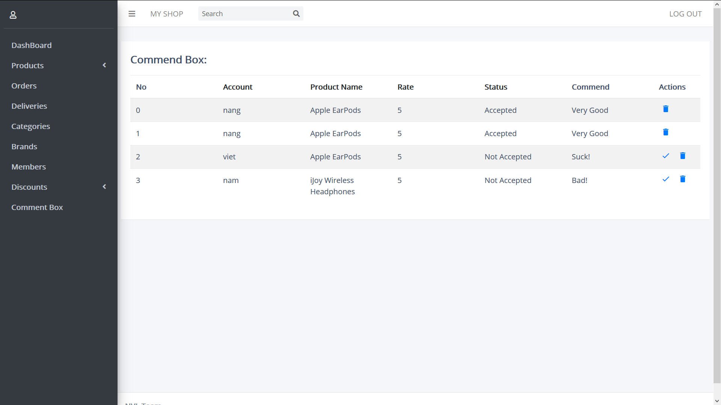

Update:

By clicking on update status icon (check icon), the comment will be accepted and the update status icon will disappear.

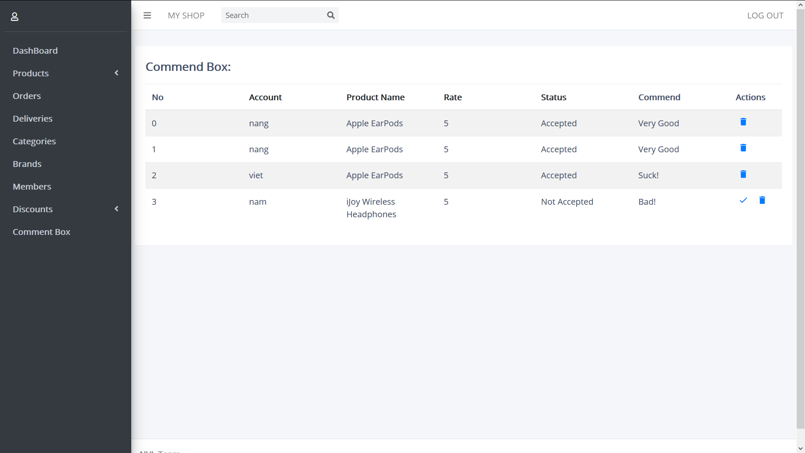

Delete:

By click on delete icon, that commend will be erase from the table.

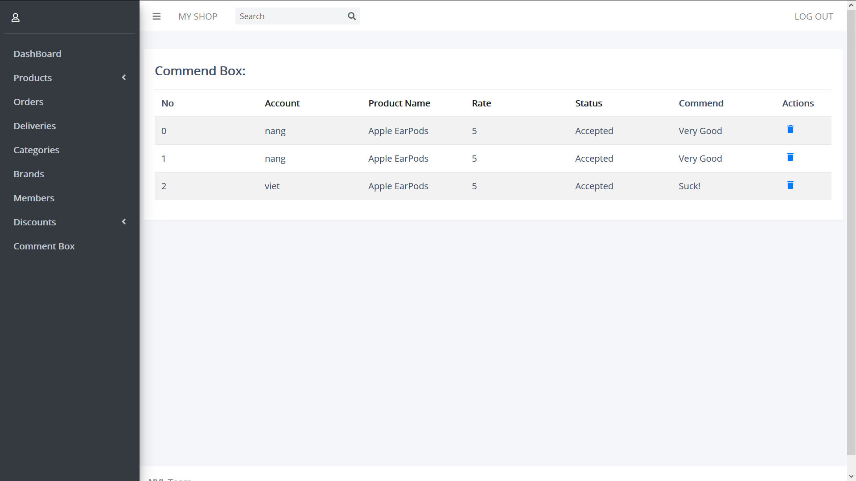

Logout:

Admin perform logout by clicking on the LOG OUT string on the top right window of the website.

After logout, user will be redirect to the login site of admin-site.

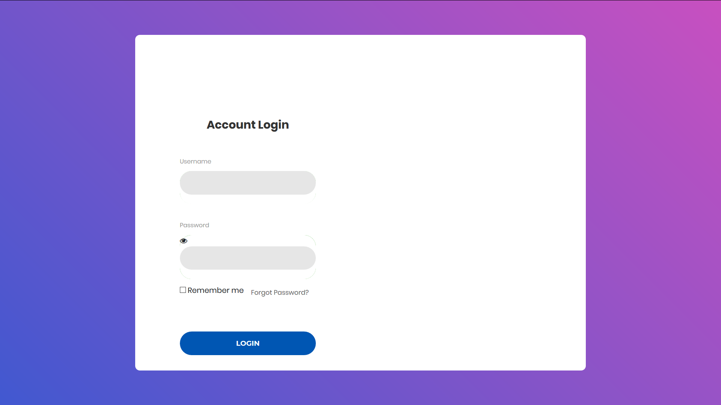

# **Session 7: Developer Guild**

## Customer Side

**File Location :**

The folder and file be soted by the location above :

* src > main > java : store all the back-end code and hibernate which connext to mysql get the table back.
* src > main > resources : store the javascript, css, properties file and regular images.
* src > main > webapp > upload : store all the product’s photo
* src > main > webapp > WEB – INF : store all pages, templates.

**Template :**

We use tiles for the template, have 3 main template. User template, Admin_template and Empty_template.

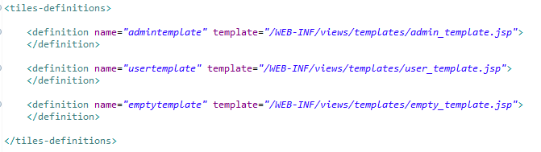

User Template :

Top Bar :



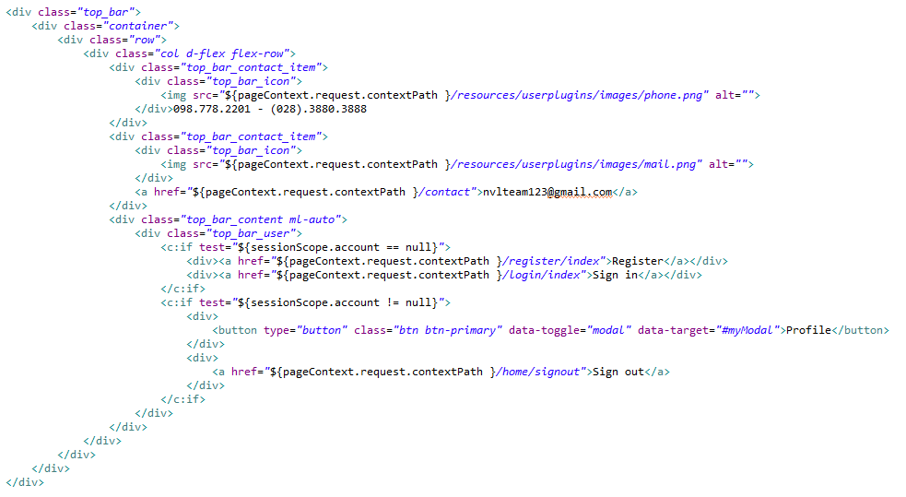

Click the Register on the right, run into RegisterController, and show the register.



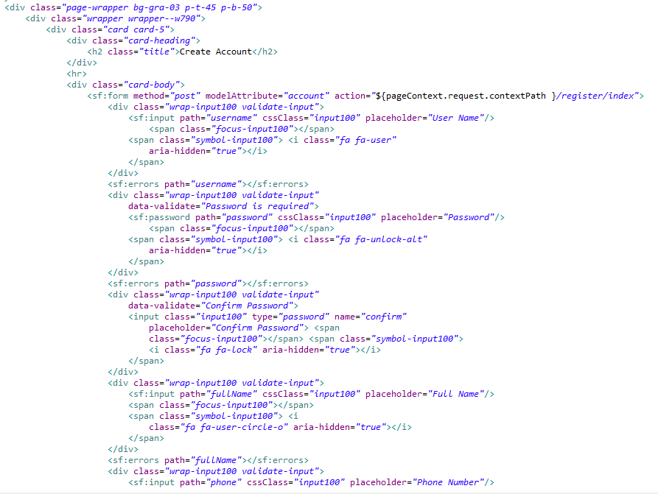

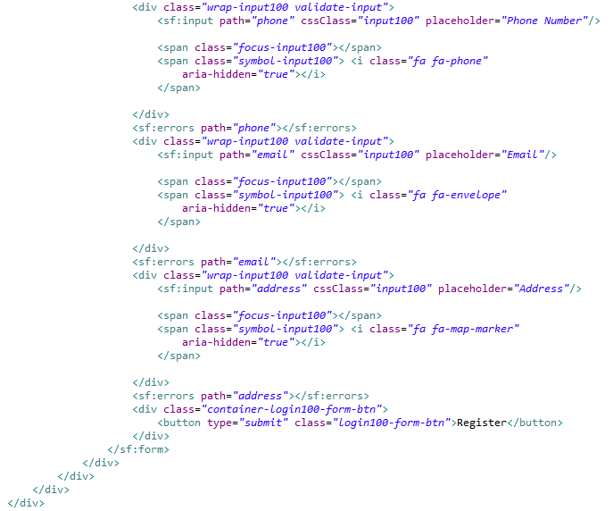

We use the Spring form for the register, when fill out all the information. run to RegisterController and checking, if the Username has existed or Password and Confirm password not match, will be return to the register page. If success the password will be encoded by BcryptPasswrodEncoder() then return to home page

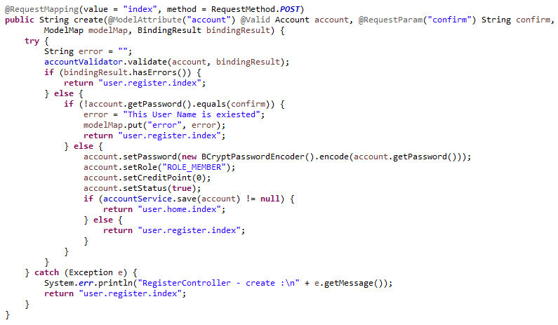

Click Sign in button will run into LoginController, then show the login page.

After fill out the username and password click enter, the get All the account from data and checking, if the username and password are true, will add the account to session and back to home page.



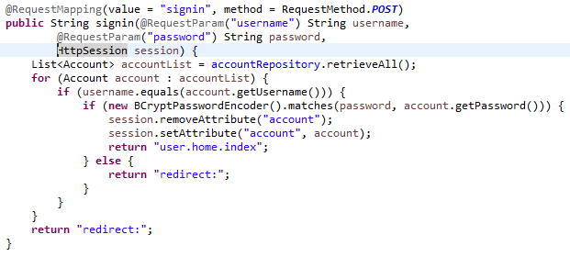

Now the Register and Sign in has changed to Profile and Sign out



When click the profile th modal will show, there are have all the account information and order history. and have edit prodile button.



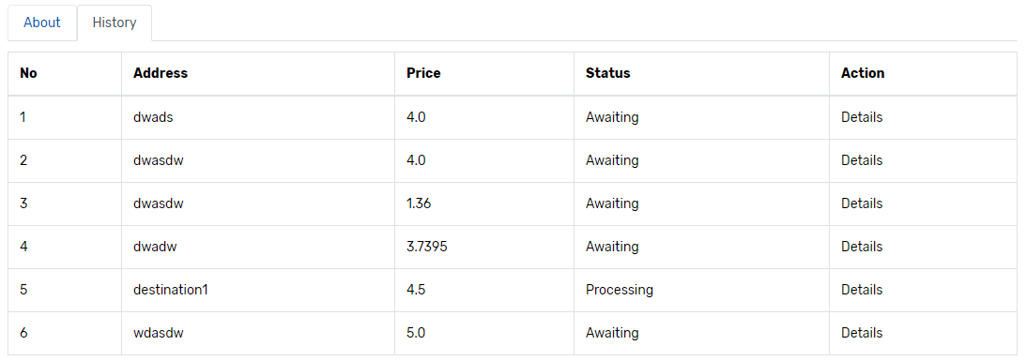

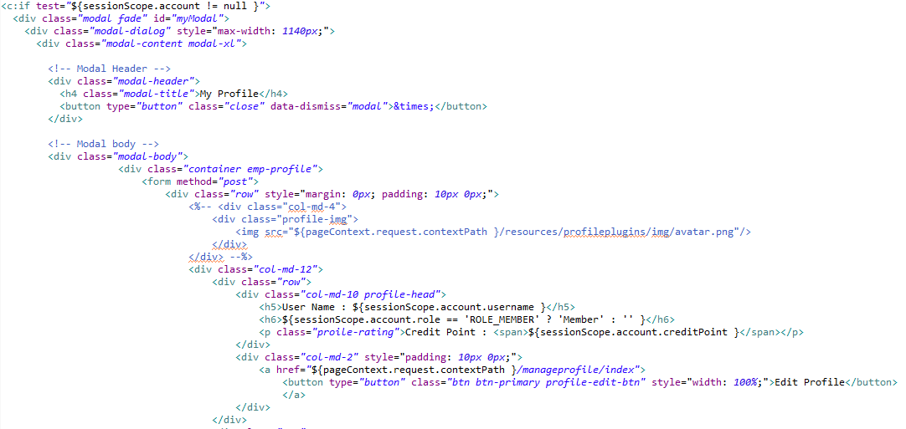

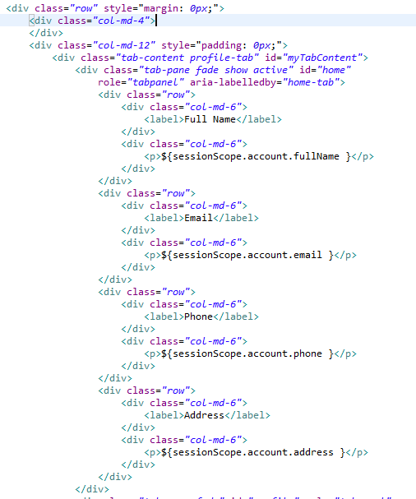

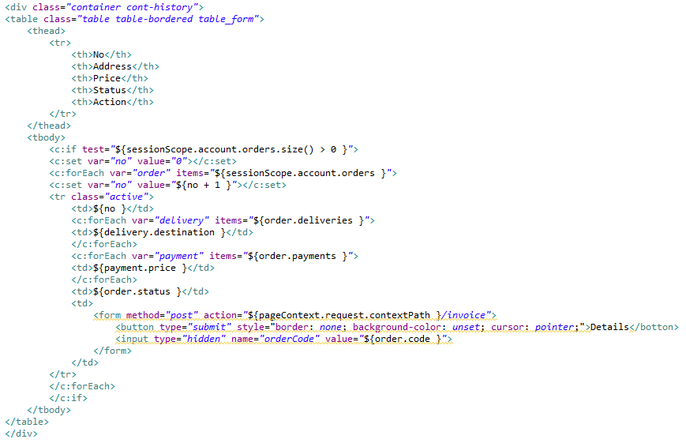

Edit Prodile we also use string form just like register. But the password and conform field are empty, if fill the password will change.

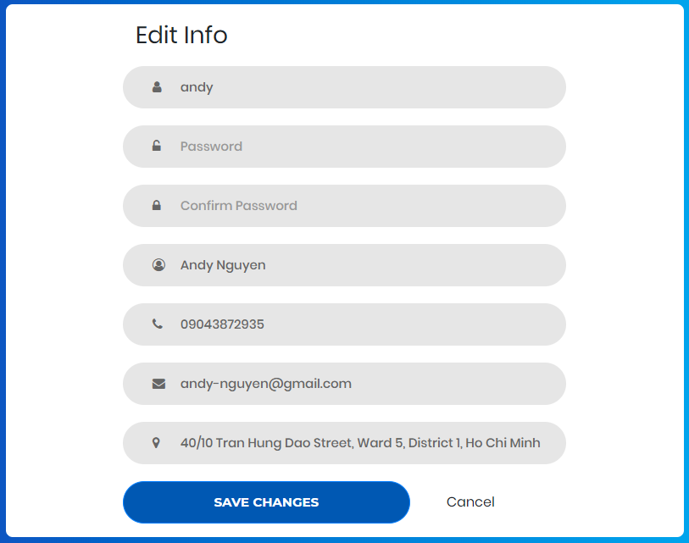

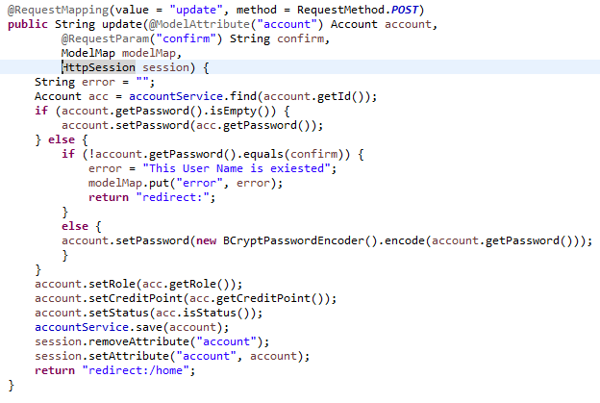

Header Main :

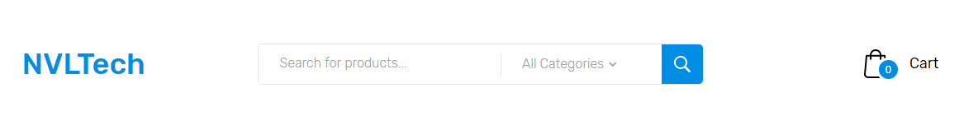

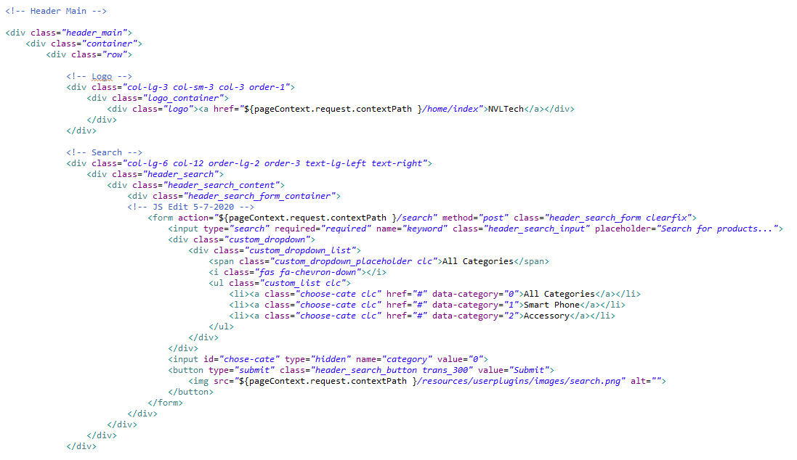

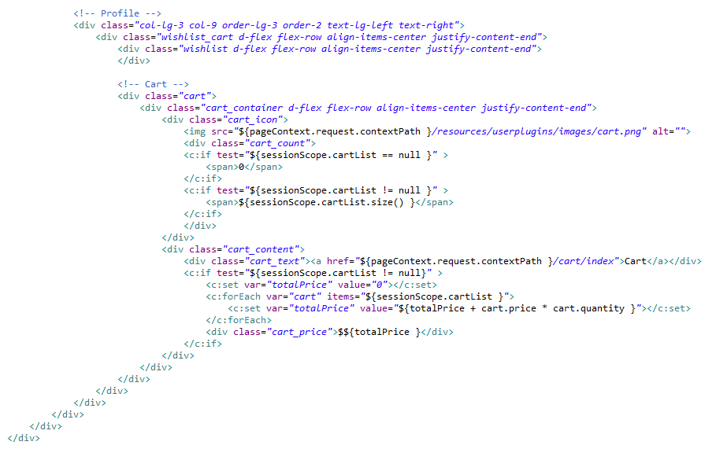

Input some keyword in search bar, press enter, run in to the SearchController (com.demo.controllers.user), will get parameter keyword and category we choose, then get to the ProductService (com.demo.services) call to ProductReposiroty (com.demo.repositories) can the data back from Database, finally the controller return to search view and show the product(s)



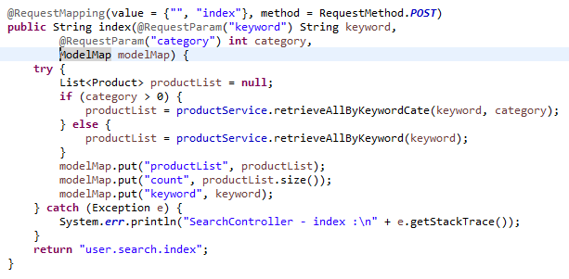

Home Category List, High Rate and Promotion the category and product get from HomeController (com.demo.controllers.user) get all the category from database





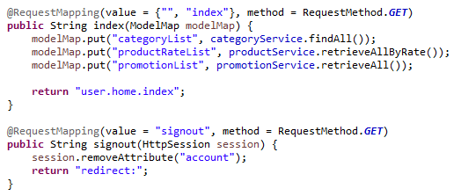

Shop Page :

Get all products from database, call to the PageHolderList() to paginate to product. There we set 10 products for each page.

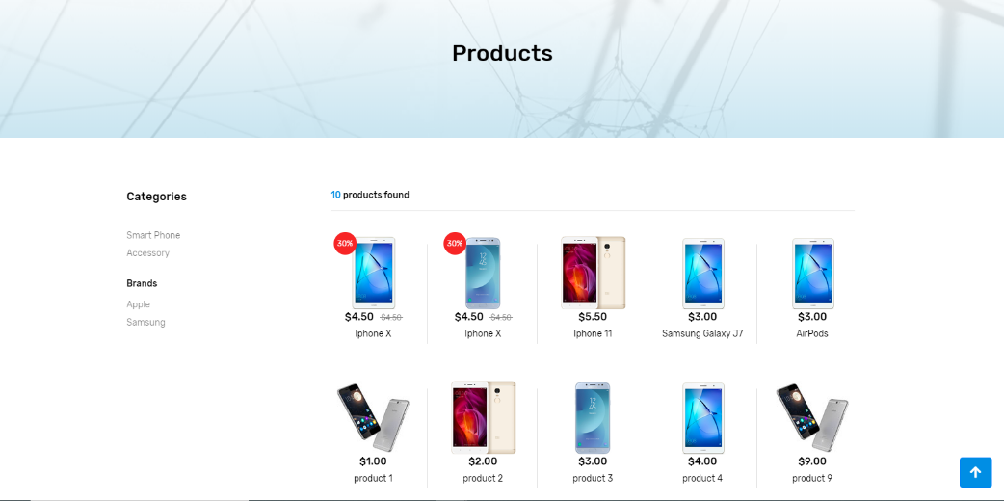

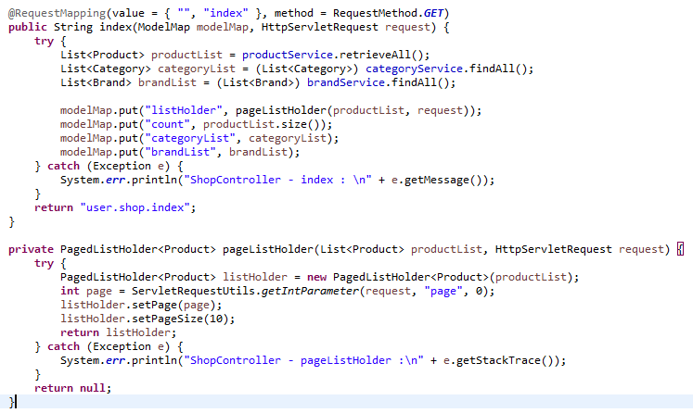

And the pagination in view side, get the customer tag from tags folder in WEB-INF



Product Page :

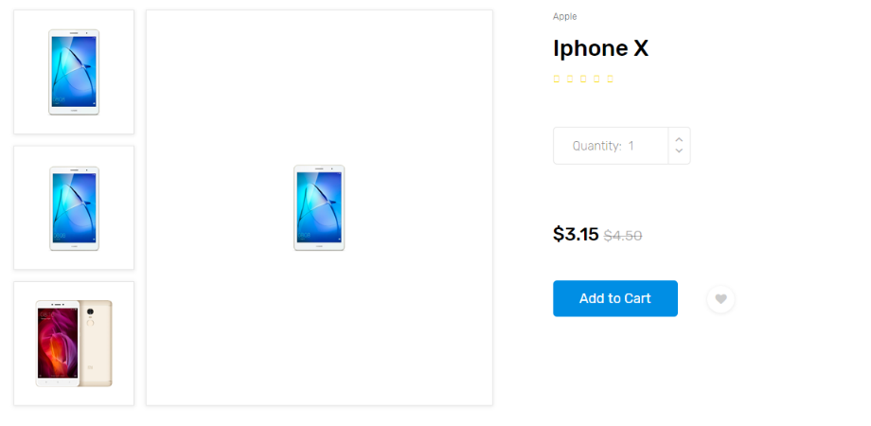

Increase quantity click add to cart run into the Cart Controller, create Object Cart add the product in the cart object. Update the product quantity and delete, alse call to the CartController (com.demo.controller.user) to process the mission.

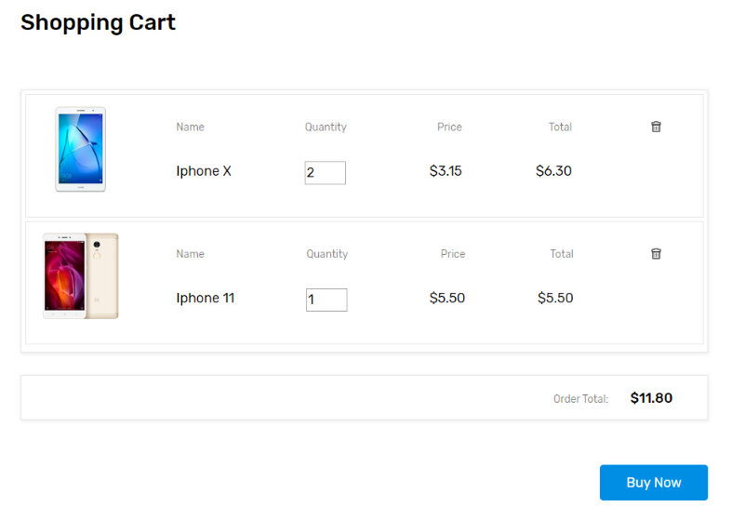

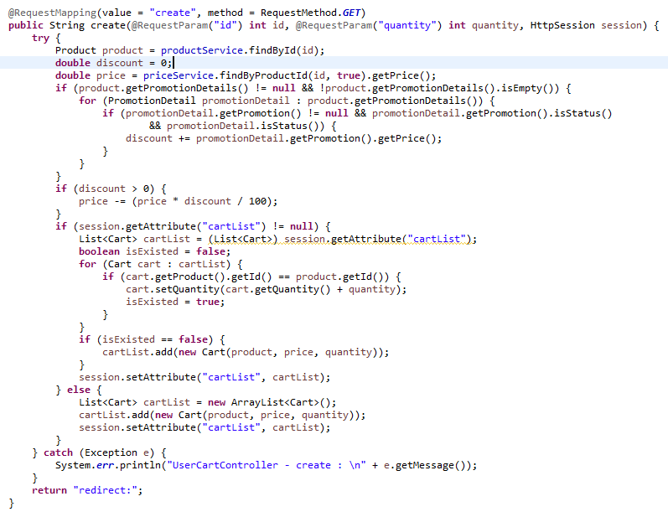

Click the “But now” button call to the PaymentController and show the price. And check the session account on the view page, if exist will get the all voucher in database. and show all the product in cart shop.



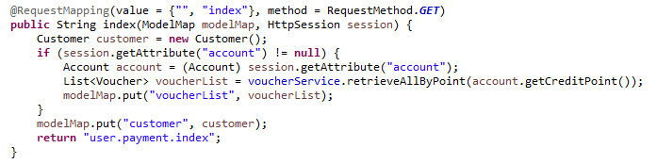

After fill out all information, click “Continue to checkout” button, it will create the Order, Payment, Delivery and Exchange, and store in the dataase.

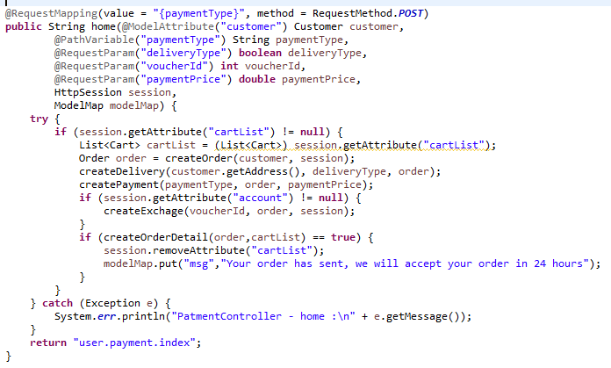

And when order is creating, run intorandomString() to create the unique order code. For customer tracking their orders easilly

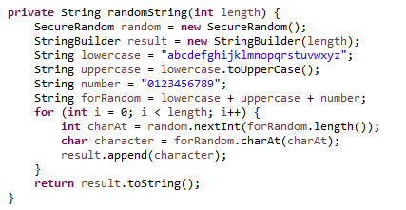

Order tracking :

On the menu bar, hover Order Tracking. In put the order code. or click the Details in profile modal.



Will get into the InvoiceController, retrieve the order by unique order code. and show the invoice.

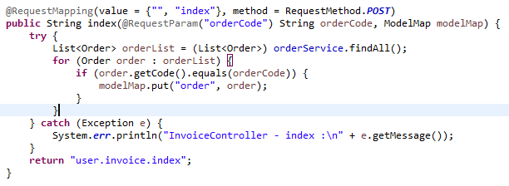

Contact Page :

The contact form for customer leave their opinion, and send to the the admin gamil.

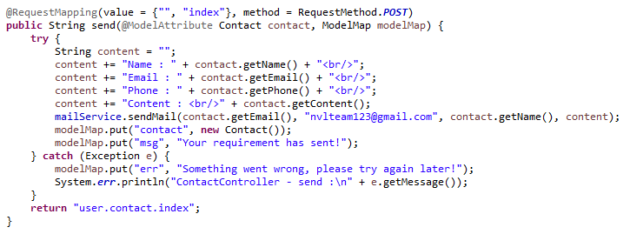

The admin gmail we set in the application.properties (src.main.resources)

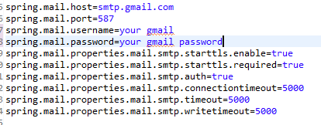

## Admin Side

This manual is written for web developer who developers or maintains the website with the administrator role.

**Structure of the web:**

Admin-site is based on the Spring MVC Model with 11 controllers and 12 views respectively.

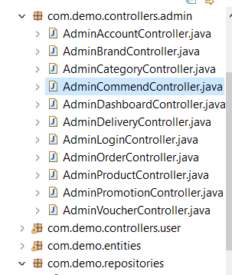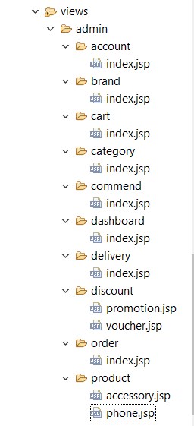

**Login page:**

When developer access to the admin-sites, the security configuration will redirect to the login page.



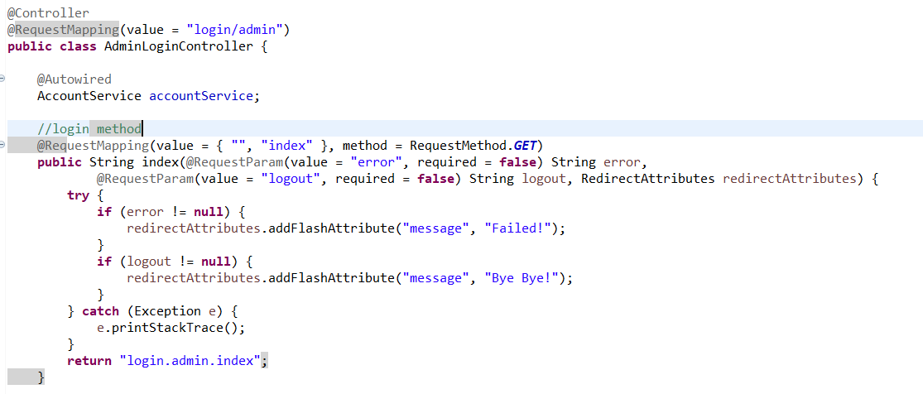

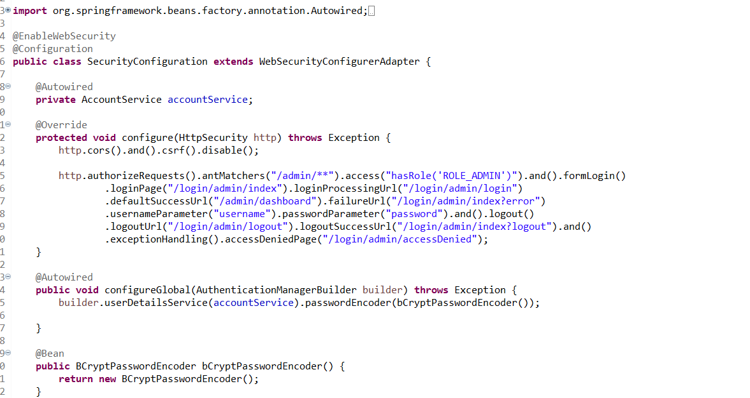

Username and password when filling will be transfer to AccountServiceImpl.java to check whether the account has the role “ROLE_ADMIN” or not, if not user will be hold at the login site until user login with the account has the role ROLE_ADMIN, security configuration will redirect to the dashboard page.

**Dashboard:**

After login successfully, user now become admin are in the dashboard page.

Dashboard page is the page containing statistic contents relative to the buying, selling and members actions of the store.

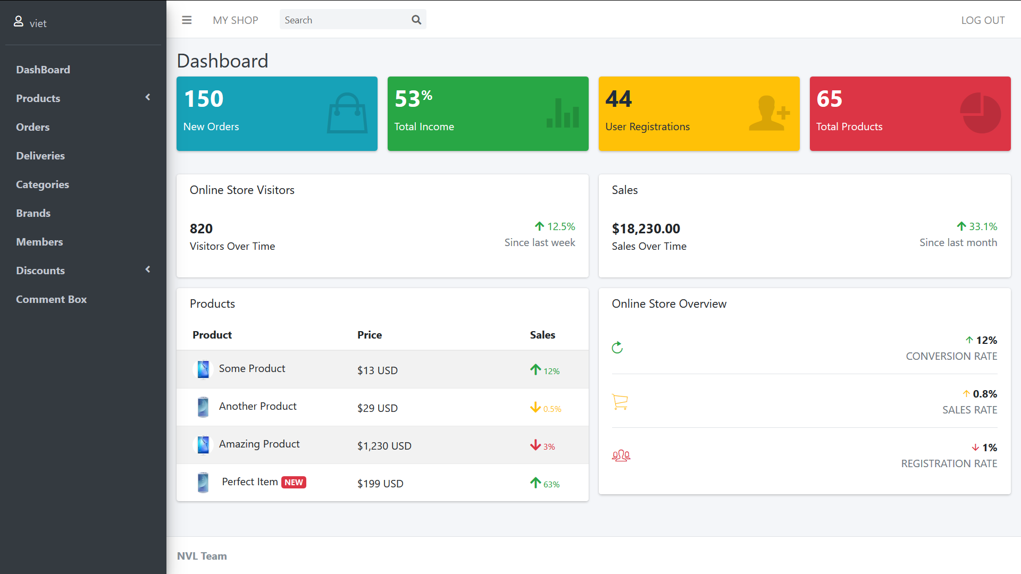

Admin_template.jsp is used in the admin-sites contains: left side menu bar, header, footer

**Header:**

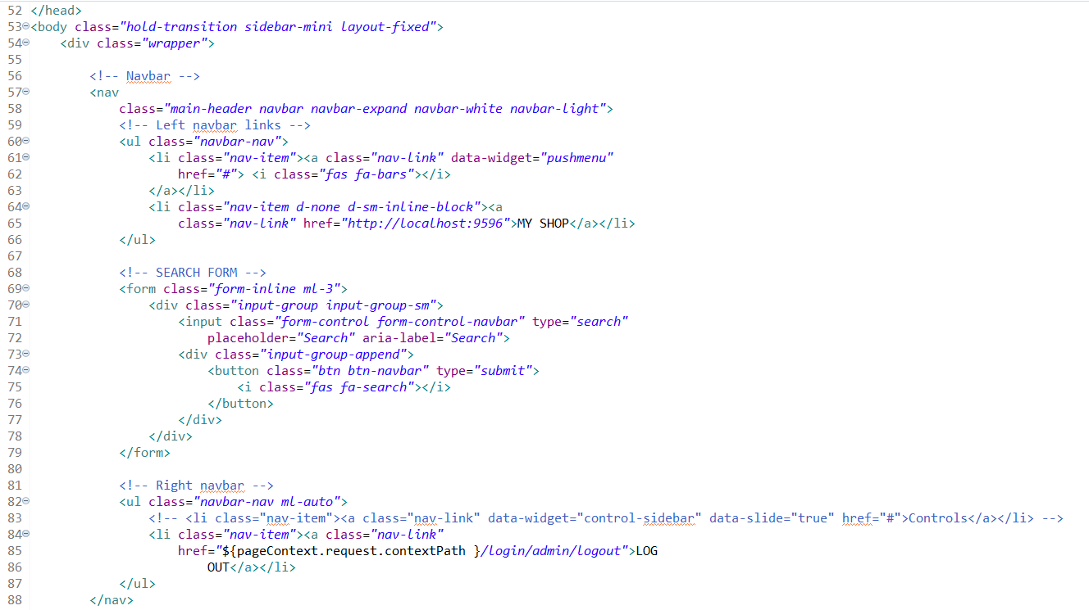

**Left side bar:**

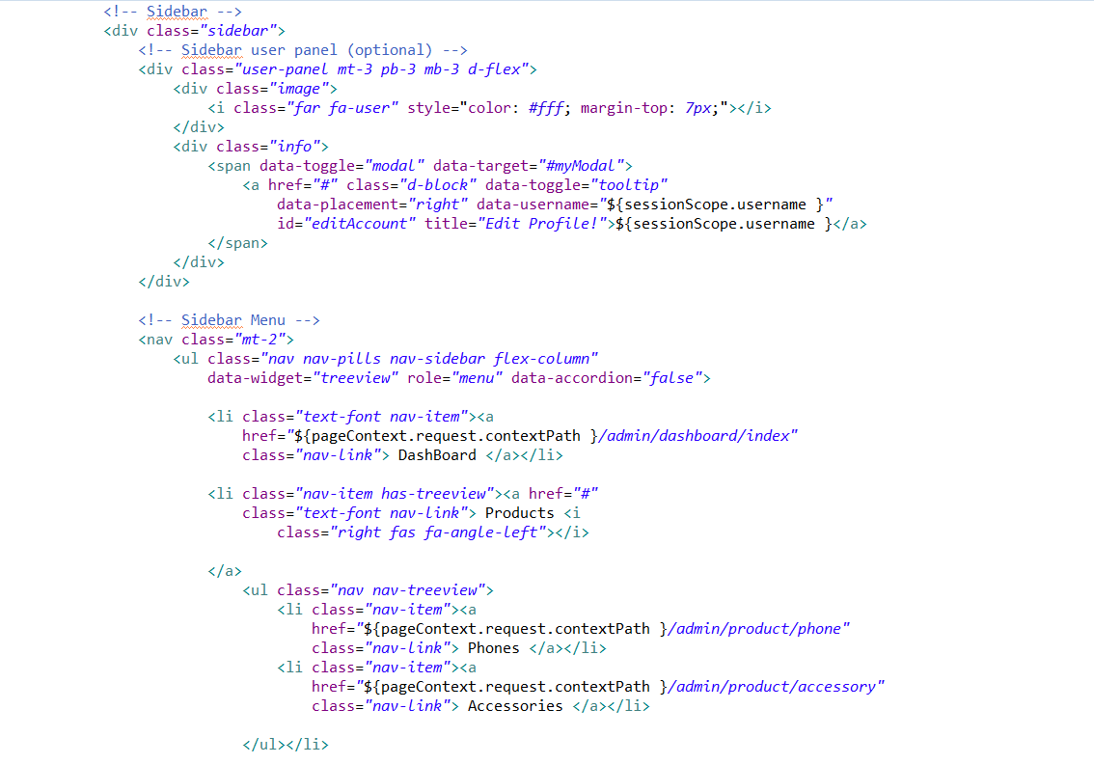

**Footer:**

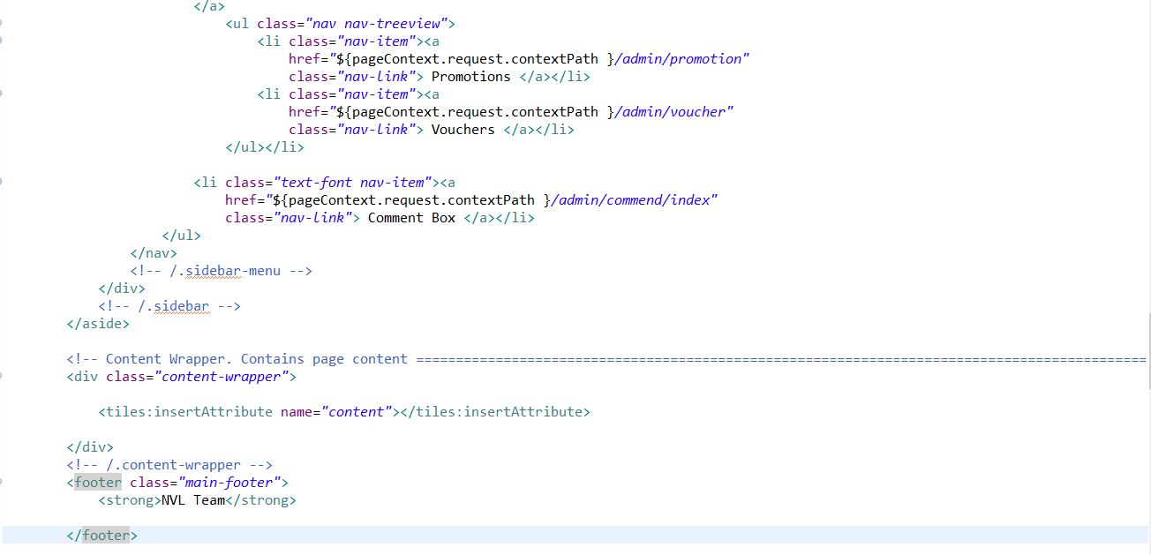

Admin_template.jsp take the role of edit admin info:

When clicking on admin logo on the top left window of the page, a modal to edit info will occur to show the information of the admin:

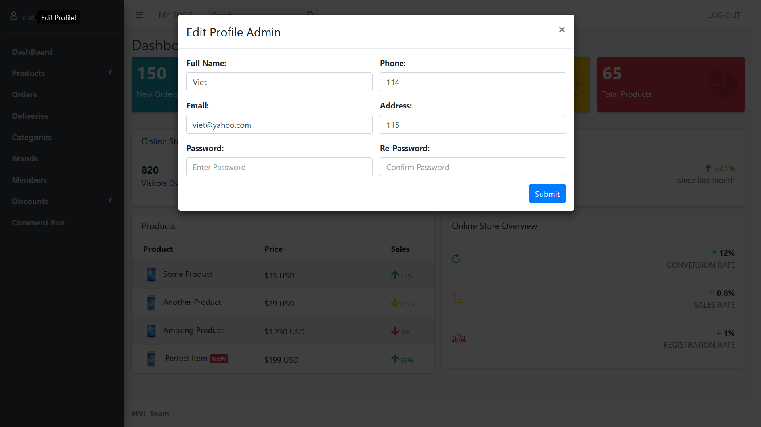

The update method will be taken on the AdminLoginController.java

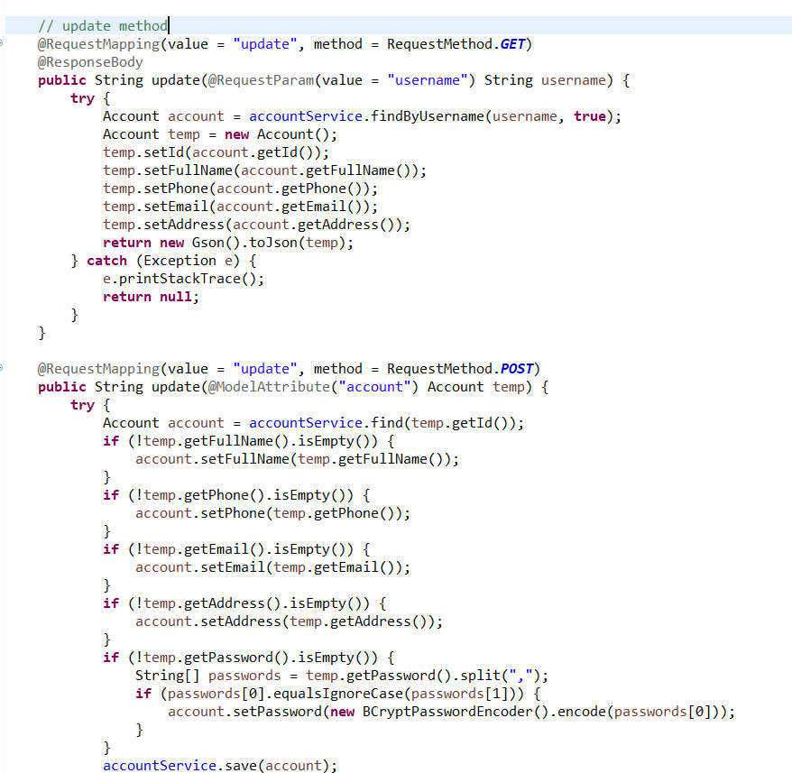

**Product – Phone page:**



**Display phones:**

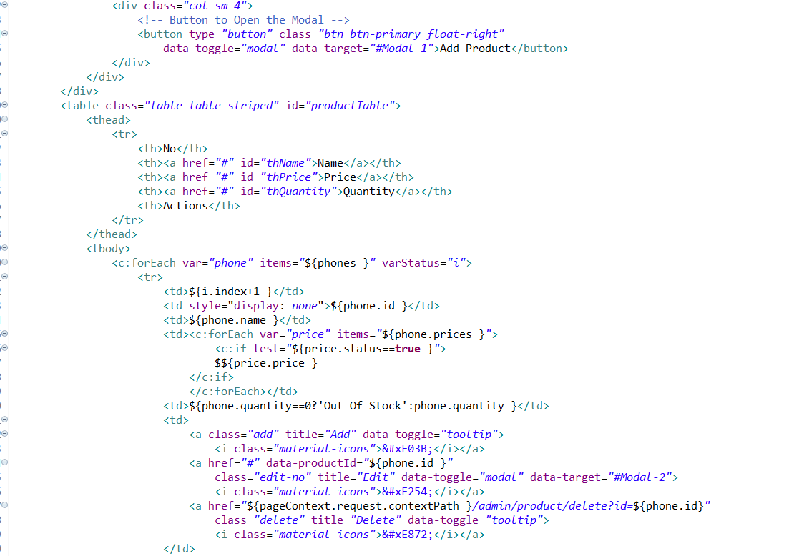

Controller: phone and accessory using the same controller in AdminProductController.java

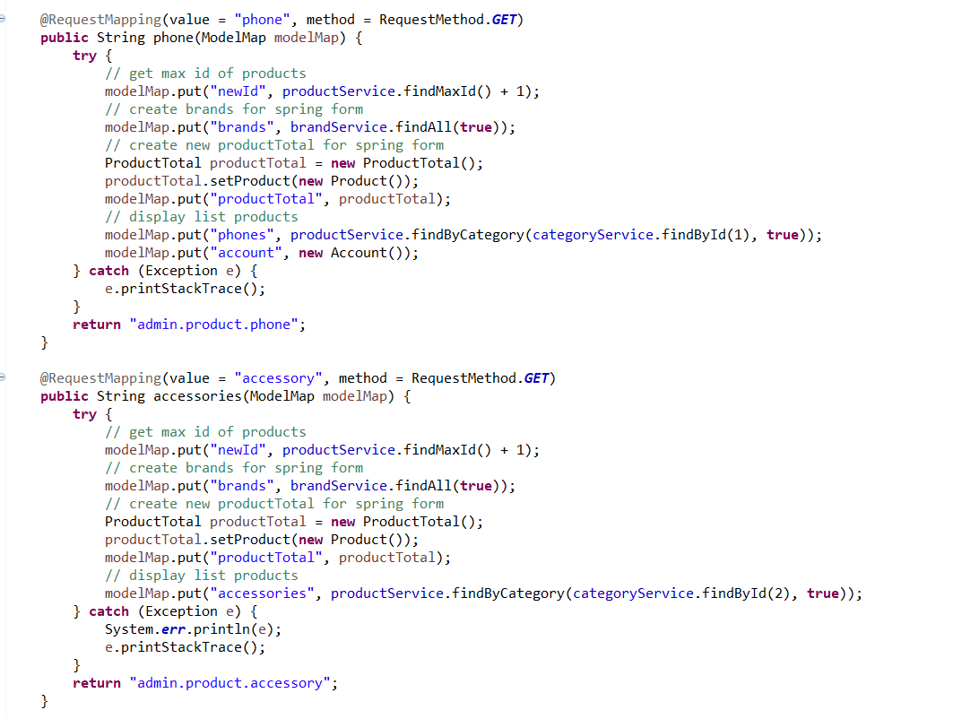

**Create:**

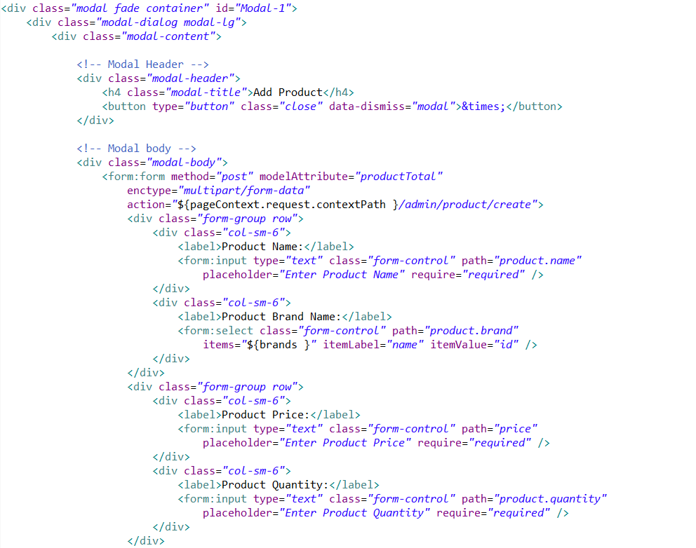

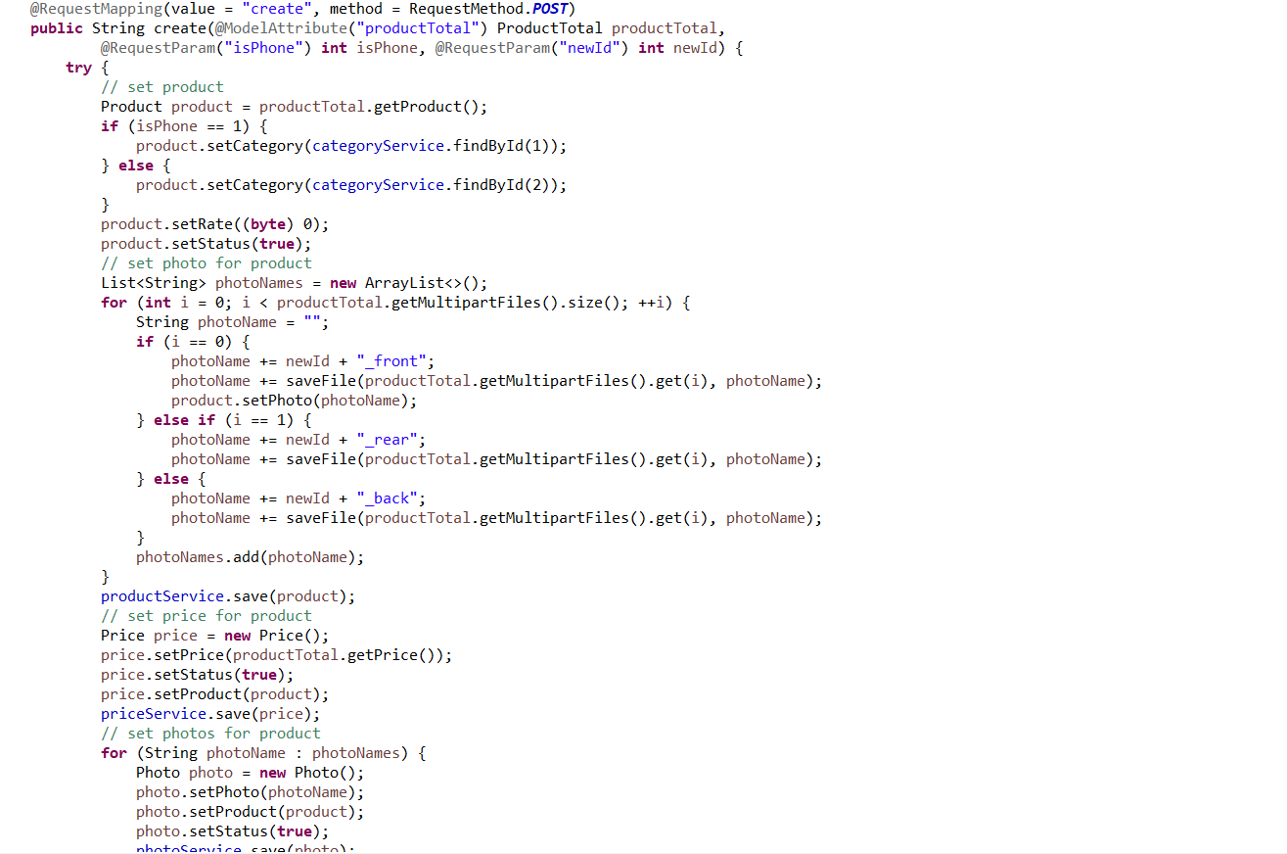

**Edit:**

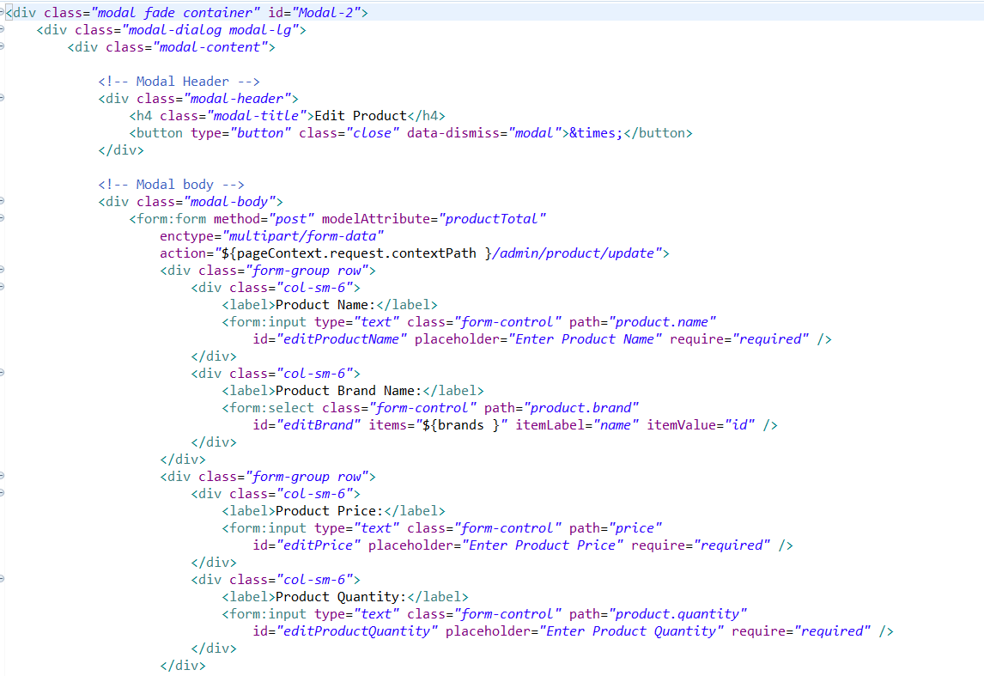

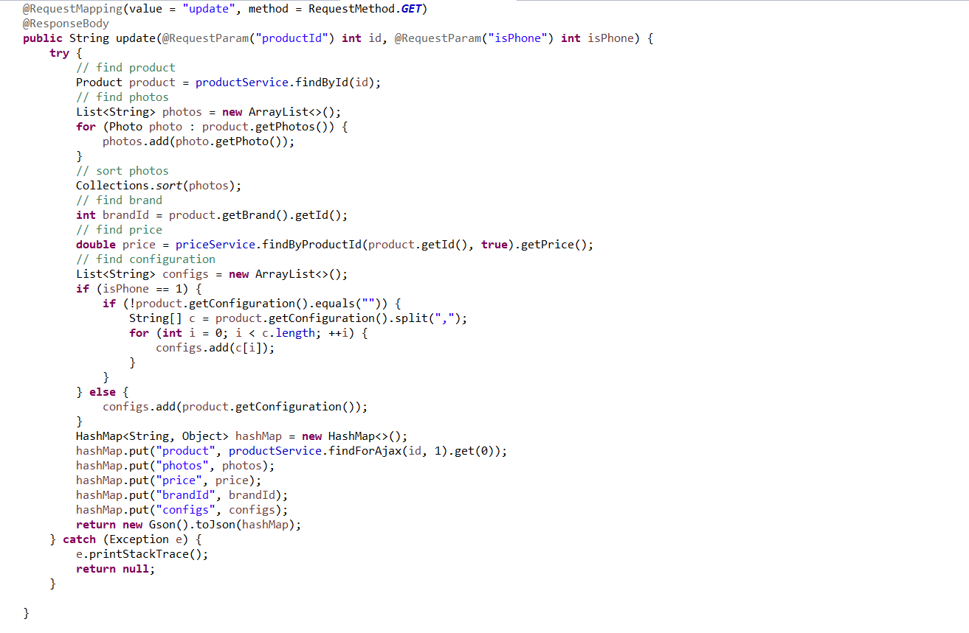

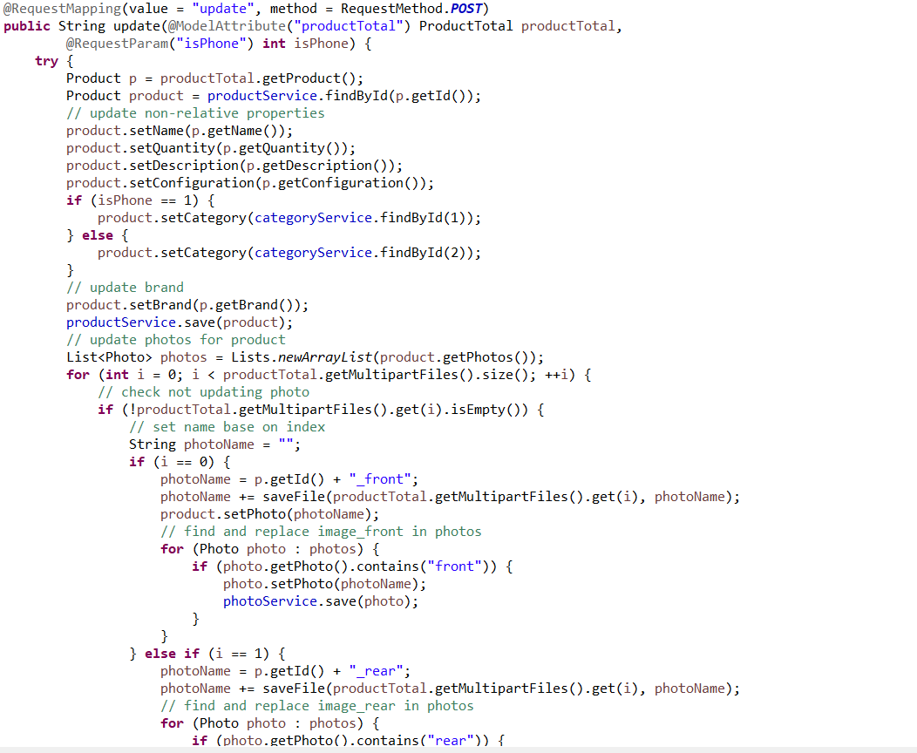

**Delete:**

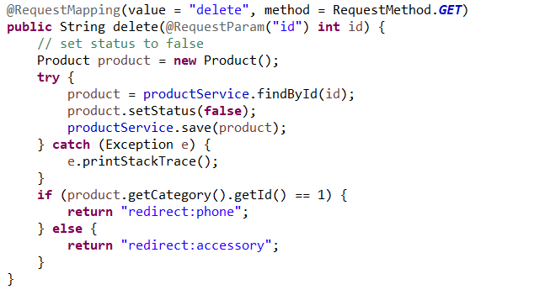

In the create and edit methods, there is a function handle the upload product photo and save it to the upload/images/products folder:

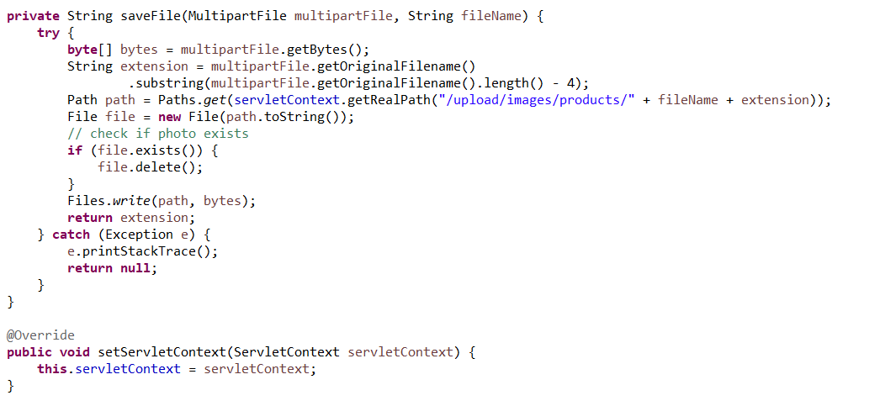

In the table of products, admin can sort the list by clicking on the header of the table, these functions is applied on almost every tables of admin-sites.

Using j Query ajax and Json to prevent reload page.

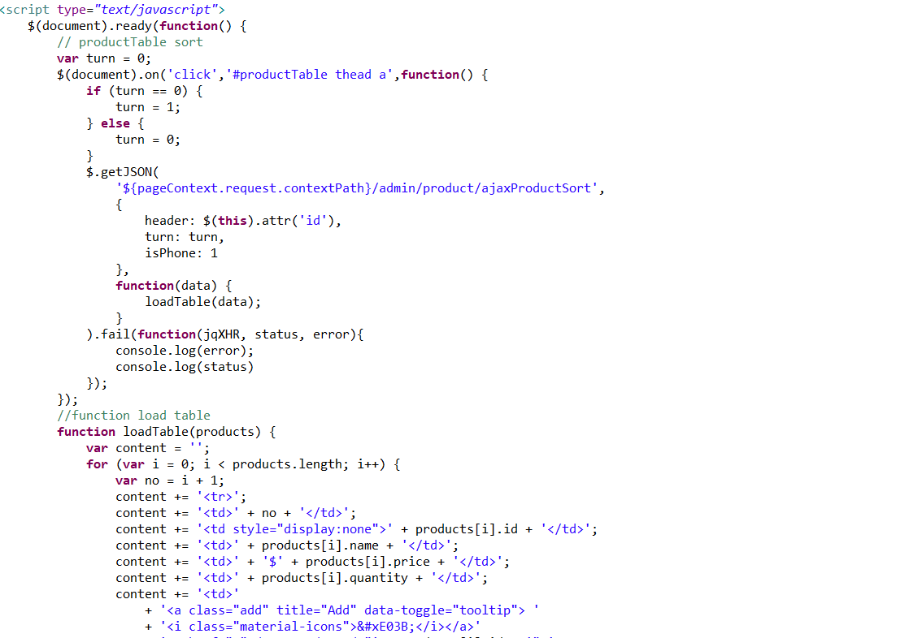

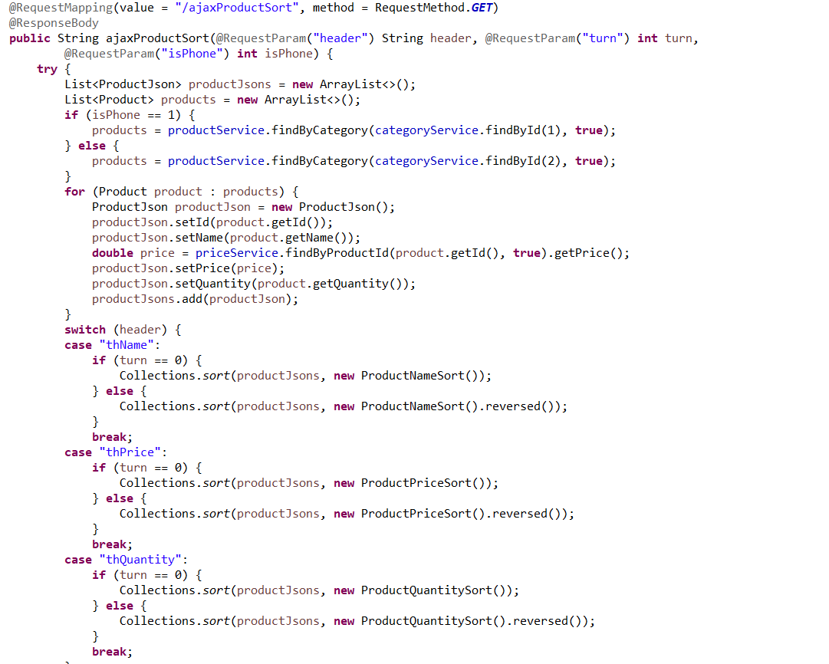

**Orders:**

Contains orders from customers buying in the guest-site

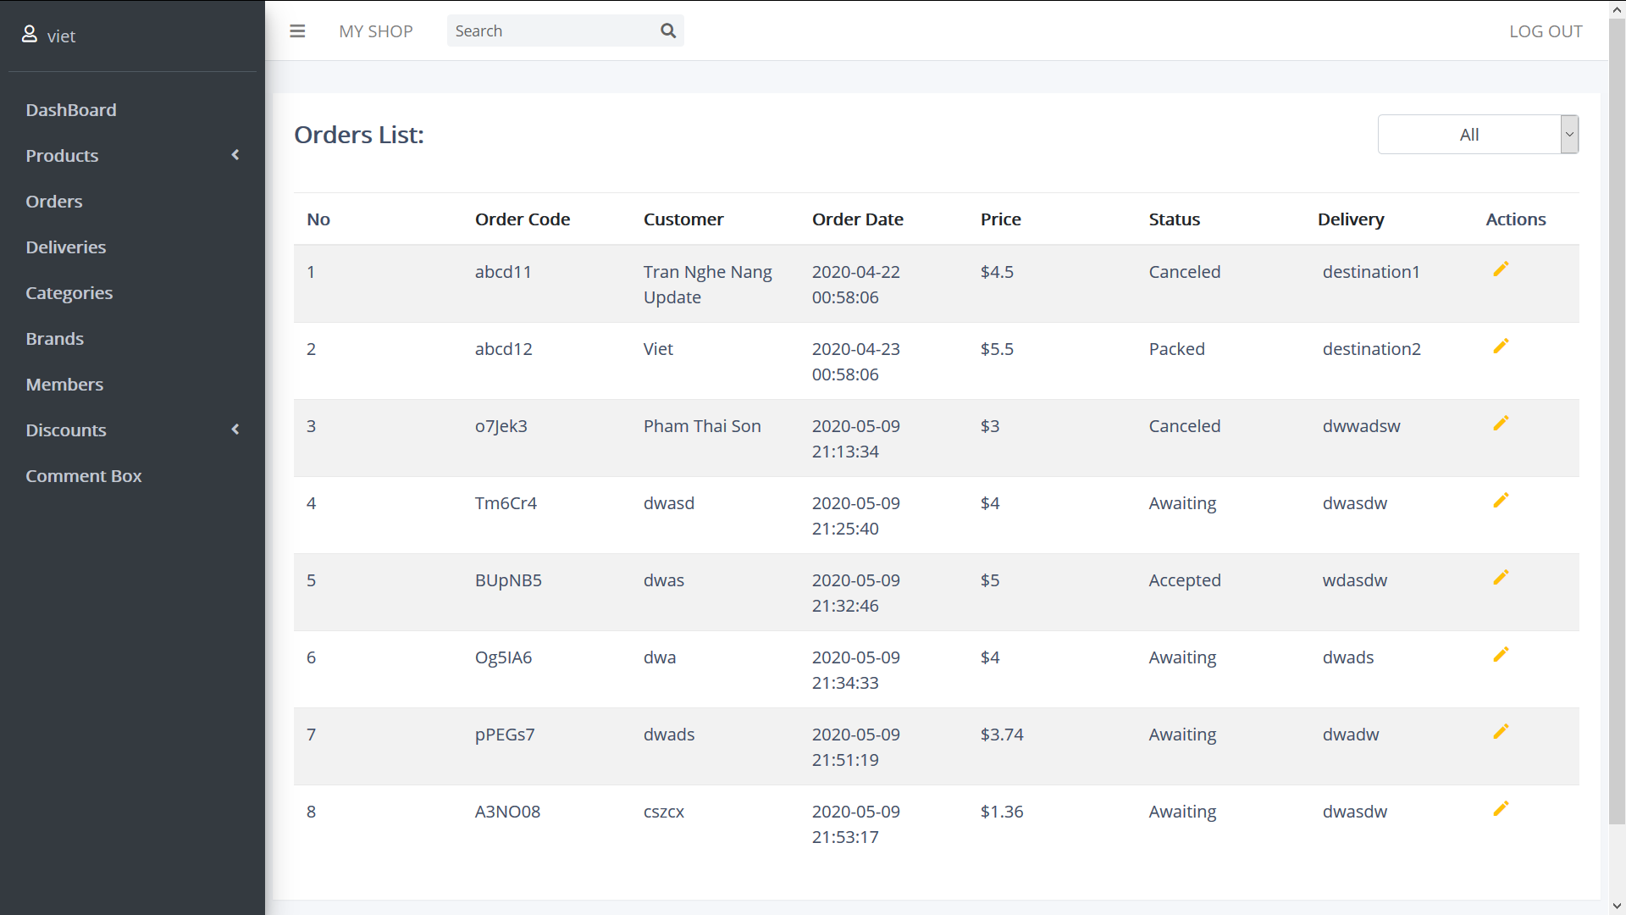

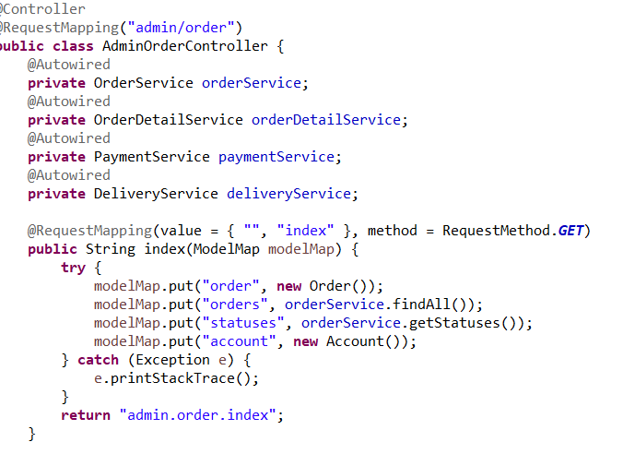

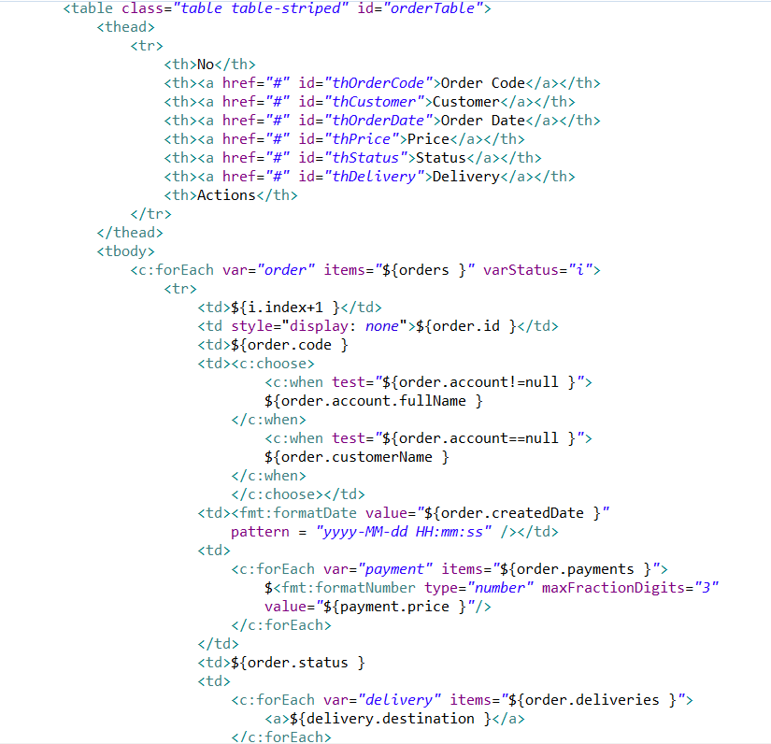

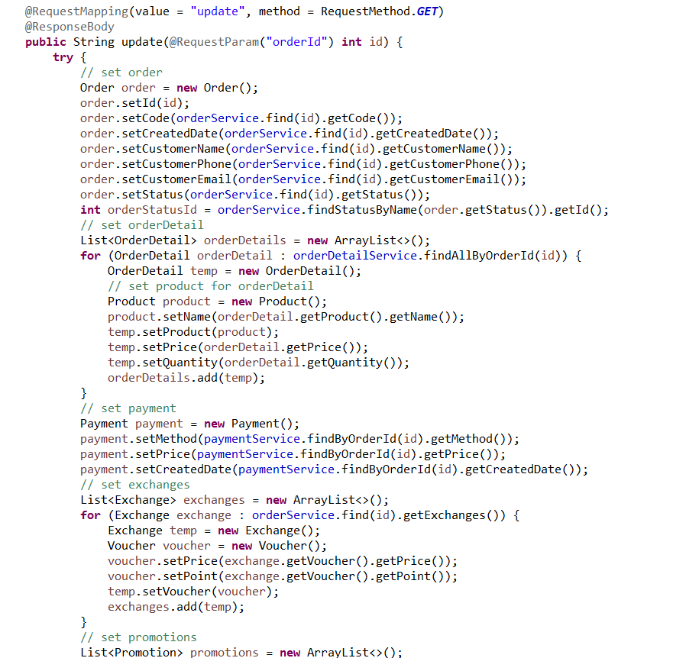

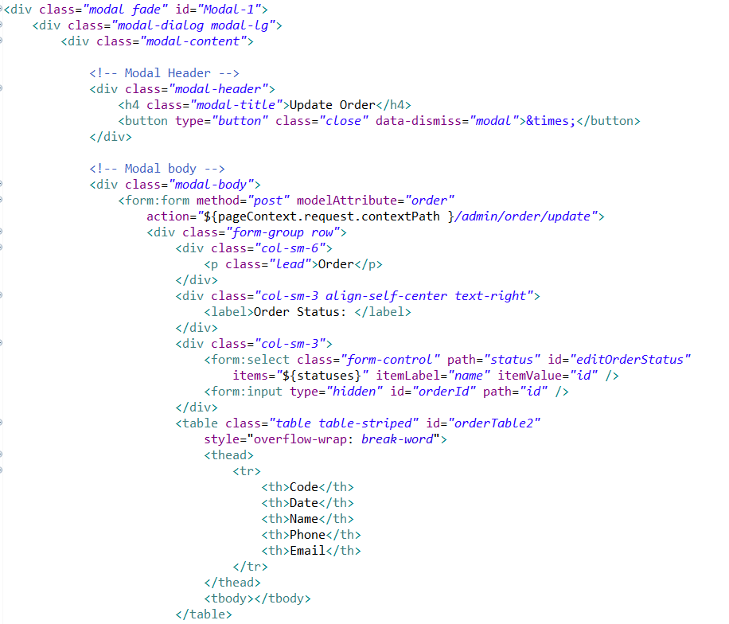

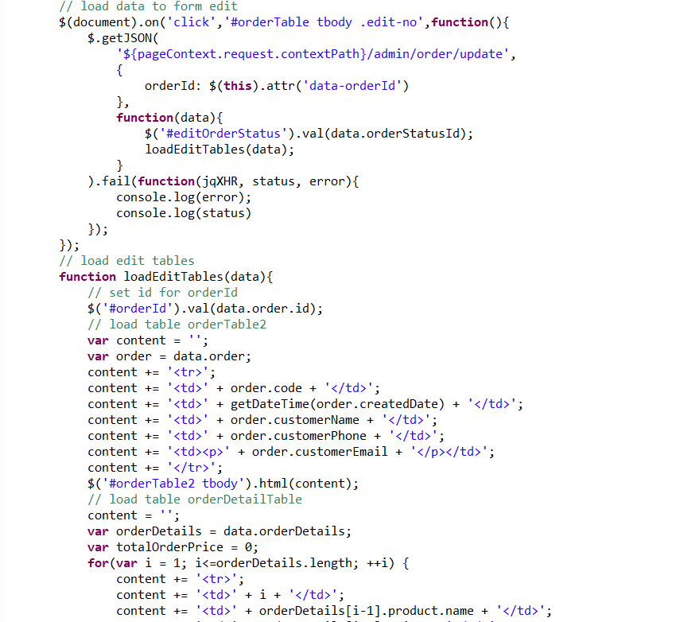

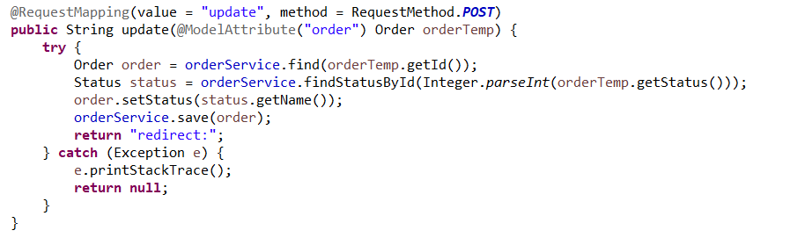

On the top right of the content page, there is a drop down list to filter the order status

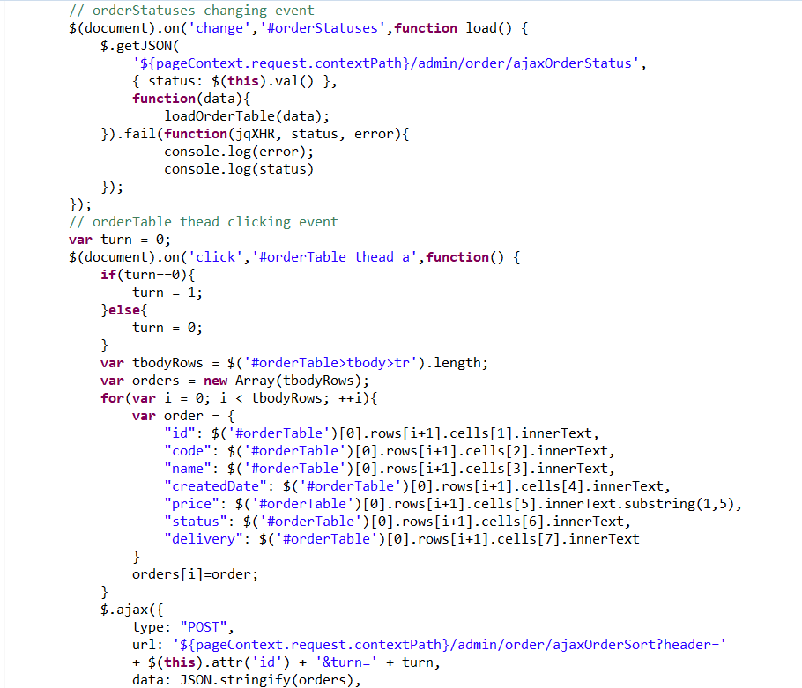

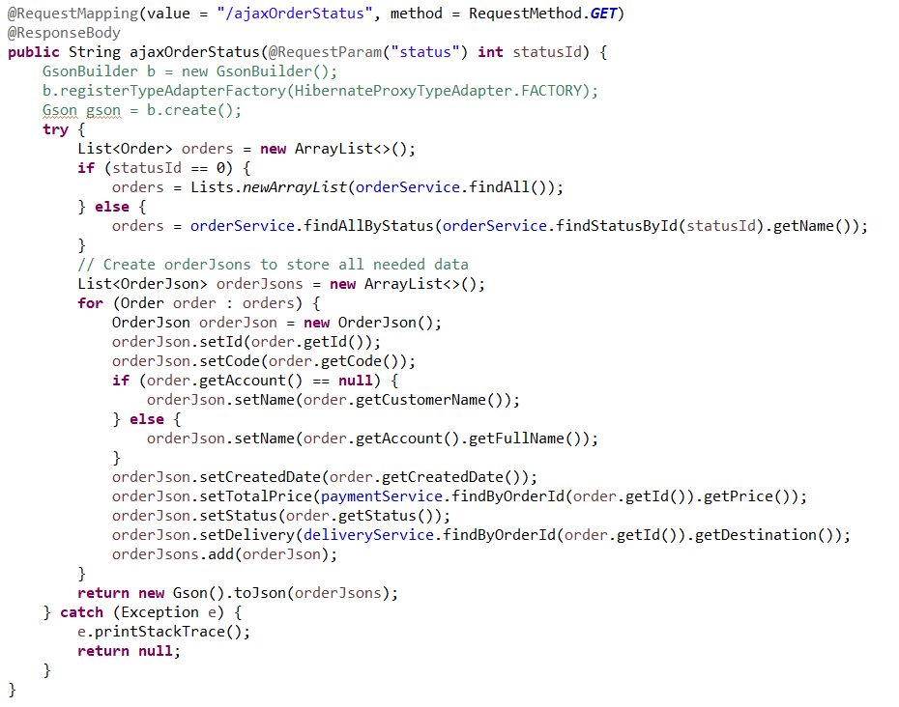

**Deliveries:**

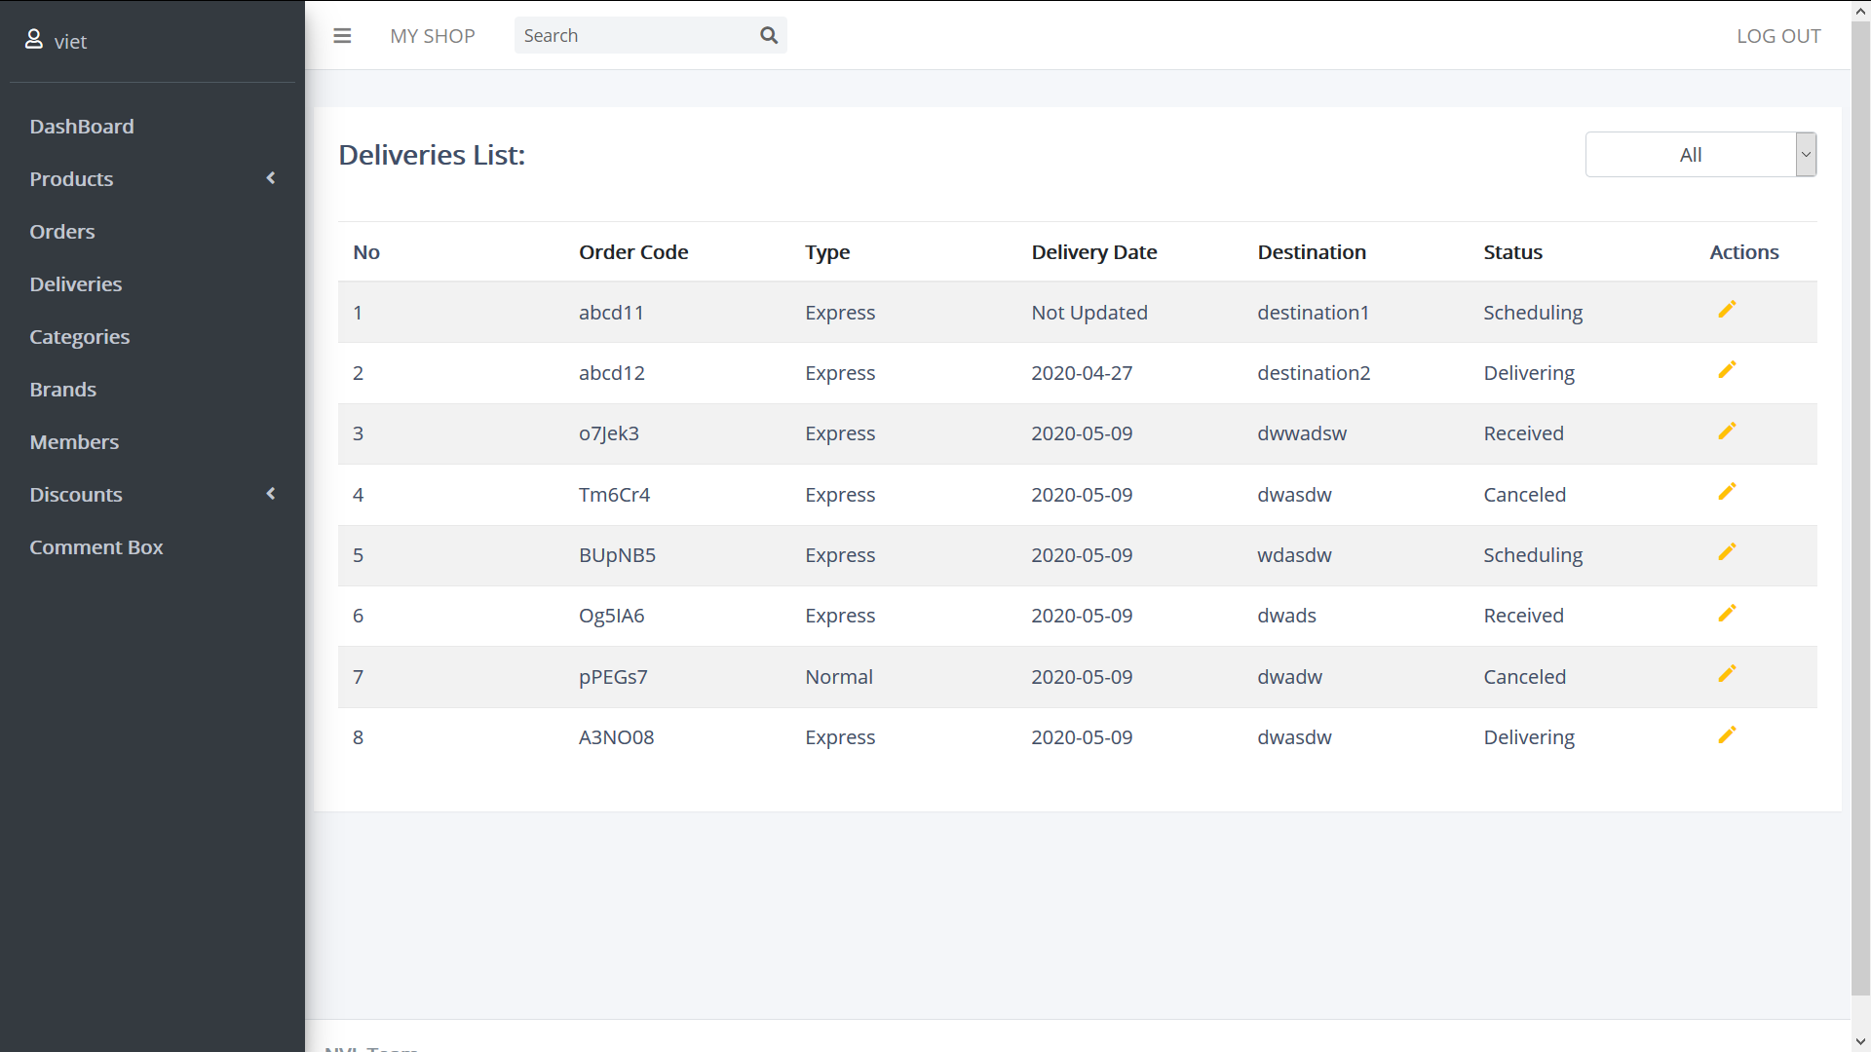

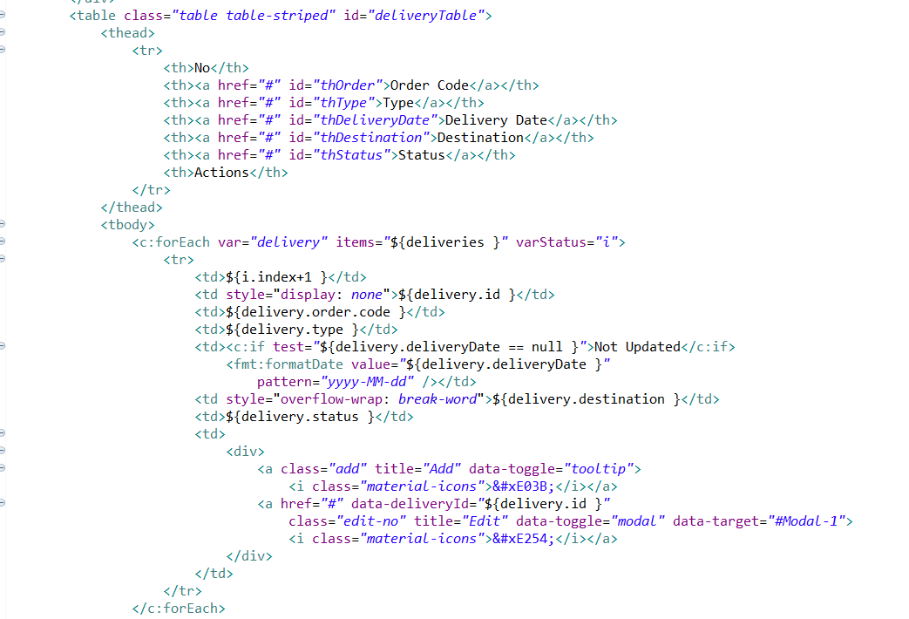

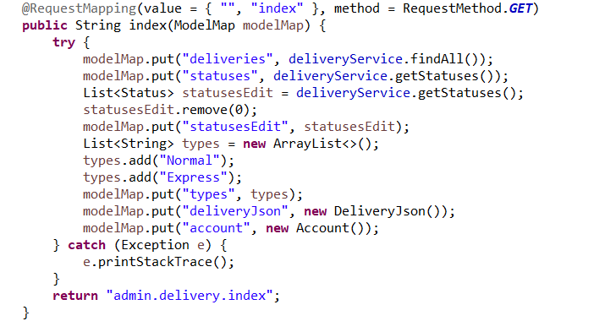

**Update:**

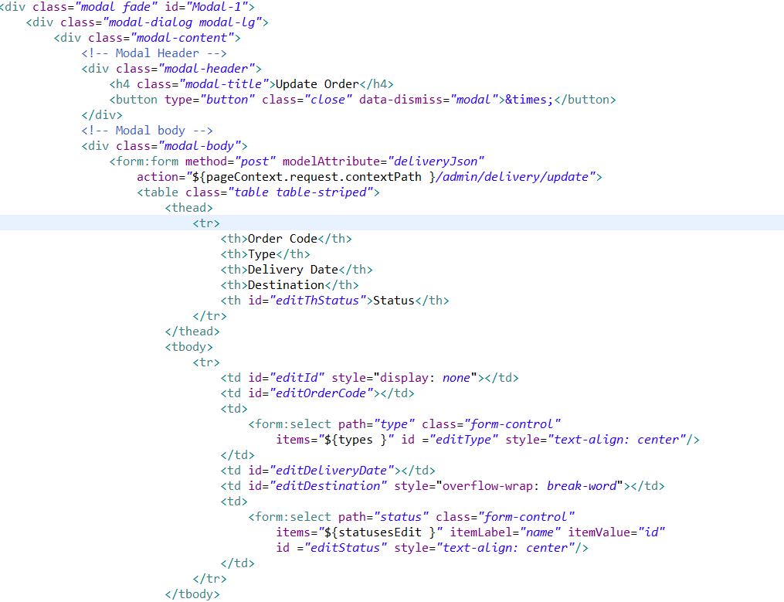

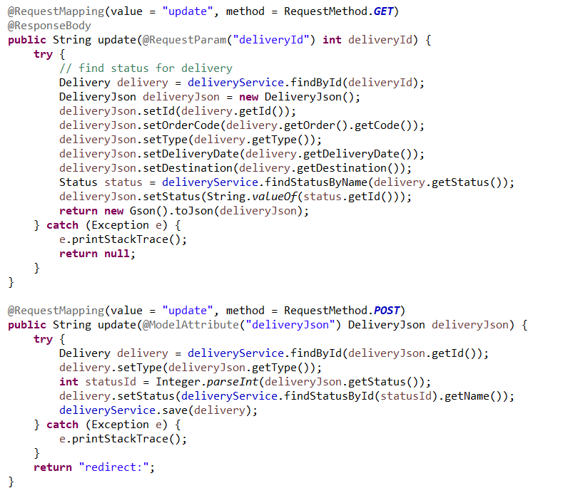

**Status filter:**

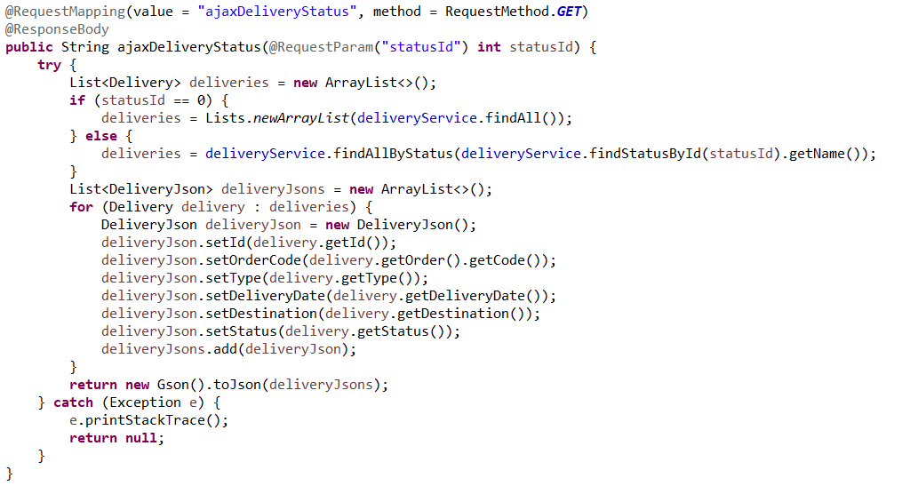

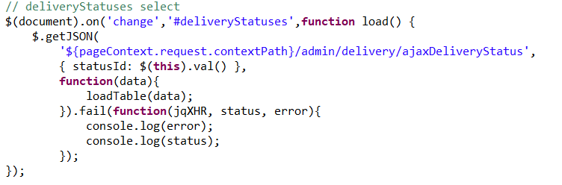

**Brands:**

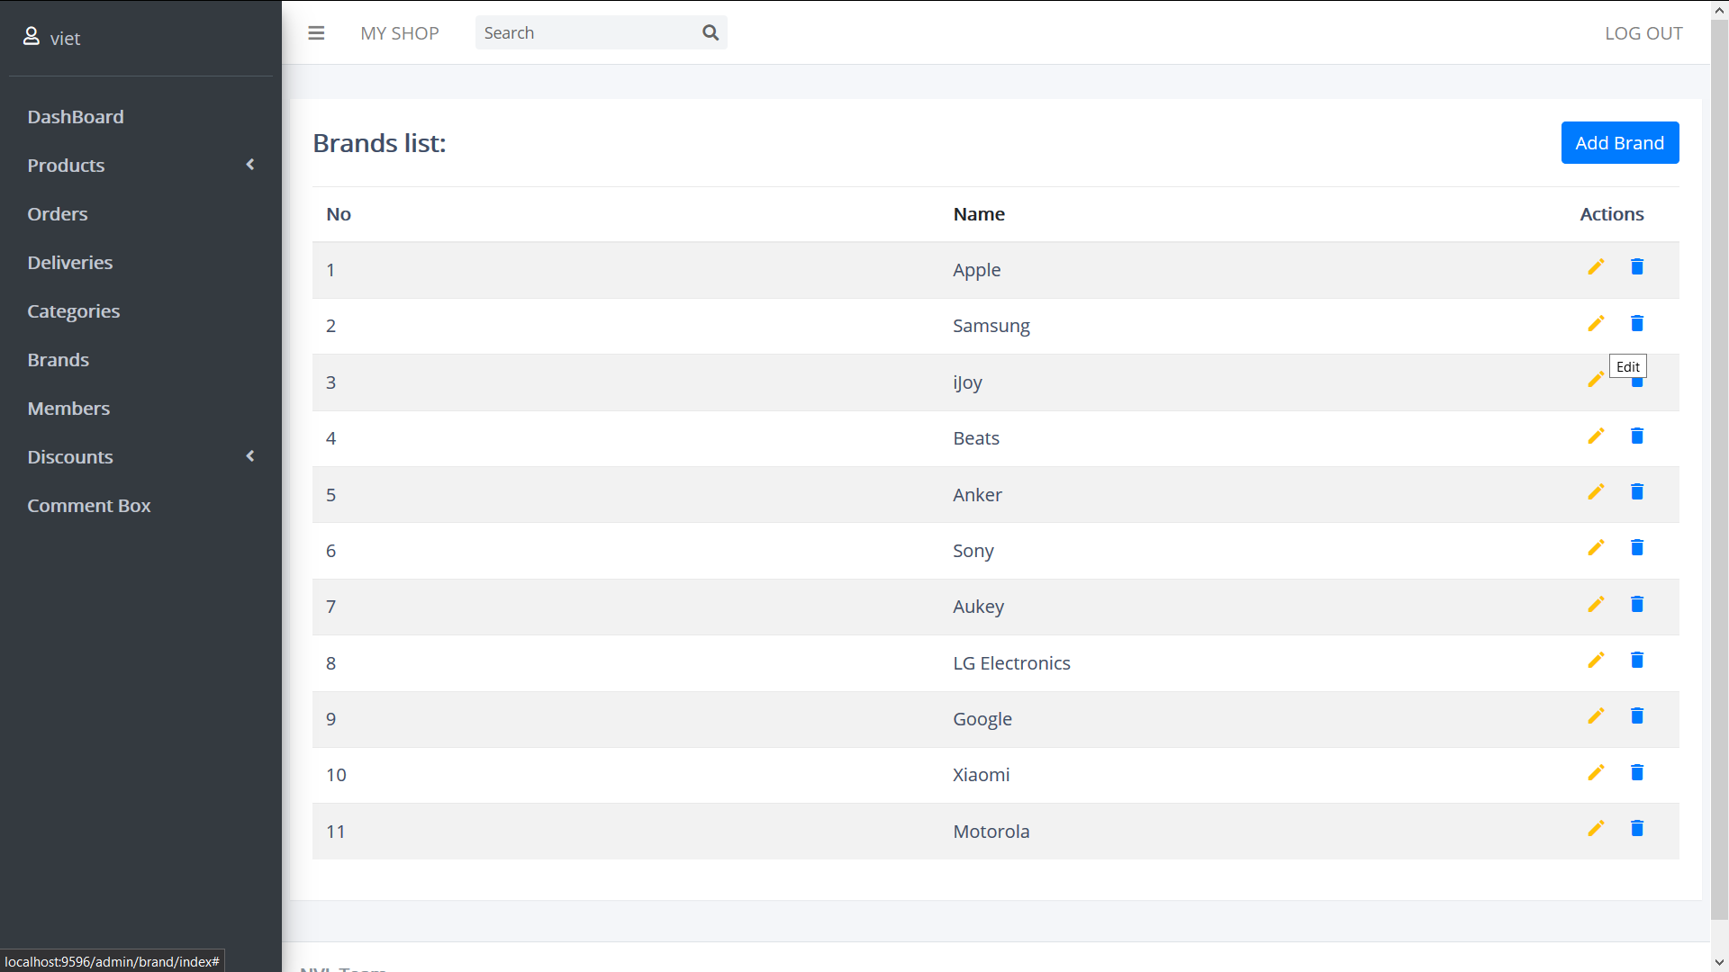

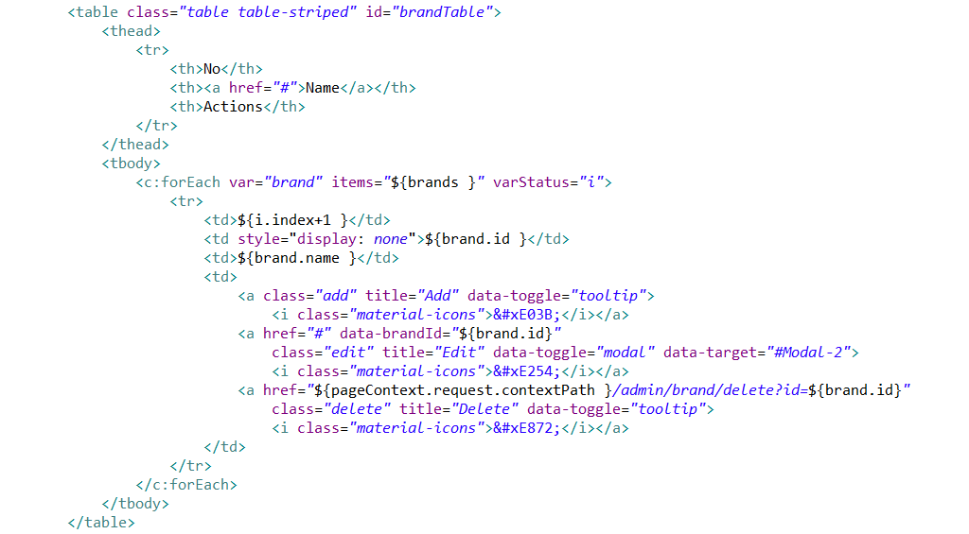

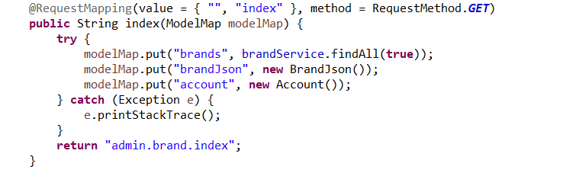

**Create:**

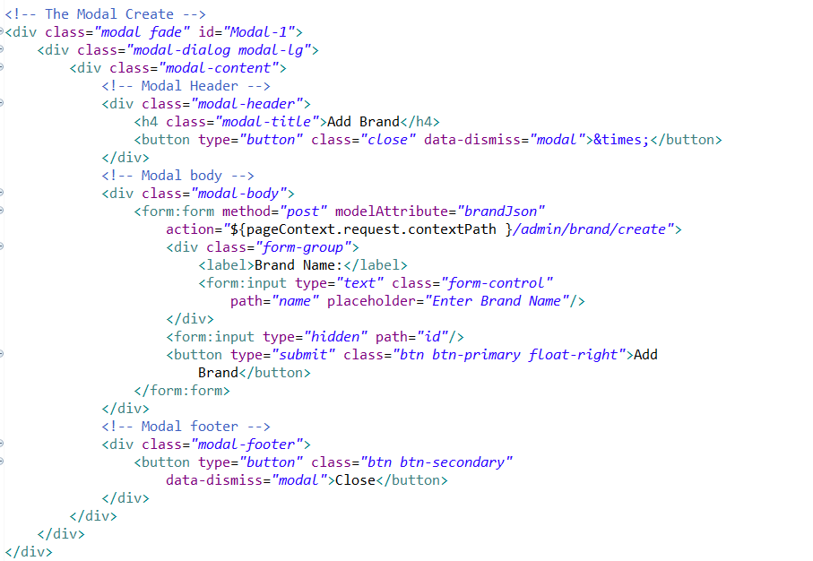

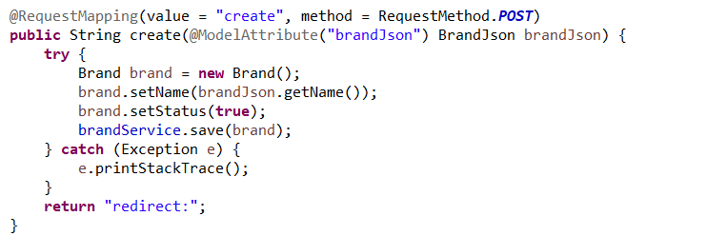

**Update:**

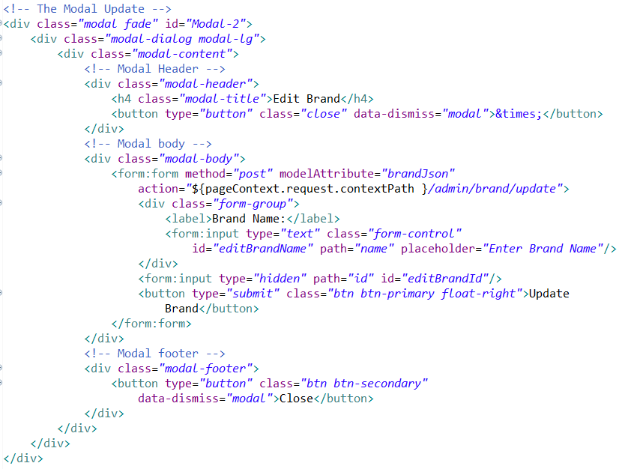

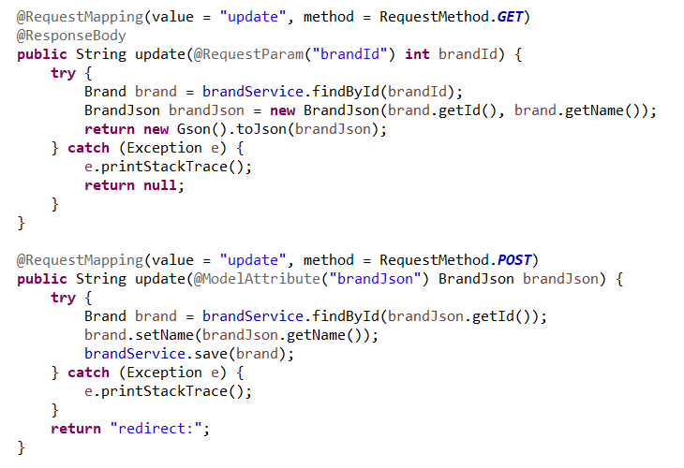

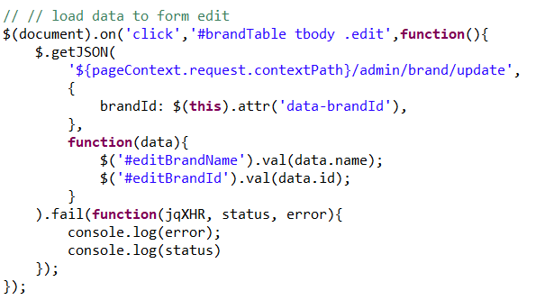

**Delete:**

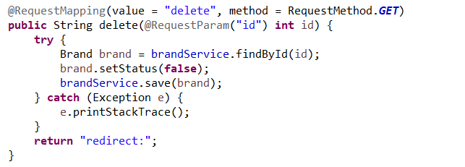

**Members:**

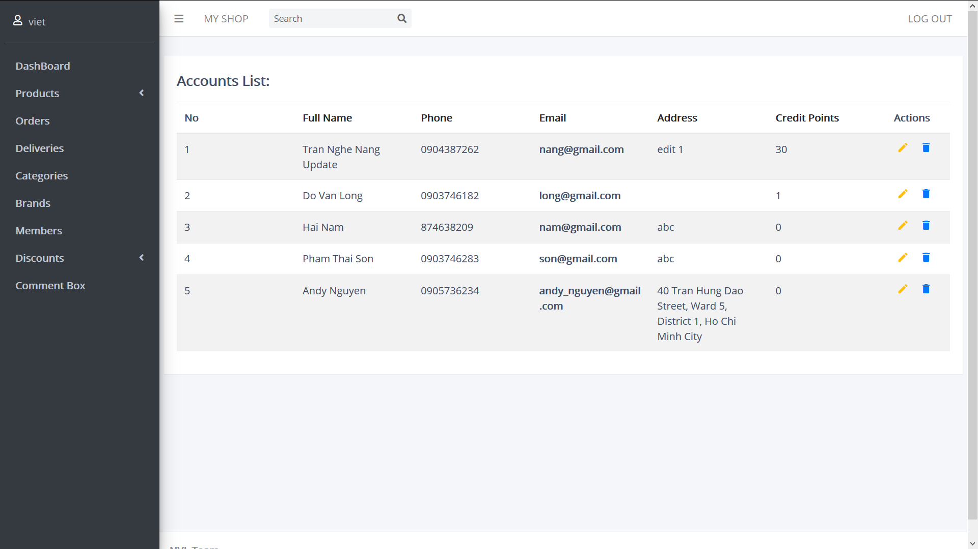

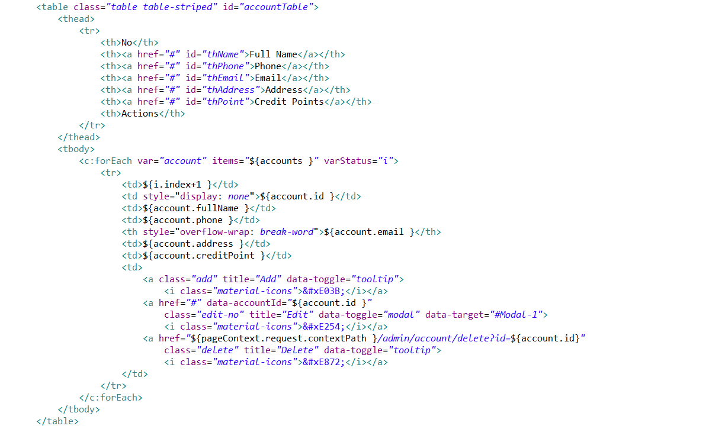

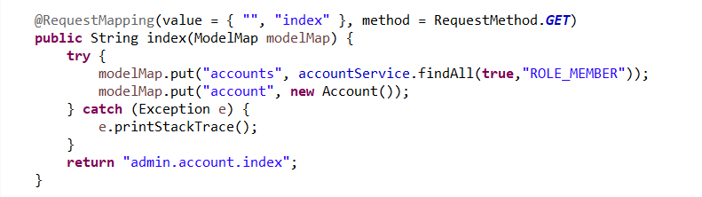

**Edit:**

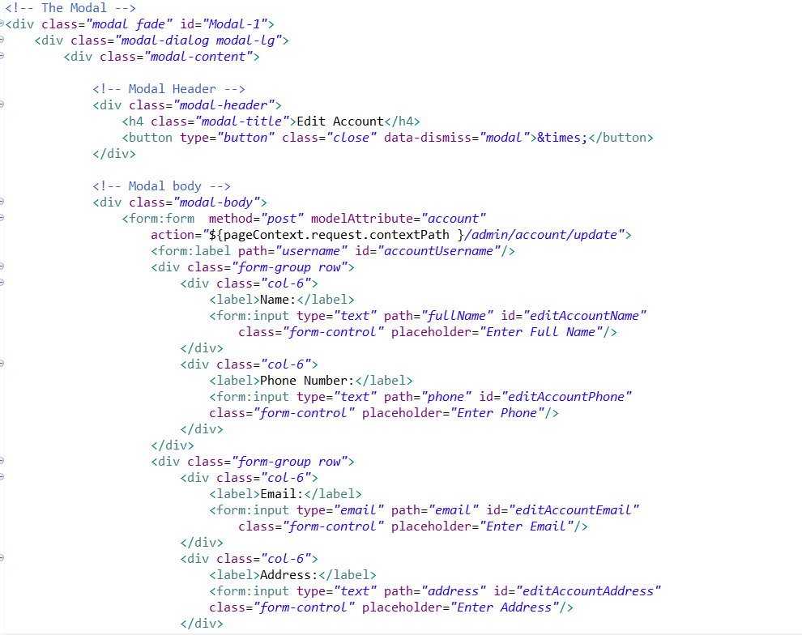

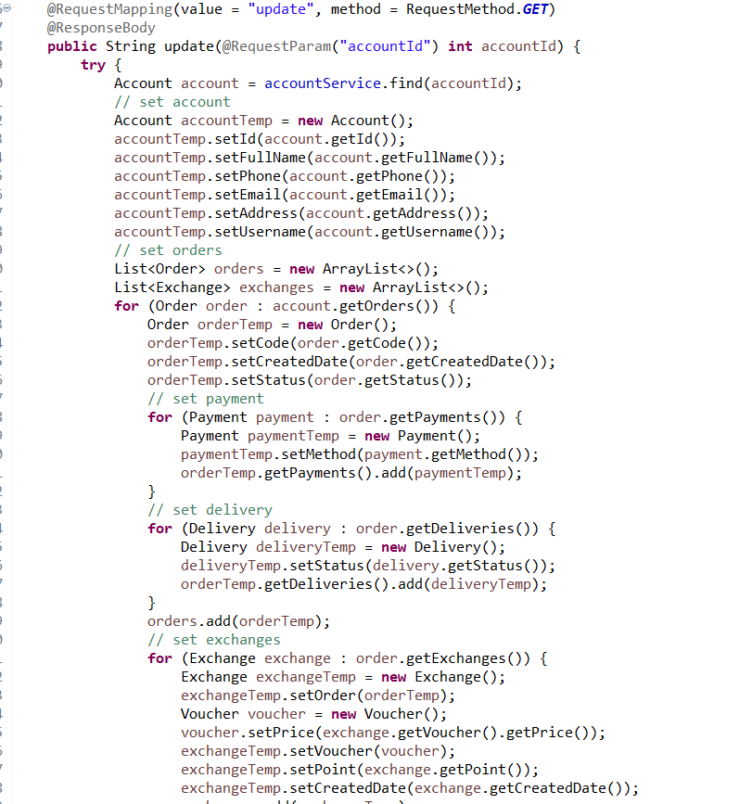

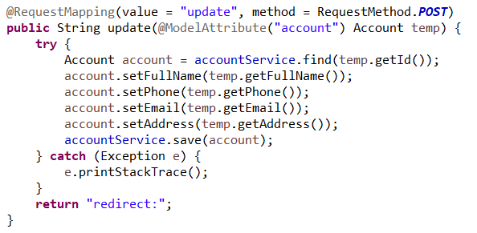

**Delete:**

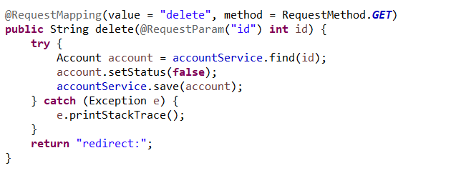

# END